YSEDC Newsletter December/January

Be the Voice a Child Deserves: Become a CASA Volunteer
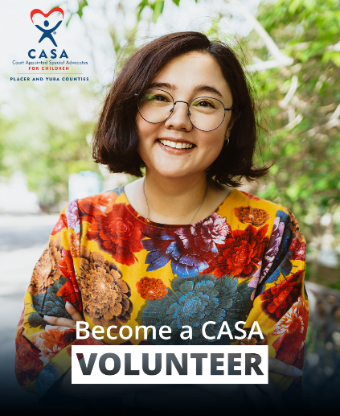
Am I ready for this?
You can be a Court Appointed Special Advocate (CASA). You just need compassion, consistency, and belief that every foster child deserves to be seen, heard, and supported. Our thorough training program provides you with the knowledge, tools, and ongoing support you need to make a lasting difference.

What does a CASA do?
CASAs form meaningful connections with children in foster care. By spending one-on-one time with their assigned child, CASAs:
• Monitor the child’s care and progress.
• Provide child-focused recommendations to the court.
• Advocate for the child’s best interests in the courtroom, classroom, and at home.

Requirements to Volunteer:
• At least 21 years old.
• Have a good driving record and reliable transportation.
• Complete a background check and provide references.

Help transform the lives of children in foster care in Yuba-Sutter!

Get started today! Book an information session at our website: casaconnects.org or for questions, email volunteer@casaconnects.org, call 530-887-1006 or visit us at 1634 Poole Blvd, Ste. 200, Yuba City, CA 95993.

