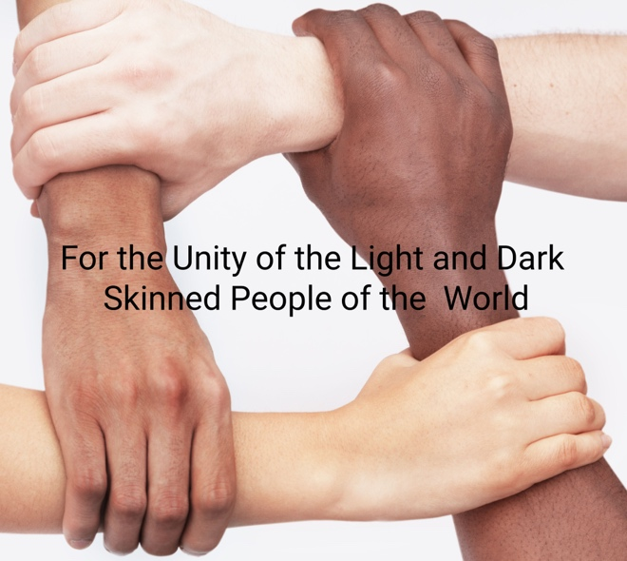

REPAIRING THE UUA'S APPROACH TO RACIAL JUSTICE
A Convocation of the UU Multiracial Unity Action Council
UUMUAC.org
Saturday, February 18, 2023, 11:00am-1:30pm Central time
(Starts at Noon Eastern, 10:00am Mountain, 9:00am Pacific)
To register send an email to UUMUAC@gmail.com;
Zoom codes will be sent the day before

Session 1. Is Racism Really "as bad as ever"?
Rev. Richard Trudeau conversation

Session 2. Is UU Culture "White Supremacist"?
Steven Myles
conversation

Session 3. Policy-Oriented Antiracism vs. Consciousness- Oriented Antiracism: What Works Best?
Dr. Kenneth Christiansen
conversation

--- Break / Music ---

Session 4. Seven Principles: Beyond Segregation & Hierarchy
Rev. Craig Moro
conversation

Session 5. MLK and the First Principle
Rev. Richard Trudeau
conversation

Session 6. What's so Wrong with the 8th Principle?
Rev. Jack Reich
conversation

