December 20th, 2017




ACPeds Parent Talk

Keeping parents up to date on the latest news in child and teen health

Shockingly inappropriate videos on YouTube Kids

In a recent New York Times article (1), parents complain of videos with well-known children's characters "in violent or lewd situations" sometimes even set to nursery rhymes. One mother caught her 3 year old son watching a video with characters from PAW Patrol "walking off a roof after being hypnotized by a likeness of a doll possessed by a demon."

A recent article in Variety (2) describes videos in which Nickelodeon characters pole-dance in a strip club and die in a fiery car crash. In that same article, a parent describes a video in which popular kids' character Peppa Pig drinks bleach. According to YouTube Kids critic James Bridle (3),

"What we're talking about is very young children, effectively from birth, being deliberately targeted with content which will traumatize and disturb them."

Thankfully parents have options besides YouTube Kids that their children can enjoy safely without the threat of perverted videos slipping through.

Protect Young Minds has developed a list of kid friendly apps that parents can trust and children can enjoy. Some of the apps included in the list are PBS Kids Video and the Nick Jr. App. Click here for the full list of YouTube Kids alternatives (4).

Though apps for kids can sometimes be helpful to parents, especially on long car rides or at times when mom or dad is busy working from home or preparing food in the kitchen, please use these apps as a last resort for entertaining your child.

Kids and teens are impressionable and the less exposure to media the better. Encourage your child to have fun in other ways including
- reading,
- playing outside,
- playing games with siblings,
- listening to music,
- drawing, or
- journaling.
Get creative. Sometimes the only thing a child can think of to do when they're bored is to get on the computer, watch TV or play video games. It's our job as parents to help them think out of the box and stimulate their imagination.

For more information
- Lead Your Child to Good Health (5) - ACPeds webpage
- Internet Safety (6) - ACPeds Patient Handout
- Parent Alert! Disturbing Videos on YouTube Kids (7) - Protect Young Minds

Flu Season Update #WeeklyBlogPost

Last season, over 100 pediatric deaths from influenza were reported to CDC. Flu season has just begun and this season is likely to be a heavy one.

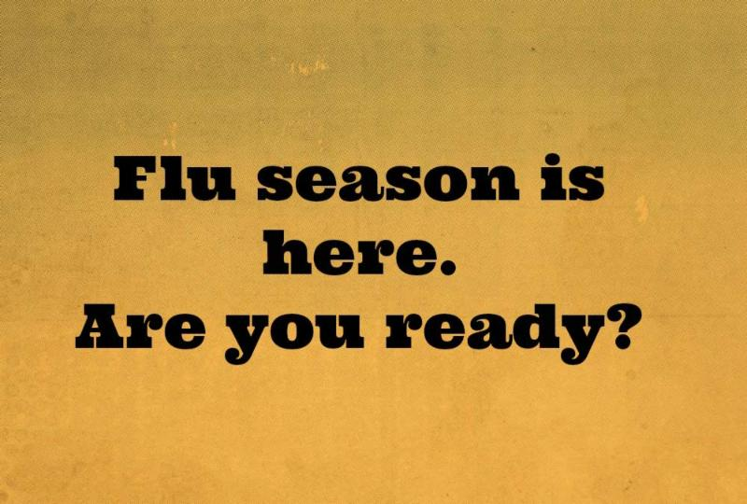

Most people who do not get their children vaccinated against flu don't think the vaccine is needed. For more information on preparing for flu season,

CLICK HERE (8) and please, leave a comment!

We love to hear from our readers and hope to receive your feedback!

Check ACPeds.org/Blog each Monday & Friday for a new post. Visit
www.acpeds.org/subscribe to subscribe to the blog and here (9) to subscribe to the Parent Talk newsletter.

Don't hesitate to contact us with your questions and comments. We look forward to hearing from you.

1 https://www.nytimes.com/2017/11/04/business/media/youtube-kids-paw-patrol.html?pagewanted=all
2 http://variety.com/2017/digital/news/youtube-kids-bizarre-disturbing-videos-blocking-age-restriction-1202611864/
3 https://www.polygon.com/2017/11/7/16620400/youtube-algorithm-kids-programming
4 https://drive.google.com/file/d/15suAD6gSAO2E7KIF77H7h_3utgRWjcz3/view?usp=sharing
5 https://www.acpeds.org/parents/lead-your-child-to-good-health
6 http://www.acpeds.org/wordpress/wp-content/uploads/9.16.15-B-Internet-Safety-Handout-with-live-streaming-and-FBI-resource.doc
7 https://protectyoungminds.org/2017/12/07/disturbing-videos-youtube-kids/
8 https://www.acpeds.org/flu-update-for-parents
9 https://visitor.r20.constantcontact.com/manage/optin?v=001_vy7Mr9Zh8wYiOUd36ZNIOQc0fzotqSL&id=preview

