GOLF TOURNAMENT REGISTRATION FORM (Complete all lines that apply)  Registration Fee: $100/person by June 9, 2017  Late Registration Fee:$125/person after June 9, 2017  Team Sponsor:  __________________________________________________________________________  Scramble Golf Tournament – Two-Person Teams (Flighted Handicap)  1. Player______________________________________________________________  Handicap or Average Score:____________________________________  Email: ______________________________________________________________  Telephone#: ______________________________________________________  2. Player______________________________________________________________  Handicap or Average Score:____________________________________  Email: ______________________________________________________________  Telephone#: ______________________________________________________  Golf Tournament will be limited to 40 two-person teams on a first come/first serve basis.  Mail completed Registration Form and Fees to:  Bobby Phills Foundation, Inc.  Attn: Memorial Golf Classic  6170 Hwy 63  Clinton, LA 70722  ** Please make all checks payable to:  BOBBY PHILLS FOUNDATION, INC.  For All Questions, or Additional Information Contact Bobby Phills by Email: bphills13@gmail.com ,  Or Cell Phone: (225-460-1066), or Web Page: www.bobbyphillsfoundation.org |  | LOTS OF FUN, PRIZES AND MORE FUN  Come out and support the Foundation’s Annual Fundraiser    For more information contact:  Bobby R. Phills, at 225-460-1066 or  Email: bphills13@gmail.com  www.bobbyphillsfoundation.org
  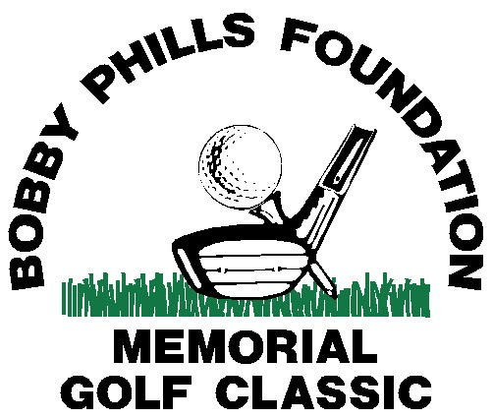
  June 19, 2017
  Shotgun Tee Time: 9:00 A.M.
  17th Annual Bobby Phills
  Memorial Classic Golf Tournament
  Copper Mill Golf Club
  2100 Copper Mill Blvd.
  Zachary, Louisiana 70791
  PH: 225-658-0656 www.coppermillgc.com/
  Patrick Schelah, Director of Golf Operations

 | On behalf of the Bobby Phills Educational Awareness Foundation, Inc. and the Bobby Phills Memorial Golf Tournament Planning Committee, I would like to take this opportunity to invite  you to consider becoming a tournament  sponsor, donor, and/or player for this year’s memorial golf tournament. Sponsors are also invited to attend the Players Awards Luncheon immediately following the tournament.  Tournament sponsors can select from one of four (4) corporate sponsor levels, Platinum, Gold, Silver, and Bronze. Each of these corporate levels comes with a hole and tee sign, plus one or more team participants based on level of sponsorship.  Funds from the Memorial Golf Tournament are used to support student scholarships at the precollege and undergraduate levels, as well as college tutorial assistance. It will also go to support community-based organizations and youth related programs that promote the growth and development of youth. To this end, we welcome both sponsor and donor funds that mirror our goals and objectives.
Additional information about the Memorial Golf Tournament, the Foundation and its founder can be found on the Foundation website: www.bobbyphillsfoundation.org. Thank you for your consideration of becoming a sponsor or donor of this year’s memorial golf tournament. We look forward to your participation in the tournament and joining us for the awards ceremony.

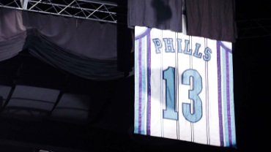

Early Bird Registration
Registration fee for persons who register prior to June 9th is $100/person. Registration after this date will be $125.00/person. Team awards will go to the first and second place winning teams of gross and net flights.
Prize Information
The 1st place team will receive $100/person and the 2nd place team will receive $50/person. Individual award categories will be “Longest Fairway Drive”, “Closest to the Pin”, and a “50/50 Money Hole” on a selected Par Three. All players, sponsors and tournament winners will be recognized during the Ceremonial Awards Luncheon immediately following the tournament.

TOURNAMENT SPONSOR/DONOR FORM
(Check all boxes that apply)

I: Golf Tournament Corporate Sponsorships
- Platinum = $5,000
*eligible for Four [4] “Two-Person” teams
- Gold = $3,000
*eligible for Three [3] “Two-Person” teams
- Silver = $2,000
*eligible for Two [2] “Two-Person” teams
- Bronze = $1,000
*eligible for One [1] “Two-Person” teams
Each Corporate Sponsorship includes a Tee and Hole Sponsorship Advertisement

II: Corporate Hole and Tee Box Sponsorships
- Hole and Tee Box = $500
- Hole or Tee Box = $300
III: Tournament Donations:
In honor of the Foundation’s Founder, the Late Bobby R. Phills, II, a Louisiana native, and Southern University graduate, the Foundation requests that donations be given in increments of $13.00, which represents the number on Bobby’s last professional basketball jersey with the NBA’s Charlotte Hornets. All donations given in support of the Foundation’s goals and objectives of promoting student scholarships, youth development, and community service activities are welcome and appreciated, regardless of the amount. It is not the amount, but the sincerity of giving.

Donation Amount: $____________________________

