WHAT YOU NEED TO MAKE DENIM FEATHERS
- Denim scraps – The scrap pieces will need to be as big as you want your feathers. You will also need pieces of denim with no seams or embellishments just plain bits of jeans fabric.
- Twine – I love Nutscene twine which comes in lots of lovely different
- colors.
- Fabric Mod Podge
- Wooden beads 10-12mm with a 5mm hole.
- Stick and drawing pins to hang the denim feathers from.

HOW TO MAKE A DENIM FEATHER WALL DECOR

1. The first thing to do is to cut out a feather shape from your scrap of denim. If you are not confident about doing this free hand you can download my feather template and use this to draw around before cutting out the feather shape.
Make sure that the template lies in the same direction as the weave of the denim. Depending on which way you lie the feather template on the denim will depend on what color feather you will make. Denim tends to be made up of a weave of both blue and white threads. 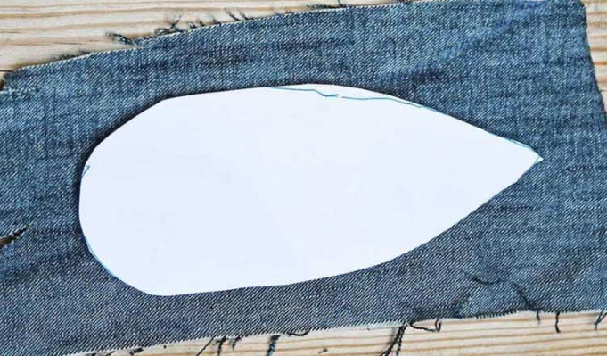

2. Next cut a piece of twine that is a couple of inches longer than denim feather shape.

3. Cover the twine in fabric glue and stick it to the center of the denim feather shape. This will create a spine for the feather.
You can stitch the twine in place if you prefer that to glue. However, the glue is better as it also stiffens the twine which helps the denim feather hold its shape.

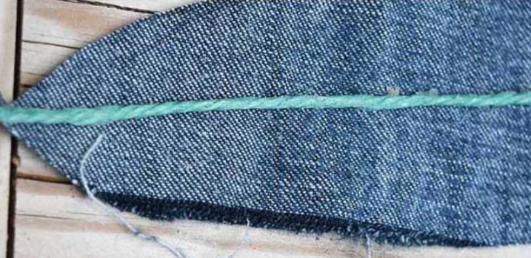

4. To make the feathers, fray the denim by pulling out the threads. Denim is frayed by removing the threads of one color. Therefore, if you remove the white threads you will end up with blue feathers. If you remove the blue threads you will end up with white feathers.
Cut the feather shape the long way, with grain for one color and cut across the grain for the other color.
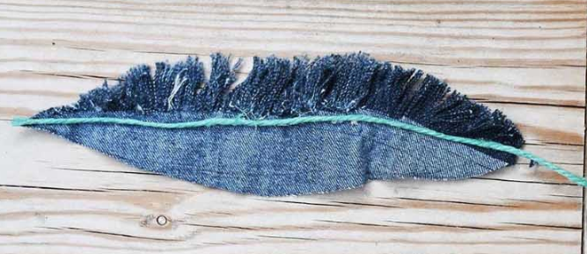

MAKING THE DENIM FEATHER WALL DECOR

5. I used this same method to make several feathers, both white and blue in various sizes. To make the denim feather wall decor, I first threaded the twine of both a blue feather and a white feather through the same wooden bead.
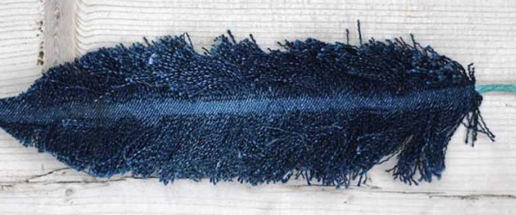

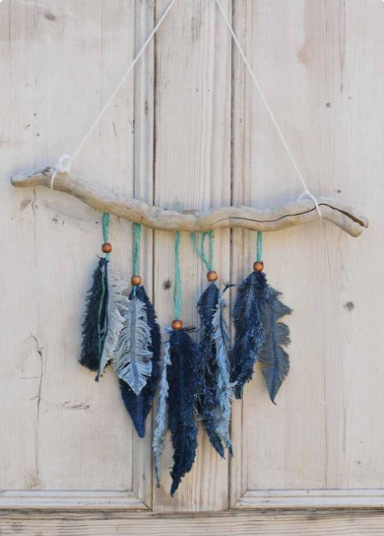
6. Finally, the pairs of repurposed denim feathers were hung from a wooden stick. They were attached to the stick with a drawing pin at the back.

I love how the denim feathers have turned out. You can make a collection of feathers in different shades of indigo by using denim scraps from different pairs of jeans.

Steps and photos from: https://www.pillarboxblue.com/denim-feather-wall-decor/

