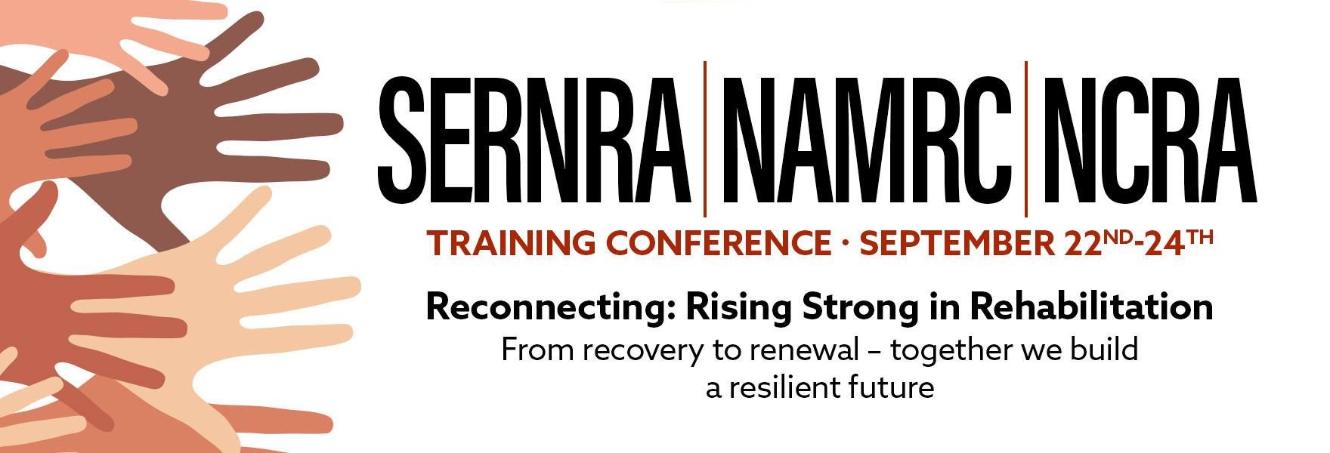

PROPOSAL SUBMISSION DEADLINE
July 9, 2025
SERNRA PRESIDENT: Cheryl Revels
NAMRC PRESIDENT: L’Tanya (Terrye) Fish, Ph.D., CRC, LCMHC-S
NCRA PRESIDENT: Toni King, MS, CRC

CONFERENCE CHAIRS:  Toni King, MS, CRC  Avery Newman,  University of Arkansas Currents | PROGRAM CO - CHAIRS:  L’Tanya (Terrye) Fish, Ph.D., CRC, LCMHC-S  Marjorie C. Donaldson, BA, CPM  Susan Rapant, CRC, CDMS, CCM,  CVE, IPEC, ABVE/D

OVERVIEW OF TRAINING NEEDS
The SERNRA * NAMRC * NCRA conference is scheduled for September 22 – 24, 2025 at the Sheraton Four Seasons in Greensboro, NC. The joint conference is an opportunity for training, education, and credentialing of our diverse membership that believes excellence and outcomes are achieved by upholding the utmost importance of continuous learning, professional development, and personal enrichment. The conference also provides networking to reconnect with partners and people across a large spectrum of rehabilitation professionals. During the two-day conference, we will offer concurrent sessions that focus on topics that intersect disability specific topics, ethics, special populations, and create a momentum to rise strongly in rehabilitation. There will be a poster session from graduate students in Rehabilitation Counseling programs from universities across the southeast region.
Target Audience
The target audience comprises of but not limited to: Vocational Rehabilitation and Independent Living Counselors and related human service professionals; Vocational Evaluators; Assistive Technology Consultants; Exceptional Children Teachers; Physical, Occupational, and Speech Therapy Professionals; Mental Health Professionals; Case Managers; ADA Coordinators and Accommodations Specialists; people with disabilities and their families/caregivers; and other interested professionals.

Training Focus Areas
- Advocacy/ Self – Determination/ Empowerment
- Clinical Supervision
- Ethics (CRCC Code of Professional Ethics)
- Health & Wellness (Resilience, Self-Care)
- Innovative Employment Practices (Career Paths, Community Rehabilitation Providers)
- Leadership
- Mental Health Services (Caregivers)
- Motivational Presentation: Reconnecting - Rising Strong in Rehabilitation
- Public Policy (legislations) and People with Disabilities
- Rehabilitation Technology: Artificial Intelligence, AT, Modification Projects
- Special Populations: Veterans, Farmers – AgrAbility.

2025 SERNRA * NAMRC * NCRA CONFERENCE Session Proposal

Title of presentation:

Objectives: Credentialing Boards require program objectives to be stated in behavioral terms with a minimum of three (Example: Objective 1: Identify the problem; Objective 2: Define a potential new approach; and Objective 3: Develop strategies to implement).

Objective 1:Click here to enter text.

Objective 2:Click here to enter text.

Objective 3:Click here to enter text.

Abstract/summary: Please limit it to seventy-five (75) words, suitable for publication.

Length of presentation: Check any options that could work for your presentation.

☐ 90 Minute Session (Required for CRC Credit)
☐ Poster Session (see below for more information)

Each presenter must provide the following information needed to obtain continuing education approval. The lead presenter will serve as liaison with the other presenters:

This person is the: ☐Lead Presenter
Name: enter full name
Email Address: enter email address
Mailing Address: enter mailing address
Phone #: best number to reach you.
Current Employer: click here to enter text
Position Title: CLICK HERE TO ENTER TEXT
Years of experience in the field: CLICK HERE TO ENTER TEXT
This person is the: ☐Co-Presenter
Name: enter full name
Email Address: enter email address
Mailing Address: enter mailing address
Phone #: best number to reach you
Current Employer: click here to enter text.
Position Title:
Years of experience in the field: Click here to enter text.
What accommodations will you NEED? click here to enter text.
What media/audiovisual equipment will you bring with YOU? click here to enter text.

Please submit all pages of your proposal via email to:
namrcconferenceproposal@gmail.com

Thank you for your interest in partnering with us!

2025 SERNRA * NAMRC * NCRA POSTER PROPOSAL FORM

A Poster Session is a graphic presentation of an author's research. Students illustrate their findings by displaying graphs, photos, diagrams and a small amount of text on the poster boards. Poster Sessions will take place for one hour. Students will hold discussions with attendees who are circulating among the poster boards. Please note that there are no virtual presentations. All presenters must register and present in person at the conference.

POSTER TITLE
In the space below, limit your title to 12 words, including punctuation marks and spaces. Proposal titles should be simple and factual.
POSTER ABSTRACT
Limit to 150 words max in the space below. An abstract is a brief, comprehensive summary of the contents of the article.

POSTER LEARNING OBJECTIVES
Learning objectives (minimum of three), (e.g., audience will be able to describe appropriate language use for population, audience will be able to evaluate for safety, and audience will recognize challenges of researchers of color)
CONTENT NARRATIVE OR DESCRIPTION OF TOPIC
REHABILITATION FOCUS (Related to the conference theme – Reconnecting: Rising Strong in Rehabilitation)
REFERENCES (list at least 5 references within the last 7 years)
Biography of the Lead Presenter (no more than 50 words) & Co-Presenters (no more than 50 words for each co-presenter):
Below, in a brief paragraph, give the lead presenter’s qualifications. Please list degree(s), areas of specialization, current position, and employer.

Please submit all pages of your proposal via email to:
namrcconferenceproposal@gmail.com

Thank you for your interest in partnering with us!

