Jupiter Gems Baby Birds Program
September to December 2022 Calendar
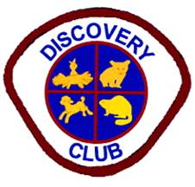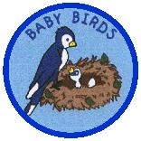
August
27 2:15 pm Registration

September
10 2:15-3:45 pm Regular meeting, field uniform

October
8 2:15-3:45 pm Regular meeting, field uniform
23 10 am Beach outing at Ocean Cay Park with Adventurers (optional; will have a popsicle sale fundraiser to benefit Restore A Child and play at the beach)

November
12 2:30 pm Induction Ceremony (optional), dress uniform
19 2:15-3:45 pm Regular meeting, field uniform

December
10 ~2 pm Share Your Faith project (optional; Caroling in the community), dress uniform

