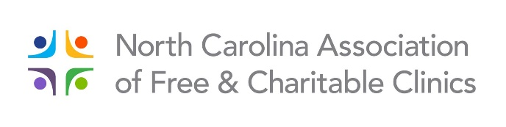
NCAFCC Summit 2020
April 30 & May 1

REGISTRATION

Name: Click or tap here to enter text.
Title: Click or tap here to enter text.
Organization: Click or tap here to enter text.
Email: Click or tap here to enter text.
Clinic Phone: Click or tap here to enter text. Cell: Click or tap here to enter text.

Note: If additional people from your clinic are attending, please complete a separate registration form for each person, e.g. clinic staff, board chair/member.

Please check New Registration Fee!

☐ Full Summit $50 for one person
$25 for each additional person

☐ One day only – Please indicate day ☐ Thursday or ☐ Friday $30 for each person attending

HOTEL INFORMATION ______
Embassy Suites by Hilton Greensboro Airport
204 Centreport Drive, Greensboro, NC 27409
(336) 668-4535

Room rate is $119 + tax
Deadline to guarantee a room and the special room rate is April 9. When making reservations, reference the NCAFCC Summit to receive the discounted room rate.

Registration form(s) and check are due no later than Thursday, April 23rd.

Please mail form(s) along with your payment to: NCAFCC
1399 Ashleybrook Lane, Suite 110
Winston-Salem, NC 27103

Refunds are given up to five days before the event.

