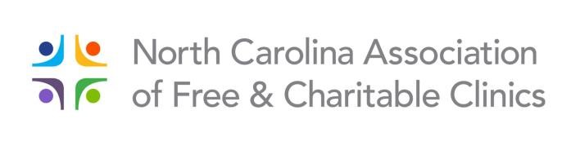

A G E N D A

Thursday, September 19, 2019

11:00 a.m. – 12:00 p.m. Registration

12:00 – 12:45 p.m. Networking Lunch Buffet

12:45 – 1:25 p.m. Welcome/NCAFCC Update
April Cook
Lake Norman Community Health Clinic
Board of Directors, Chair

Randy Jordan, CEO
NC Association of Free & Charitable Clinics

1:30 – 2:15 p.m. Strategic Learning Part 1: Lessons from the Road
Josh Jacobson, Managing Director
Next Stage
Strategic Planning & Consulting for Nonprofits

2:15 – 2:45 p.m. Ice Cream Social
Networking and Time with Sponsors

3:00 – 4:00 p.m. Strategic Learning Part 2: Building an Adaptive Culture
Josh Jacobson

4:00 – 4:45 p.m. NC QuitLine
Stephanie Gans LCAS, LCSWA, CTTS
Tobacco Treatment Specialist
Division of Public Health, Tobacco Prevention & Control Branch
North Carolina Department of Health and Human Services

All sessions take place in the Piedmont Ballroom
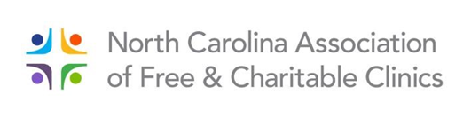

A G E N D A

Friday, September 20, 2019

8:30 – 9:00 a.m. Registration

9:00 – 9:50 a.m. HR: What You Need to Know and Why You Need to Know It
Heather Bumgarner
People Development Partners

10:00 – 10:50 a.m. Treating the Whole Person: Recognizing Implications of Traumatic and Adverse Experiences – Responding with a Compassionate Approach
Jenna Crawley, LPC, LCAS, EMDR Certified Therapist
Mental Health Counselor, Community Care Clinic and Hospitality House

10:50 – 11:00 a.m. Break

11:00 – 11:50 a.m. What Does a Great Leader Look Like?
Lisa Bottomley, ED
Community Care Clinic

12:00 – 12:55 p.m. Lunch

1:00 – 1:50 p.m. Peer-to-Peer Discussion
John Devaney, CEO
Cape Fear Clinic

1:50 – 2:00 p.m. Break

2:00 – 2:50 p.m. Mark Twain and Medicine: "Any Mummery Will Cure"
K. Patrick Ober, MD

All sessions take place in the Piedmont Ballroom

