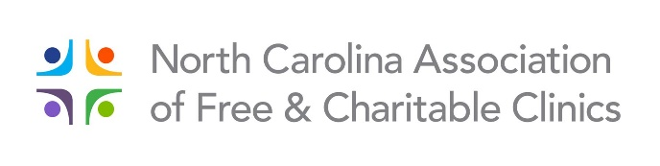
Leadership Retreat
September 19 & 20
Historic Brookstown Inn – Winston-Salem

REGISTRATION

Registration Deadline: Friday, September 13, 2019

Name: Click or tap here to enter text.
Title: Click or tap here to enter text.
Organization: Click or tap here to enter text.
Email: Click or tap here to enter text.
Clinic Phone: Click or tap here to enter text. Cell: Click or tap here to enter text.

Note: If additional people from your clinic are attending, please complete a separate registration form for each person, e.g. clinic director, board chair/member.

Please check New!

☐ Full Retreat $250 for one person
$80 for each additional person

☐ One Day ONLY – Please indicate day ☐ Thursday or ☐ Friday $125 for one person
$40 for each additional person

HOTEL INFORMATION
To make your reservations, call the Brookstown Inn at 336-725-1120 and mention you are with the “NC Association of Free and Charitable Clinic’s Leadership Retreat.” NCAFCC has secured a special rate of $125.00 which includes a complimentary hot breakfast bar. Please note: The room block expires on August 20. Make your reservations early because the rate cannot be guaranteed after August 31st.

Registration form and check are due no later than September 13, 2019.

Please mail this form along with your payment to: NCAFCC
1399 Ashleybrook Lane, Suite 110
Winston-Salem, NC 27103

Refunds are given up to five days before the event.

