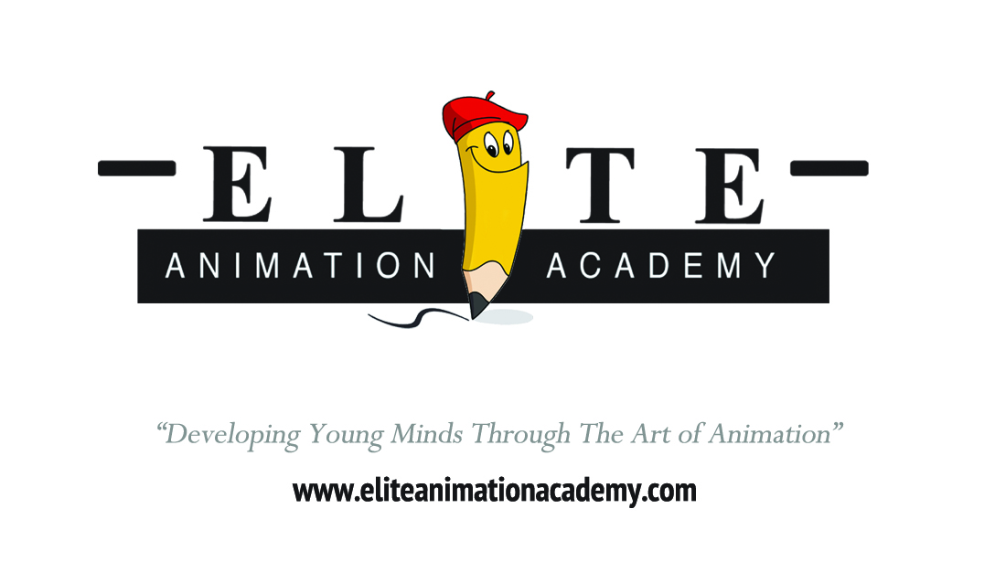
2019 FALL COURSE STUDIO SCHEDULE – ORLANDO
DRAWING – ANIMATION - GAMING
SEPTEMBER 14th to NOVEMBER 16th, 2019– 10 WEEKS
(COURSE MEETS EVERY SATURDAY FOR 10 WEEKS)
Saturday – Foundational Drawing 10:00 am to 12:00 noon Saturday – Anime/Manga 10:00 am to 12:00 noon Saturday – 2D Character Animation 10:00 am to 12:00 noon
Saturday – Traditional Animation 12:00 noon to 2:00 pm Saturday – Character Design w/ Photoshop - 12:00 noon to 2:00 pm Saturday – NEW! Game Design Fundamentals - 12:00 noon to 2:00 pm
Saturday – Sketching 2:00 pm to 4:00 pm Saturday – Comics and Cartooning 2:00 pm to 4:00 pm
Saturday – NEW! Video Editing & Special Effects 2:00 pm to 4:00 pm
Saturday – Figure Drawing 4:00 pm to 6:00 pm Saturday – Digital Illustration & Painting - 4:00 pm to 6:00 pm Saturday – 3D Fundamentals - 4:00 pm to 6:00 pm

“Developing Young Minds Through the Art of Animation®”

