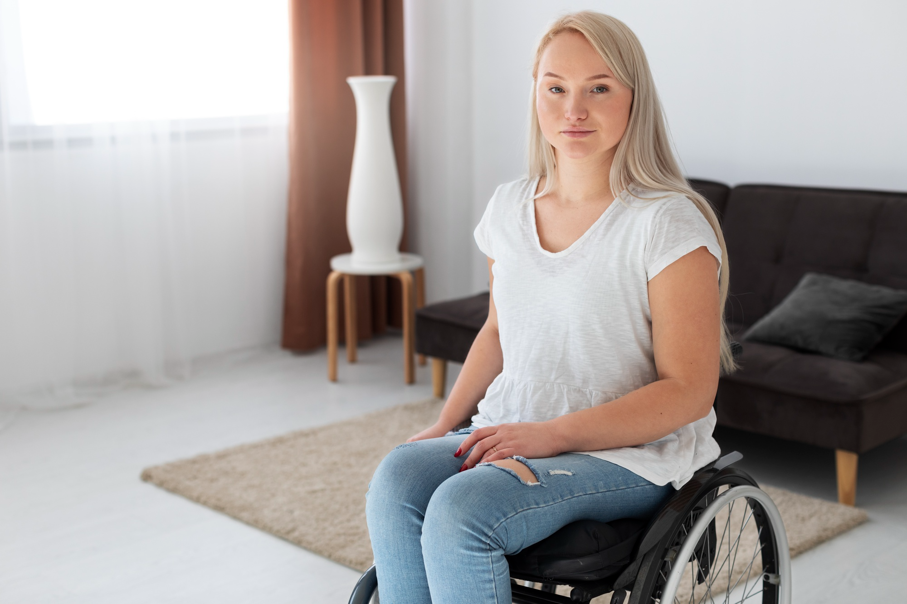
Image from Freepik

Preparing for Parenthood With a Disability: Practical Ways to Set Up Your Home and Life
Becoming a parent is a big transition for anyone. There’s excitement, nerves, and a thousand decisions, many of them happening while you’re still trying to rest, work, and live your normal life. The most helpful way to prepare is to build a setup that supports your routines, protects your energy, and makes daily care feel smoother once baby arrives.

A steady approach
Think in terms of access + ease + recovery: make essentials reachable, reduce unnecessary steps, and plan for rest.

Making decisions when stress spikes
It’s normal to feel anxious when planning for a baby, especially when you’re juggling lots of details and trying to make the best choices. The key is that decision-making under stress is best when guided mindfully, so pause and gather your thoughts. When a decision starts to feel heavy, weigh it gently instead of rushing in.
A few practical ways to slow stress and evaluate choices more clearly:
- Take a deep breath before deciding—this can help you think more calmly
- Ask “What would make daily life easier?” (instead of “What’s the perfect option?”)
- Choose one next step, not the whole plan at once
- Write down your top 3 priorities (comfort, safety, ease of use) and use them as a filter
- If you’re overwhelmed, pause the decision and revisit it after rest or a break in the outdoors

Design your home around your real daily flow
Instead of aiming for a picture-perfect nursery, focus on making the most common tasks simple and comfortable.
Helpful home adjustments:
- Create two “care stations” (for example, bedroom and living room) so you’re not forced to move supplies constantly
- Store baby essentials at waist or chest level to reduce bending or reaching
- Use rolling carts or bins to keep supplies portable and organized
- Choose a changing setup that feels stable and safe for you (table, dresser topper, wall-mounted, or bed-level system)
- Keep a night setup ready: diapers, wipes, burp cloth, swaddle/sleep sack, bottle supplies if needed

Choose baby gear that reduces strain and steps
The best gear is the gear that makes care easier—not the most expensive items.
Consider:
- A stroller that opens and folds smoothly and fits your vehicle/living space
- A baby carrier or wrap style that feels comfortable for your body and easy to secure
- A bassinet or sleep space that’s easy to access at night
- Diaper pails or trash systems placed where they’re easiest to use
- Hands-free lighting (motion night lights, touch lamps) for nighttime feeding and changes
If possible, try items in person or watch demos so you can picture how they’ll work in your day.

Prep routines for feeding, sleep, and soothing
Newborn care is repetitive, which can be a gift—because routines can become supportive systems.
Simple ways to prep:
- Set up a feeding station with water, snacks, chargers, burp cloths, and supplies
- Create a calming “reset plan” for fussy times (swaddle, white noise, rocking, dim lights)
- Plan for sleep support: blackout curtains, sound machine, night lights, comfortable seating
The goal is to reduce decision-making when you’re tired.

Build a support plan that’s specific and easy to activate
Support works best when it’s clear. People often want to help; they just don’t know how.
Ways to set up support ahead of time:
- Create a short list of task-based help (meals, laundry, errands, dog walks, dishes)
- Identify who can help with transportation or appointments if needed
- Set a communication plan: a group text or shared list for requests
- Plan backup options for days when you need extra rest
If you have a partner, it can help to discuss shifts and responsibilities in advance so expectations feel clear.

Keep paperwork and essentials organized early
Preparing documents and logistics ahead of time can reduce stress later.
Helpful items to prepare:
- A folder (paper or digital) for medical documents and appointment notes
- Emergency contacts and “who to call” list
- A simple checklist for hospital bag and baby essentials
- Any home deliveries set up in advance (diapers, wipes, household needs)

Practice “micro-recovery” so you don’t run on empty
Parenthood includes a lot of start-and-stop days. Having small recovery habits ready makes a difference.
Examples:
- Short breathing resets (60–90 seconds)
- A glass of water every time you feed the baby
- Stretching during a diaper change break
- A quick snack station so you don’t forget to eat
Small recovery habits are protective, especially in the early weeks.

Quick preparation checklist
☐ Set up two baby-care stations in the home
☐ Organize supplies at easy-to-reach height
☐ Choose gear that reduces strain and steps
☐ Plan simple routines for feeding, soothing, and sleep
☐ Build a support list with specific tasks people can do
☐ Prep documents, contacts, and home deliveries
☐ Practice micro-recovery habits daily

Wrap-up
Preparing for parenthood is less about having everything perfect and more about creating a setup that supports your real life. When your home is organized around ease, your routines are simple, and your support plan is clear, the early weeks feel more manageable. Focus on comfort, access, and recovery—then let the rest come together step by step. You’re building a steady foundation for your family, and that’s the win.

