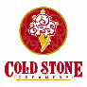
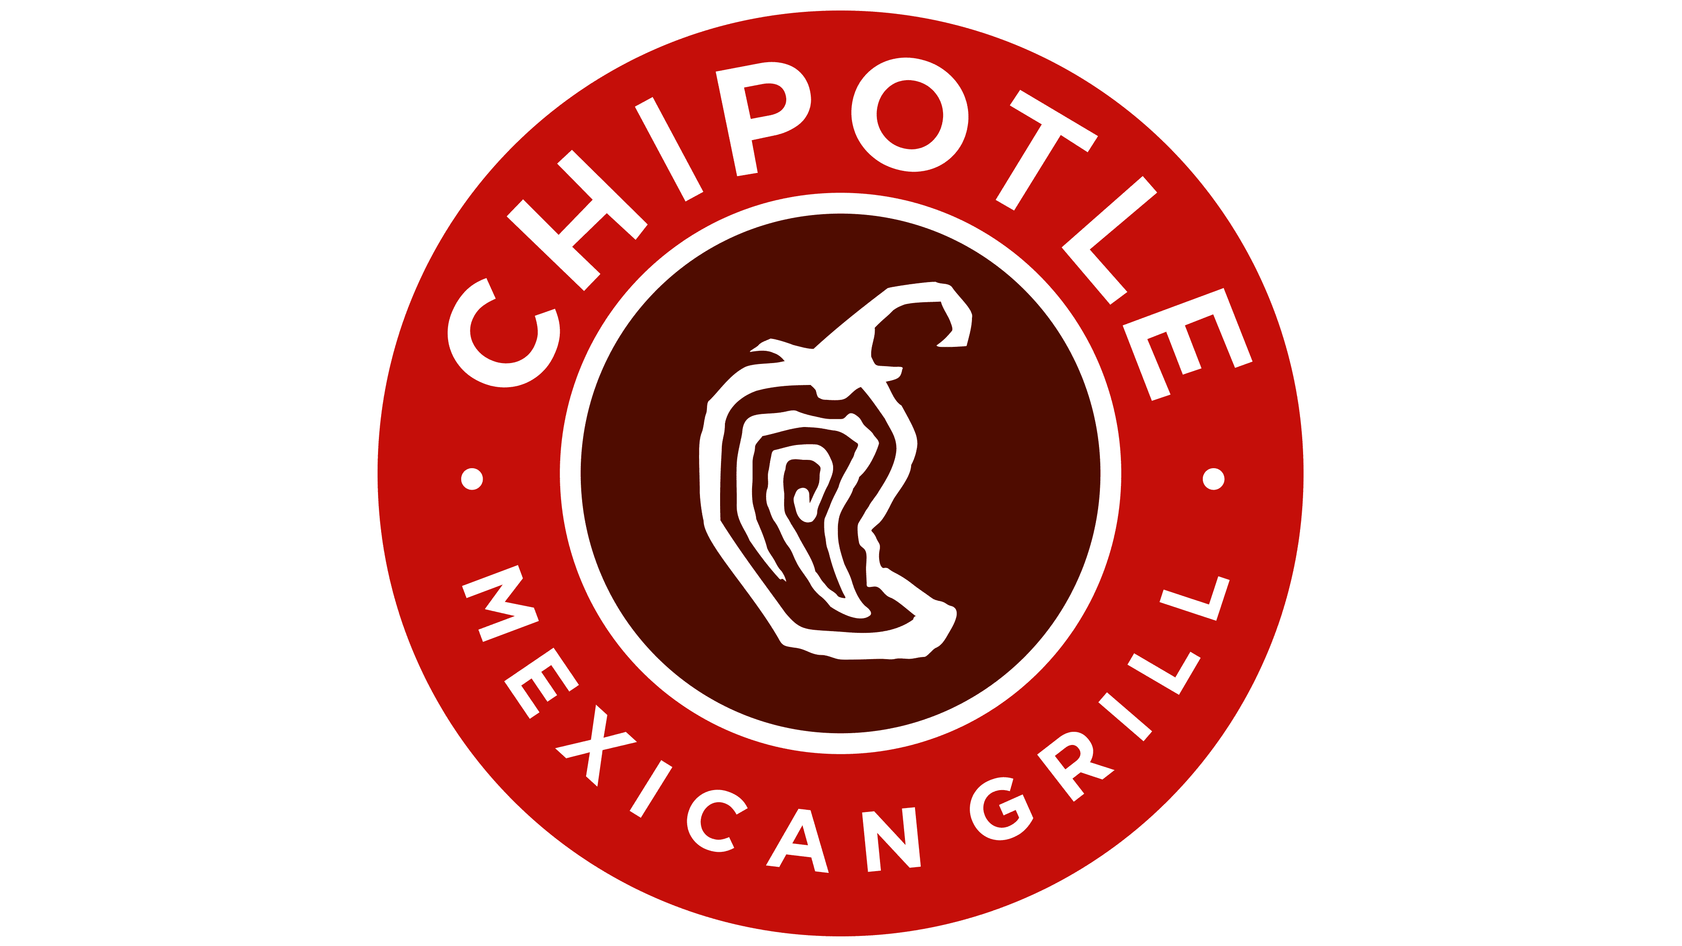
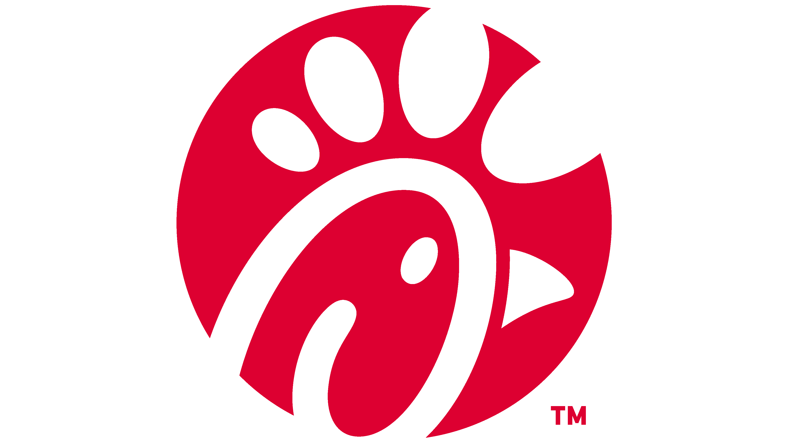
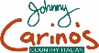
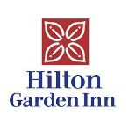
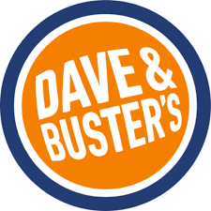
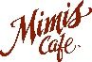
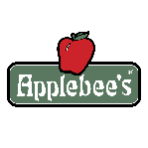
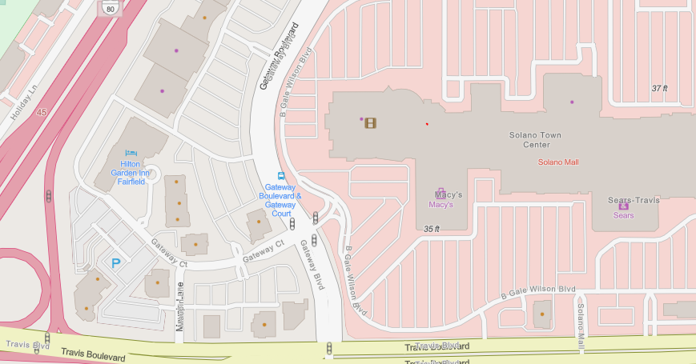
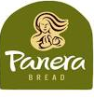
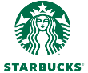
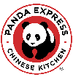
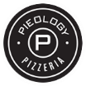
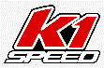

120th Annual Meeting of the CAA:

Around the Conference
 | Sit Down Restaurants | Take Out/Fast Food | Entertainment | Outside Attractions
 | Applebee’s | Chick-Fil-A | Barnes & Noble | Jelly Belly Factory
 | Chevys Mexican Restaurant | Chipotle | Dave & Busters | Pena Adobe park
 | Dave & Busters | Cold Stone Creamery | K1 Speed | Rockville Hills Regional Park
 | Johnny Carino’s | Five Guys | Regal Cinemas | Vacaville Premium Outlets
 | Mel’s Diner | Panda Express
 | Mimi’s Cafe | Panera
 | Red Lobster | Pieology
 |  | Starbucks

