Gwinnett Online Campus Arrival & Dismissal Plan

ARRIVAL - Drop off begins promptly at 8:30 a.m. for Core and Learning Labs. Please do not drop students prior to this designated time; GOC does not have adequate staff designated to monitor students.
DISMISSAL – Please follow the dismissal schedule for the appropriate grade level. You should plan to pick-up your student within 15 minutes of dismissal time. After that students will be sent to the Productivity Center and parents will need to park and come inside to pick-up their student.
Students will exit the building through the front doors and be picked up in the front lanes. Please maintain one lane of cars and pull forward as far as possible in the front driveway. Please be mindful, we can NOT block Hi Hope Road or pull in the grass area waiting for dismissal to begin. If the front lane is already full, please utilize the Hurricane Shoals side parking lot and wait until the lane begins moving.

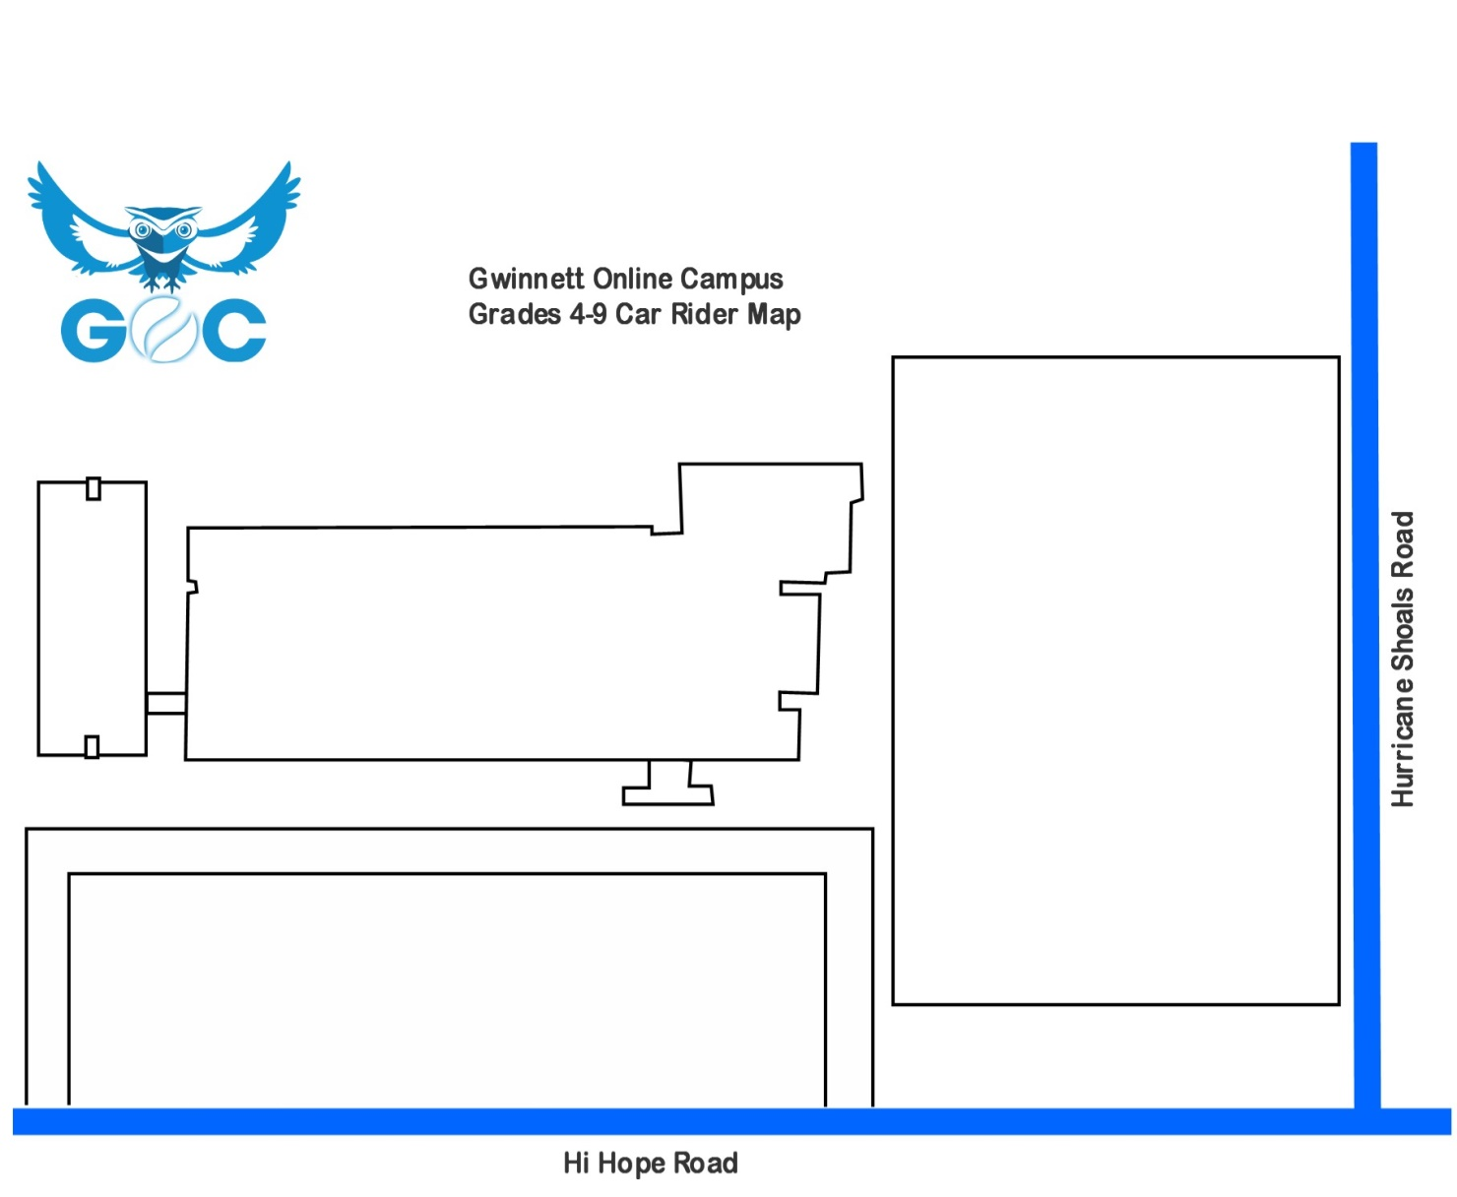

Gwinnett Online Campus
Car Rider Map

Please DO NOT BLOCK Hi Hope Road or Hurricane Shoals Road.
Grade 9

