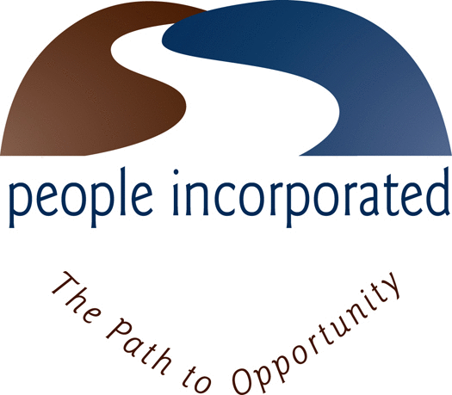
FOR IMMEDIATE RELEASE Contact: Peter Daley
pdaley@peopleinc-fr.org

Hallene takes helm as People Incorporated’s Director of Healthy Families and Welcome Family programs

FALL RIVER, MA (August 20, 2019) - People Incorporated has hired Rachel Hallene as the new director of the Agency’s Healthy Families and Welcome Family programs.
Hallene has years of experience working in clinical and nonprofit settings as a therapist, director, and supervisor. She spent three years working with Healthy Families America providing training to supervisors in the program. Experience working in clinical settings has provided Hallene with skills in team building and staff development, and her talents in management and strategic planning allow her to bring together her staff while moving the programs in a positive direction.
Hallene is pursuing a master’s degree in social work from the Rhode Island College Graduate School of Social Work and is nearing completion. Hallene is also certified as a Maternal Child Health Specialist and is a certified Lactation Counselor. She hopes to help the Healthy Families and Welcome Family programs grow within the community and plans to reach even more families to give them the resources they need. Hallene’s passion lies in strengthening the community by supporting families to build heathy and secure attachments between caregivers and their babies as early as possible
In her role as director of Healthy Families and Welcome Family, Hellene will work with a team of individuals dedicated to assisting the residents throughout Greater Fall River. Other programs in her purview include co-parenting groups, medical legal partnership, and Choices in Childbirth, all of which bring services and resources to many families in the area.
The Greater Fall River Healthy Families program provides education, support, resources, and referrals to first-time parents of any age who reside in Fall River through home visits and support groups. The program provides the same services to first-time parents who are 20 years of age and younger, residing in the communities of Westport, Somerset, and Swansea or any age mother living in Fall River.
For more information on Healthy Families / Welcome Family or other programs at People Incorporated visit www.peopleinc-fr.org or call 508-679-5233.

