Resilient Living

One Ingredient, Five Meals: Lentils & Chickpeas

Lentil Curry
Main Ingredient: Lentils
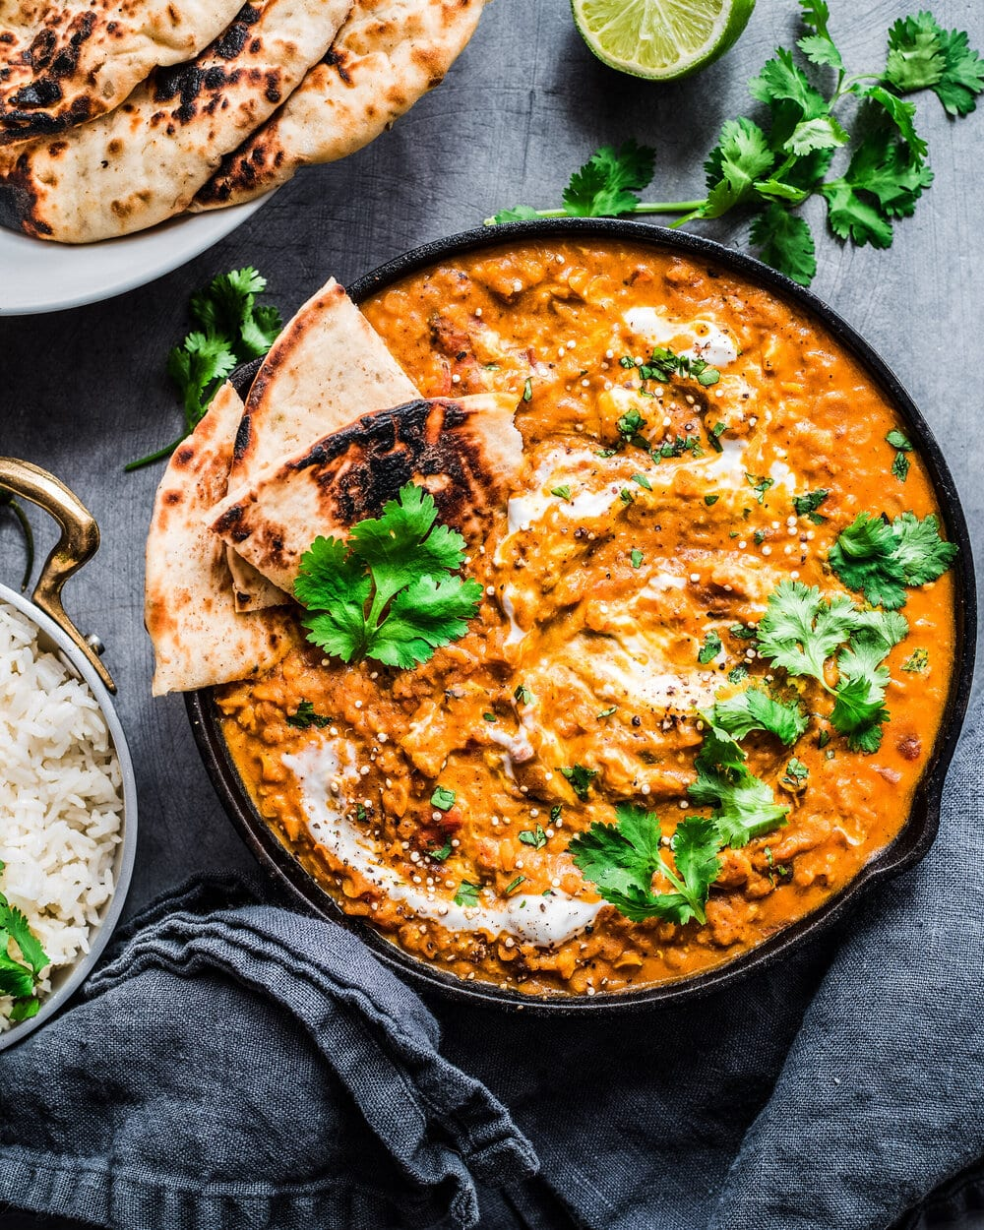

Ingredients
- 1 tbsp coconut oil
- 1 small onion, diced
- 2 cloves garlic, minced
- 1 inch ginger, grated
- 2 tbsp curry powder or paste
- 1 cup cooked lentils
- 1 can (14 oz) coconut milk
- 1 can (14 oz) diced tomatoes
- Salt to taste

Instructions
1. Heat coconut oil in a pan over medium heat. Add onion, garlic, and ginger, and sauté until fragrant.
2. Stir in curry powder or paste and cook for another minute.
3. Add cooked lentils, coconut milk, and diced tomatoes.
4. Simmer for 15-20 minutes until thickened. Season with salt to taste.
5. Serve hot over rice or with naan.

Chickpea Shawarma Wraps
Main Ingredient: Chickpeas

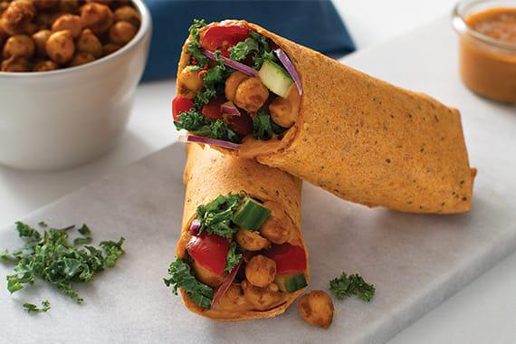

Ingredients
- 1 can chickpeas, drained and rinsed
- 1 tbsp olive oil
- 1 tsp cumin
- 1 tsp paprika
- 1/2 tsp garlic powder
- 1 tbsp lemon juice
- Pita bread
- Toppings: cucumber, tomato, red onion, tahini or yogurt sauce

Instructions
1. Preheat oven to 400°F (200°C). Toss chickpeas with olive oil, spices, and lemon juice.
2. Spread on a baking sheet and roast for 25–30 minutes until crispy.
3. Load into pita with desired toppings.
4. Drizzle with tahini or yogurt sauce and serve.

Cold Lentil Salad
Main Ingredient: Lentils

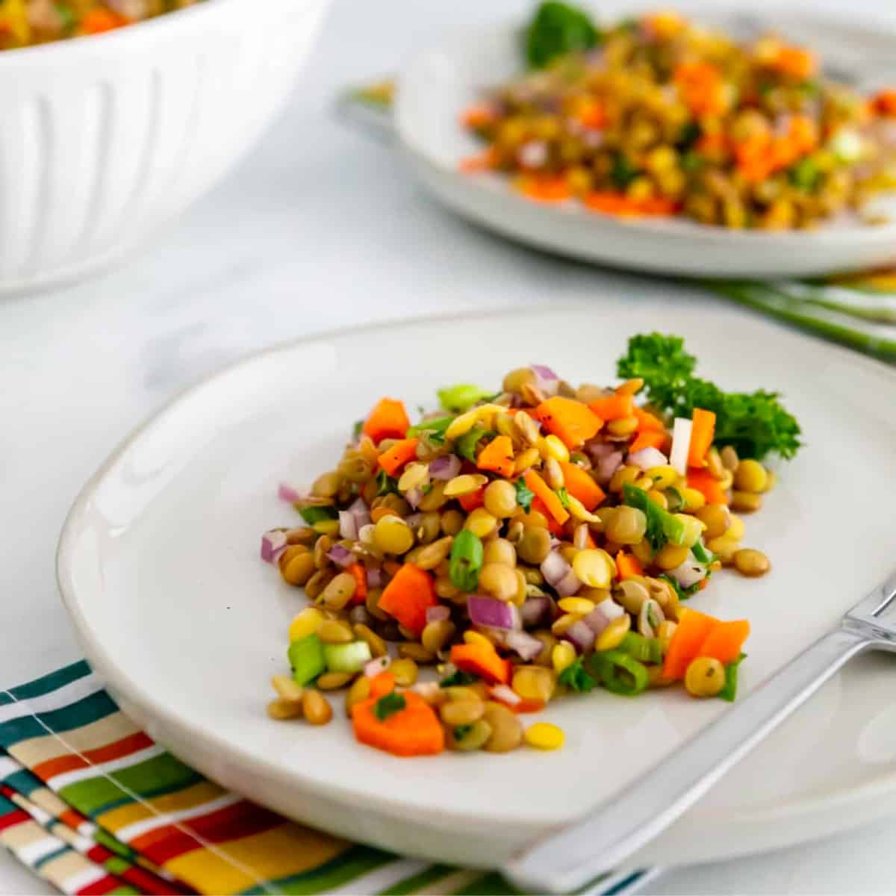

Ingredients
- 1 cup cooked lentils, cooled
- 1/2 red bell pepper, diced
- 1/2 cucumber, diced
- 1/4 red onion, finely chopped
- 2 tbsp chopped parsley
- 1/4 cup crumbled feta
- 2 tbsp olive oil
- 1 tbsp lemon juice
- Salt and pepper to taste

Instructions
1. In a large bowl, combine lentils, bell pepper, cucumber, onion, parsley, and feta.
2. In a small bowl, whisk together olive oil, lemon juice, salt, and pepper.
3. Pour dressing over salad and toss well.
4. Chill before serving.

Chickpea Veggie Burgers
Main Ingredient: Chickpeas

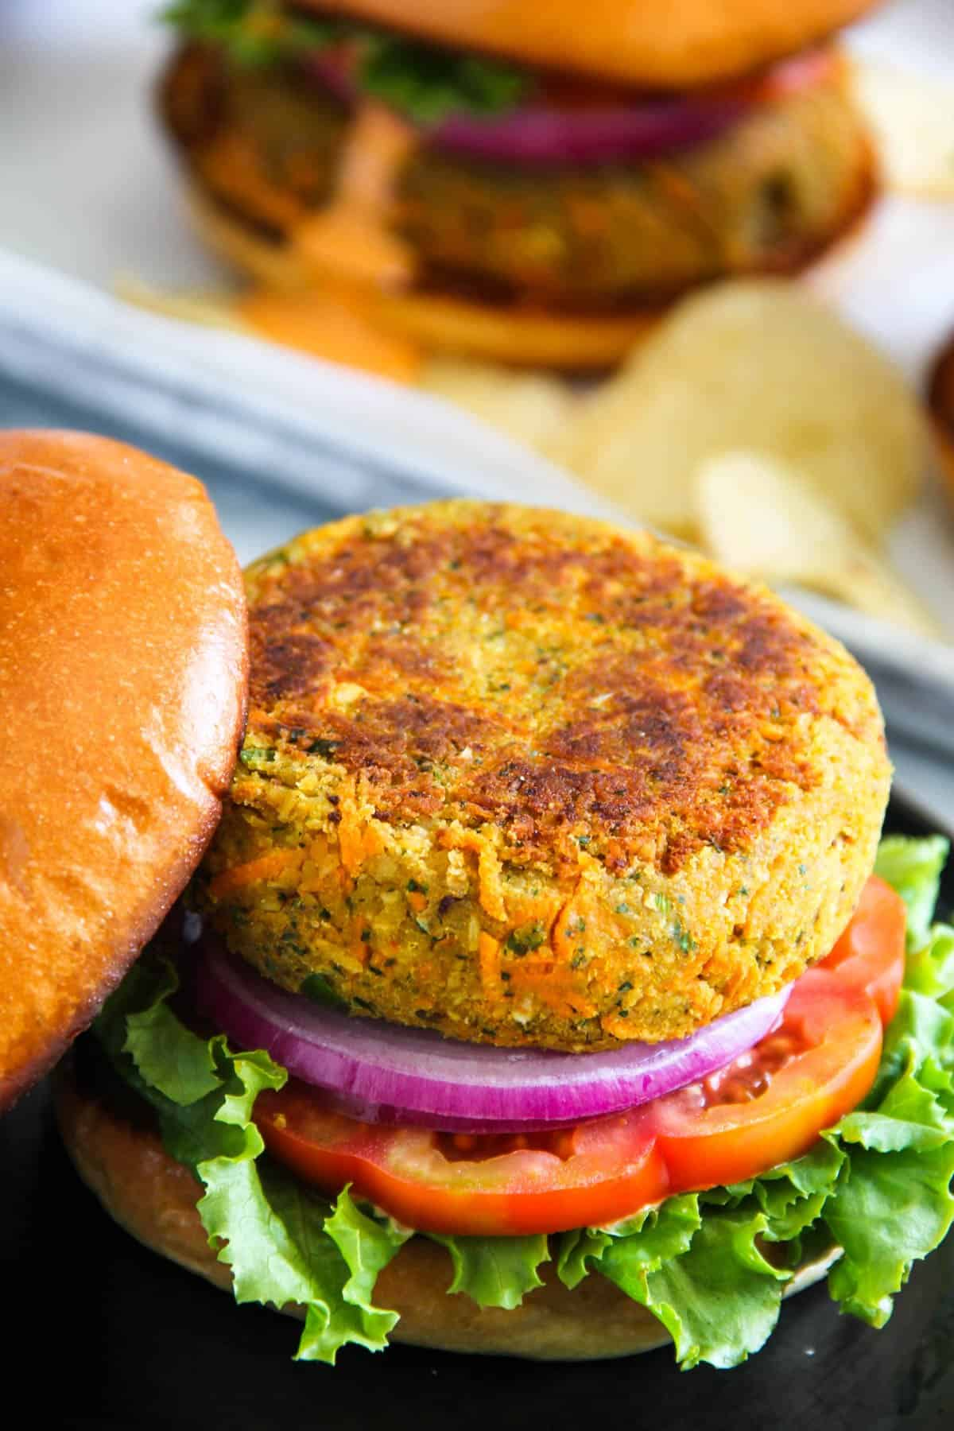

Ingredients
- 1 can chickpeas, drained
- 1/2 carrot, grated
- 1/4 onion, finely chopped
- 1 clove garlic, minced
- 1/2 cup breadcrumbs
- 1 egg or flax egg
- Salt and pepper to taste
- Olive oil for frying

Instructions
1. In a bowl, mash chickpeas with a fork.
2. Add grated carrot, onion, garlic, breadcrumbs, and egg. Mix until well combined.
3. Form mixture into patties.
4. Heat oil in a pan and cook patties for 3–4 minutes on each side, until golden.
5. Serve on buns or lettuce wraps with desired toppings.

Lentil & Chickpea Soup
Main Ingredient: Lentils & Chickpeas
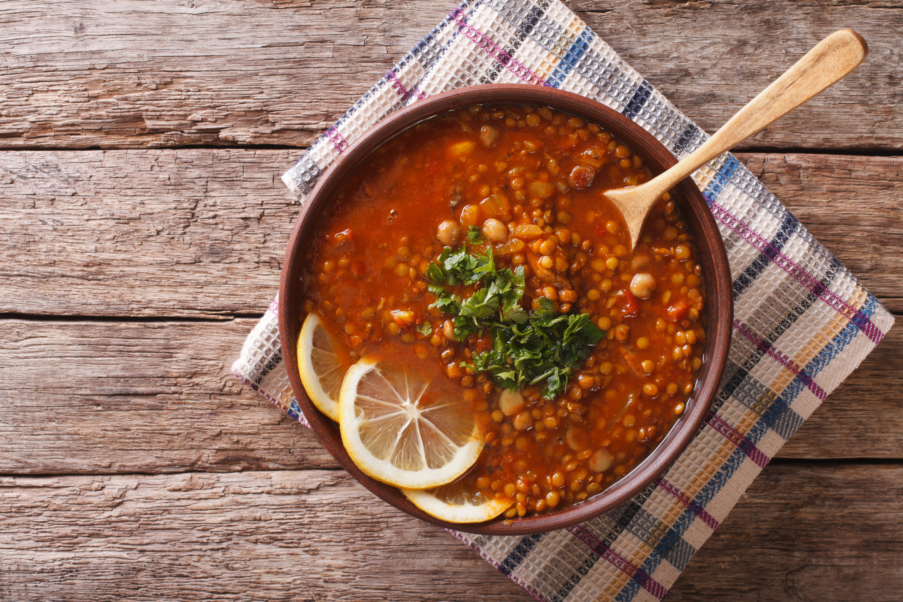

Ingredients
- 1 tbsp olive oil
- 1 onion, diced
- 1 carrot, diced
- 1 celery stalk, diced
- 2 cloves garlic, minced
- 1/2 cup cooked lentils
- 1/2 cup chickpeas
- 4 cups vegetable broth
- 1 tsp Italian seasoning
- Salt and pepper to taste
- Lemon juice for garnish

Instructions
1. Heat olive oil in a pot and sauté onion, carrot, celery, and garlic until soft.
2. Add lentils, chickpeas, broth, and seasoning.
3. Bring to a boil, then reduce heat and simmer for 20–25 minutes.
4. Season with salt and pepper, and finish with a squeeze of lemon juice.
5. Serve warm with crusty bread.

