2018 NJPGA CETP Training Schedule & Course Descriptions

Plant Operations (3.1 - 3.5) – 3 days - $360/person
Tues - Thurs, May 22-24, 2018, 8:30 a.m.-4:30 p.m., (Instructor: Dan Waters)
86 Vanderveer Road, Freehold, NJ 07728

Basic Plant Operations provides training for safely and efficiently performing bulk plant operations tasks. The Plant Operations Class is for plant personnel that recondition, repair and maintain propane tanks and cylinders. The class also covers liquid transfer operation in the plant yard and some of the basic maintenance requirements for maintaining a bulk propane plant. This course includes the DOT cylinder requalification requirements for personnel that requalify cylinders, process paperwork, and mark & label propane cylinders. Safety considerations for activities at the plant are also covered at length.

Exterior Vapor Distribution Systems (4.1) – 3 days - $360 per person
Tues - Thurs, June 5-7, 2018, 8:30 a.m.-4:30 p.m., (Instructor: Dan Waters)
180 Centennial Avenue Piscataway Twp, NJ 08854

4.1 Exterior Vapor Distribution Systems provides information on vapor distribution systems from the storage container to the outlet of the second stage regulator. On a typical propane system this would cover installation of above ground or underground storage tank, pigtail, first stage regulator, high pressure line and second stage regulator. The course includes sizing for all the aforementioned items and setback and installation codes from NFPA 58.

Placing Vapor Distribution Systems & Appliances into Operation (4.2)
3 days -- $360/person
Tues - Thurs, July 24-26, 2018, 8:30 a.m.-4:30 p.m., (Instructor: Dan Waters)
180 Centennial Avenue Piscataway Twp, NJ 08854

This course provides an overview of key concepts and strategies for field personnel and will aid in preparing for NPGA’s CETP certification. It is an essential tool for ensuring employee safety and continuing success.
Course Objectives
- Identify vapor distribution system & appliance checks/tests and recognize the steps to perform them.
- Explain general procedure for placing a vapor distribution system into operation and when to make the final connection to turn on the system.
- Identify how to validate container, pipe and tubing, regulator, and vapor meter installations.
- Understand the importance of proper venting, combustion air, and purging.
- Identify appliance controls and safety devices and understand their purpose.
- Understand burning propane characteristics (burner components/air adjustments/flame abnormalities.)
- Understand the importance of communicating customer safety information.

Basic Propane Appliance Service/Troubleshooting (4.5) – 5 days - $500/ person
Mon - Fri, Aug 6-10, 2018, 8:30 a.m.-4:30 p.m., (Instructors: Dan & Ron Waters)
86 Vanderveer Road, Freehold, NJ 07728

The new 4.5 Vapor Distribution Class covers servicing, troubleshooting, and repairing basic propane appliances. It is the most comprehensive propane class ever produced in respect to CETP classes. The class combines electrical troubleshooting, appliance gas regulation, appliance combustion principles, burners, complete and incomplete combustion, carbon monoxide testing and heat exchanger inspection. Students will have classroom instruction and then practical hands on troubleshooting for each of the sections completed. The course also covers gas orifices and flow tests, lockup tests, differential pressure tests and more. The five day class can be completed after taking basic principles and practices but the basic electrical class is very helpful in respect to being prepared to take this class. Many experienced propane industry workers have taken the old 7.0 appliance service class; the 7.0 class will also work as good primer for completing the new 4.5 Appliance Trouble shooting class.

Propane Delivery, Combined Delivery – 3 days - $360 per person
Tues - Thurs, October 2-4, 2018, 8:30 a.m.-4:30 p.m., (Instructor: Dan Waters)
180 Centennial Avenue Piscataway Twp, NJ 08854

Propane Delivery Basics: Provides general information applicable to all drivers of cargo tank motor vehicles used to deliver propane, including DOT driver qualifications; personal protective equipment; CMT pre-trip inspections; verifying placarding, markings & inspections; flammable & combustible liquids; verifying the presence of odorant; handling CMV accidents, breakdowns & emergencies; parking/garaging of vehicles.

Bobtail Delivery: Identifying bobtail equipment and operating procedures, pre-unloading inspections, bulk plant loading/unloading systems & procedures, walk-around inspection of CTMV, purging propane containers prior to transferring product, handling out-of-gas calls & piping leak checks, evacuating ASME tanks, post-trip inspections, required monthly inspections, bobtail loading via compressor or auxiliary inlet.

Cylinder Delivery: Identifying features of cylinder delivery vehicles, preparing cylinders for storage & transportation, inspecting, evacuating and flaring cylinders, replacing valves & fittings on cylinders, requalifying cylinders, operating a dispenser, identifying DOT marking/labeling requirements, transporting DOT cylinders, operating a dispenser to fill vehicle-mounted ASME tanks, driving techniques, examining customer cylinders & installations, handling out-of-gas calls & leak checking piping systems, DOT exchange and motor fuel cylinder cabinet installation requirements, performing post-trip inspections.

Requirements for Certification for each course include:
- A passing score on the exam
- Completed Skills Assessment returned to testing center within 12 months of passing the exam
- Prerequisite 1.0 Certification completed within 12 months of passing the exam*

*For example, if you take Delivery and have not yet taken the prerequisite Basic Principles & Practices, you have one year after passing the Delivery exam to complete certification for Basic Principles & Practices, in order to receive credit for Delivery. (Questions? Please call NJPGA at 609-890-6094.)

Prices for all classes include book(s), exam, continental breakfast, and lunch.

2018
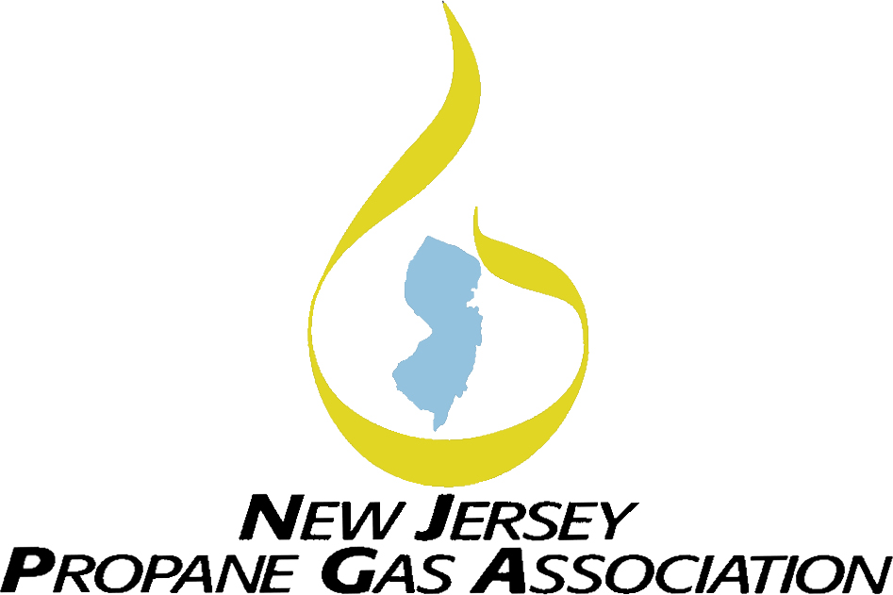
NJPGA Training Program

What is CETP?

What is CETP?

Certified Employee Training Program (CETP) gives trainers and employers a formal structure for:

- Training Employees;
- Testing their knowledge; and
- Documenting their successful completion of a training program

Combining hands-on practice with written activities, CETP assures that workers have the knowledge and skills needed to do their job safely. Once they’ve successfully completed CETP – and that success has been verified – workers receive a certificate and uniform patch attesting to their professionalism.

CETP is based on common industry practices. Companies who participate in CETP will benefit by being provided with:

- Safer, better-trained employees,
- A uniform, documentable training system,
- An objective means of measuring employee performance and training.

Prerequisites
You must have the Basic Principles & Practices course in order to obtain credit and be certified. If you enroll in another course prior to taking the Basics course, you will not receive a pass or fail grade until completing the Basics course. The Basic Principles & Practice course will be April 25 -26 in Lawrenceville.

Why CETP?

The New Jersey Administrative Code N.J.A.C. 5:18 – Liquefied Petroleum Gas requires that employees of propane marketers be certified through the National Propane Gas Association’s CETP program. Any employee in New Jersey who is handling or delivering propane must complete CETP Basic Principles and Practices
as well as any other modules according to the services being provided. Proof of completion of the required modules is needed to obtain the applicable Propane Certification, issued by the Department of Community Affairs.

All marketers, including out-of-state marketers, are required to have certified employees operating within the State of New Jersey.

In response to these regulations, the New Jersey Propane Gas Association is holding CETP training courses during the course of the year which will cover Basic Principles & Practices and other required courses. Please refer to the CETP 2018 Schedule for more information.

More information on the CETP program as well as CETP E-Learning DVDs and Online Certification Testing Option can be found on the National Propane Gas Association website (www.npga.org). Please call NJPGA HQ with questions regarding NJ law requirements.
(Registration form on reverse side.)

Registration Form for 2018 CETP Courses
LOCATIONS
Courses in May and August:
Tarantin Industries, Inc.
86 Vanderveer Road
Freehold, NJ 07728

Courses in June, July and October:
FW Webb – Victor Division
180 Centennial Avenue
Piscataway Twp, NJ 08854

These courses are discounted due to state rebate funding received from PERC.


Send completed form and payment to:

NJPGA, 1255 Whitehorse-Mercerville Road
Building B - Suite 514, Trenton, NJ 08619
609-890-6094 - 609-581-8244 (Fax)
njpga@hq4u.com

Name & Date of Course(s) you are Registering for:

PAYMENT INFORMATION:

__ Visa __ Master Card __ Amex __ Check

Card #

Exp Date

Cardholder’s Name:

Courses run from 8:30 a.m. until 4:00 p.m. each day.
See 2018 Training Schedule for dates and details.
Registration is on a first-come, first-served basis. Please call Headquarters at 609-890-6094 with any questions. Thank you.
Instructions to Registrants:

See Course Fees in the
Course Description

- Please use a separate form to register each person…photocopy if necessary.
- Registration fees include required manuals, tests, continental breakfast, and lunch.
- Fee listed is per person
- This form must be accompanied by payment (check or money order payable to NJPGA or credit card).

Full Name:
Nick Name: Company:
Address: City: State: __________ Zip:
Phone: Fax: Email:
(Do we have your e-mail address?)

Amount Enclosed $

