**2017**

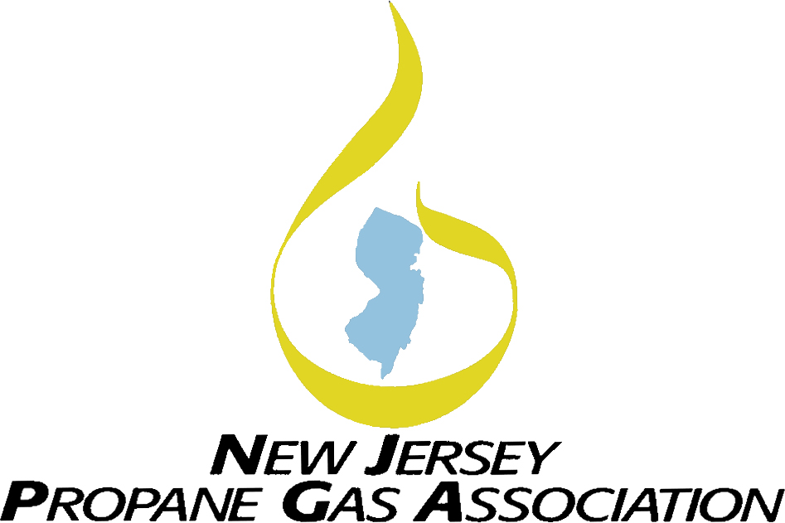

NJPGA Training Program

**What is CETP?**

**What is CETP?**

Certified Employee Training Program (CETP) gives trainers and employers a formal structure for:

* Training Employees;
* Testing their knowledge; and
* Documenting their successful completion of a training program

Combining hands-on practice with written activities, CETP assures that workers have the knowledge and skills needed to do their job safely. Once they’ve successfully completed CETP – and that success has been verified – workers receive a certificate and uniform patch attesting to their professionalism.

CETP is based on common industry practices. Companies who participate in CETP will benefit by being provided with:

* Safer, better-trained employees,
* A uniform, documentable training system,
* An objective means of measuring employee performance and training.

**Prerequisites**

You must have the Basic Principles & Practices course in order to obtain credit and be certified. If you enroll in another course prior to taking the Basics course, you will not receive a pass or fail grade until completing the Basics course. The Basics course is being offered twice in 2017.

**Why CETP?**

The New Jersey Administrative Code N.J.A.C. 5:18 – Liquefied Petroleum Gas requires that employees of propane marketers be certified through the National Propane Gas Association’s CETP program. Any employee in New Jersey who is handling or delivering propane must complete CETP Basic Principles and Practices

as well as any other modules according to the services being provided. Proof of completion of the required modules is needed to obtain the applicable Propane Certification, issued by the Department of Community Affairs.

All marketers, including out-of-state marketers, are required to have certified employees operating within the State of New Jersey.

In response to these regulations, the New Jersey Propane Gas Association is holding CETP training courses during the course of the year which will cover Basic Principles & Practices and other required courses. Please refer to the CETP 2017 Schedule for more information.

More information on the CETP program as well as CETP E-Learning DVDs and Online Certification Testing Option can be found on the National Propane Gas Association website ([www.npga.org](http://www.npga.org)). Please call NJPGA HQ with questions regarding NJ law requirements.

*(Registration form on reverse side.)*

**Registration Form for 2017 CETP Courses**

These courses are discounted due to state rebate funding received from PERC.



tazwcyao[1]

Instructions to Registrants:

1. Please use a separate form to register each person…photocopy if necessary.
2. Registration fees include required manuals, tests, continental breakfast, and lunch.
3. Fee listed is per person
4. This form must be accompanied by payment (check or money order payable to NJPGA or credit card).

**Registration Fee**

**(See attached list for prices)**

Full Name:

Nick Name: Company:

Address: City: State: __________ Zip:

Phone: Fax: Email:

*(Do we have your e-mail address?)*

Amount Enclosed $

Send completed form and payment to:

NJPGA, 1255 Whitehorse-Mercerville Road

Building B - Suite 514, Trenton, NJ 08619

609-890-6094 - 609-581-8244 (Fax)

[njpga@hq4u.com](mailto:njpga@hq4u.com)

***Name of Course You are Registering for:***

***Dates of Course You are Registering for:***

PAYMENT INFORMATION:

__ Visa __ Master Card __ Amex __ Check

Card #

Exp Date

Cardholder’s Name:

**Courses run from 8:30 a.m. until 4:30 p.m. each day.**

See 2017 Training Schedule for dates and details.

Registration is on a first-come, first-served basis. Please call Headquarters at 609-890-6094 with any questions. Thank you.

**2017 Training Course Registration**

**B Form**

**Location:**

**3150 Brunswick Pike, Suite 300**

**Lawrenceville, NJ 08648**