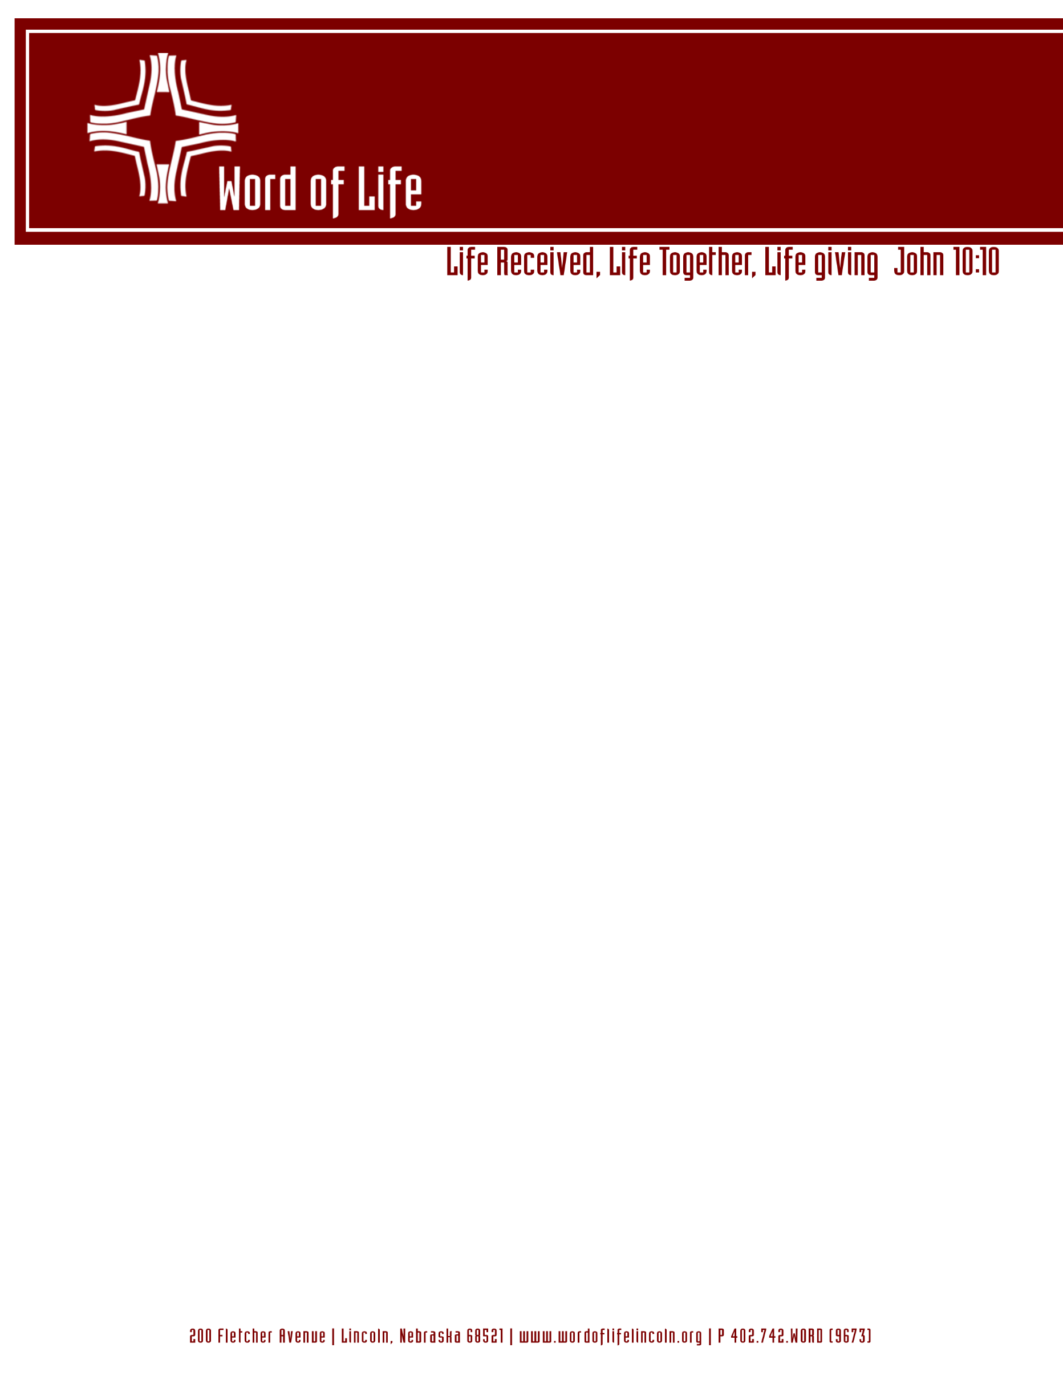

Dear Members of Word of Life Lutheran Church,
As our congregation continues to serve our community, we are mindful of our responsibility to maintain a safe, welcoming, and visible campus for all who join us. To that end, we are preparing for a voters meeting to discuss and decide upon two key property improvements: the updating of our parking lot lighting and the installation of a new monument sign. These updates are intended not only to improve the safety and security of our grounds during evening services and events but also to provide a clear, inviting presence to those in our community. We invite you to review the following options and prayerfully consider how these investments might best support our shared mission and the long-term stewardship of our campus.

Property improvement options for consideration:
- Option A (up to $25,000)
  - Replace existing light pole heads with new LED heads.
  - Install one new parking lot light pole with LED head.
  - Install one new driveway light pole with LED head.
  - Install illuminated, double-face, monument sign with manual changeable letter track.
  - Trenching and electrical conduit for new light pole and sign.
- Option B (up to $9,000)
  - Replace existing light pole heads with new LED heads.
  - Install one new driveway light pole with LED head.

Available funds for property improvements:
 | Checking | CD/Term Note | Total
General Fund | $21,492.51 | $20,000.00 | $41,492.51
Building Fund | $7,829.24 | $44,699.77 | $52,529.01
Total | $29,321.75 | $64,699.77 | $94,021.52

In total, including unrestricted general funds and the Building Fund, Word of Life has $94,021.52 that may be allocated toward property improvement projects. Of this total, $64,699.77 is held in LCEF Term Notes that incur early redemption penalties if we withdraw funds prior to their maturity dates. The General Fund Term Note ($20,000) is earning 3.5% with a maturity date of 9/30/26 and the Building Fund Term Note ($44,699.77) is earning 4.25% with a maturity date of 9/10/26. The early redemption penalty for both term notes is 90 days of interest. The remaining available funds of $29,321.75 is in checking accounts that have no withdrawal penalties. If the congregation votes to proceed with one of the options for property improvements, we can draw from the Building Fund-Checking first before drawing from the General Fund-Checking. Then, when the Building Fund Term Note matures in September 2026, the Board of Lay Ministry could consider authorizing a transfer from this term note to replenish the General Fund without incurring a penalty.
We look forward to your presence and voice at this important meeting. Whether we move forward with a comprehensive project or a more modest approach, our primary goal remains to be faithful stewards of the resources and the property God has entrusted to us. Please join us in prayer as we seek clarity and consensus for the path ahead. If you have questions regarding either of the property improvement options prior to the meeting, do not hesitate to reach out to the Board of Lay Ministry.

In Christ,
The Board of Lay Ministry

