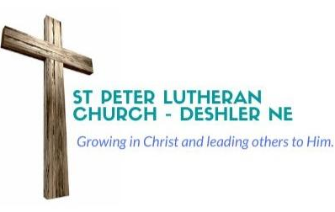

Dear Members at Word of Life –

I am writing to you to let you know that I am humbled by the Divine Call that you have extended to me to be your next pastor. I have received the call papers and I have begun the process of bringing this to the Lord in prayer and having discussions with my family.

My wife and I are looking forward to visiting Word of Life soon to learn more about your congregation and the work that the Lord is doing in and through you.

I ask that you keep me and family in your prayers during this process as well as the congregations of St Peter in Deshler and Faith in Hebron that I currently serve. May the Lord give me, my family, and the congregations wisdom and discernment as we seek God’s plan for ministry.

In Jesus,

Pastor Brian Francik
pastorbfrancik@gmail.com
Cell Phone 402-710-6679

