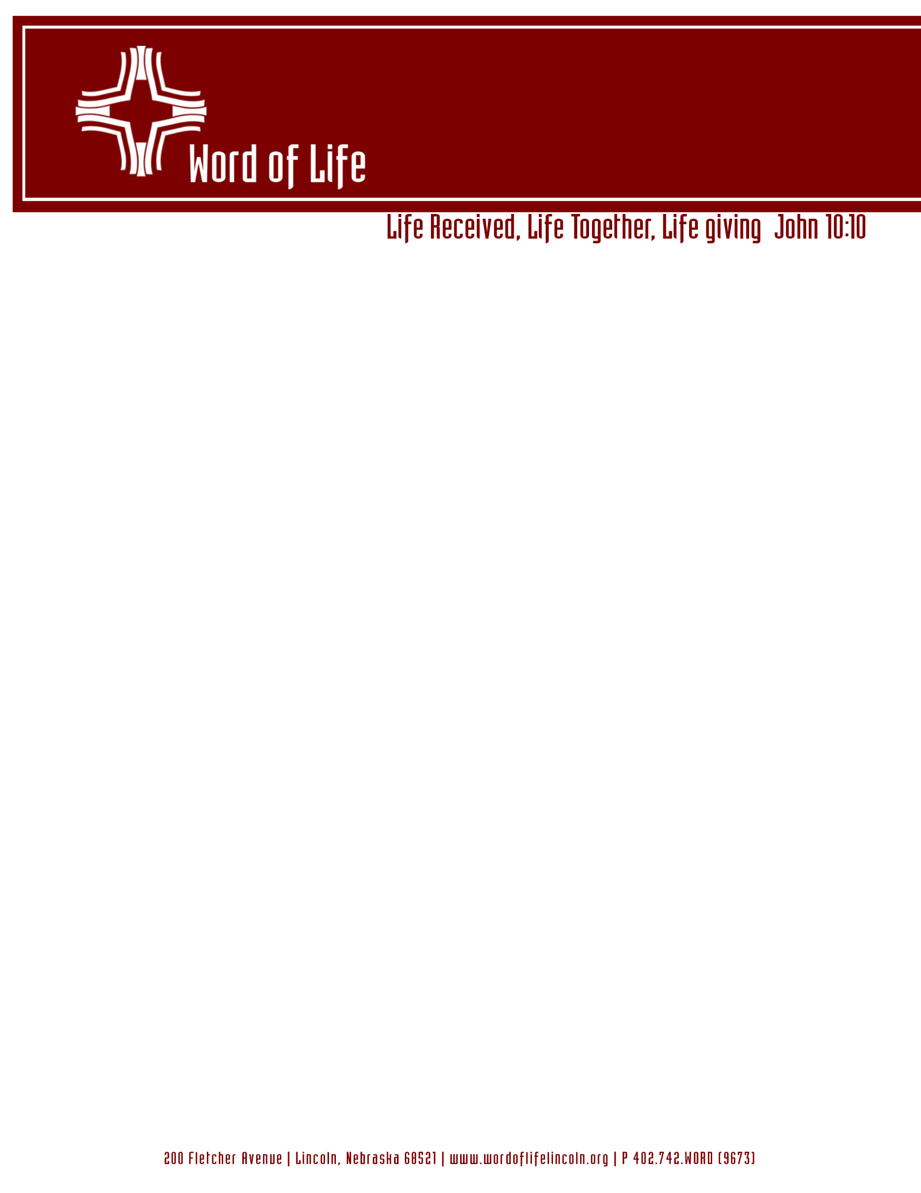

May 20, 2026

Dear Word of Life Member:
We are writing to say thank you to those who have given both through acts of service and through your tithing in the past year. Without your support our church’s ministry could not have flourished.
Your offering helps provide for our ministries for missions, Sunday school, Christian formation for all ages, for our pastor’s wages, for upkeep of our church, for utilities, supplies and much more.
Our congregation is full of generous givers! As we move forward in the call process and plan for next year’s budget we are asking that you pray about and consider what you can pledge for the coming year. At this time, we are asking that our members complete the enclosed commitment cards. Receiving our congregation’s planned giving amounts will allow the church to plan accurately for ministries since we can base our budget on the dollar amount members plan to give. In addition, having our congregation complete a commitment card can help our members carve out some time for personal examination and prayer to guide your time and tithing priorities and decide how to live out your faith at the church this year. Please note that the cards do not have a space for your name. We do not need to know the names of who plans to give what amount, but we feel seeing what commitment the congregation has as a whole will give us an idea of how to move forward in a fiscally responsible manner.
Some of you receiving this letter may be struggling financially and may not be able to give right now. Know that we care and if there is any way we can be of support to you, praying for you, talking with you, or providing other assistance please contact a lay board member.
Enclosed you will find a commitment card. Please take some time to pray about your plans for this year and fill out the card. Then bring the card with you on Sunday June 28, 2026 and we will collect commitment cards during the worship service. If you are unable to be present that day you can return the card to the office or bring it to worship the following Sunday.
Thank you for all you do, at and for Word of Life to further our mission. You make a difference here!
God Bless,
The Lay Ministry Board

After spending time in prayer my/our financial
commitment to Word of Life Church for June 2026 to
May 2027 is:

$_________ Weekly/52 weeks
Or
$_________Annually

After spending time in prayer my/our financial
commitment to Word of Life Church for June 2026 to
May 2027 is:

$_________ Weekly/52 weeks
Or
$_________Annually

After spending time in prayer my/our financial
commitment to Word of Life Church for June 2026 to
May 2027 is:

$_________ Weekly/52 weeks
Or
$_________Annually

