
Church Yearbook Instructions – 2026

Why submit your annual data?
We have compiled twelve reasons for you to consider why you should submit your annual data. You can find it on the Yearbook webpage.

The Database and Directories will be available from January 26, 2026, through April 10, 2026. Please submit your data as early as possible to avoid potential delays if you should need assistance. If your Conference has asked you to submit your data before April 10th, please follow their guidelines.

Accessing UCC Database and Directories
- To log into UCC Database and Directories please go to engage.suran.com/ucc/s/login. Alternately, you will find a link to the site on the Yearbook webpage.
- If you already have an Engage account from previous yearbook reporting or from ministerial profiles, simply enter your username and password to sign in.
- If you do not have an existing account or are unsure if you have one, click the green “Sign Up: Yearbook Reporter” button and enter your email address on the following screen.
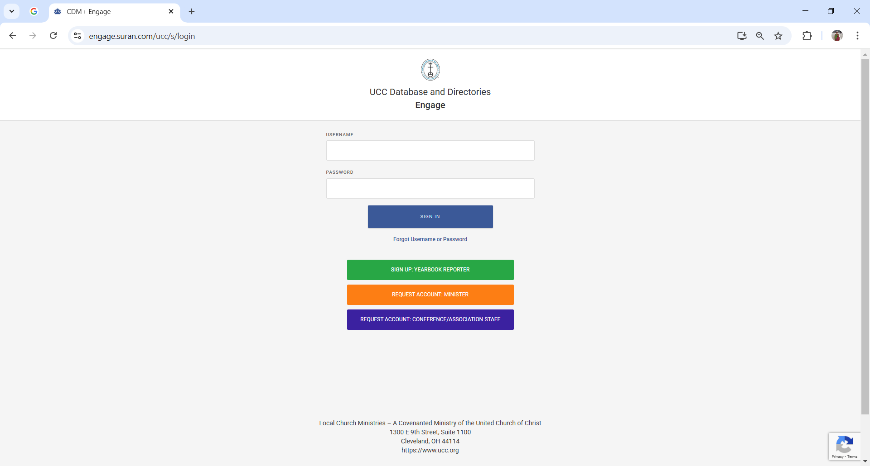
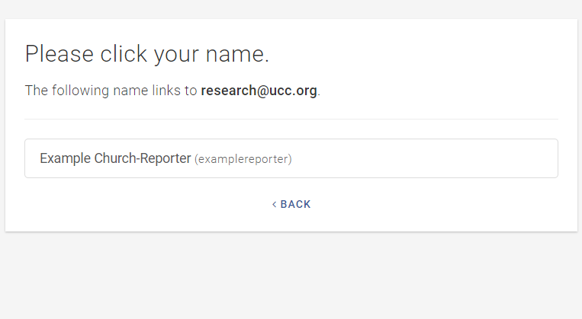
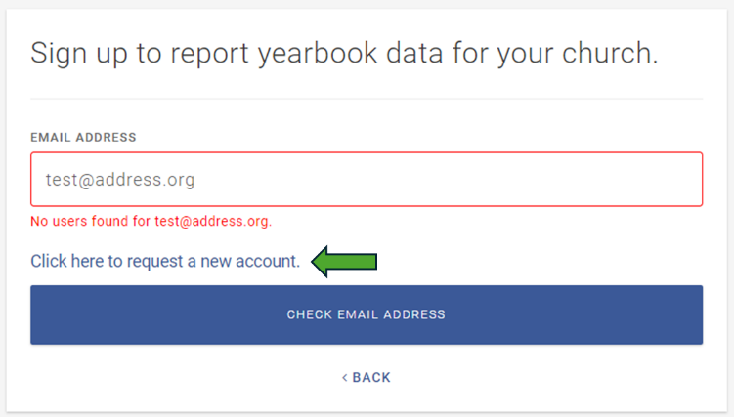
- If the email address matches one or more of the accounts on record, you will be prompted to select the account on the following screen (see below, left). If no match is found, click “Click here to request a new account” (below, right)

- From here, you will be prompted to enter your first and last name, church role, church ID, and access code.
  - Your Conference or Association can provide your Church ID and this year’s access code
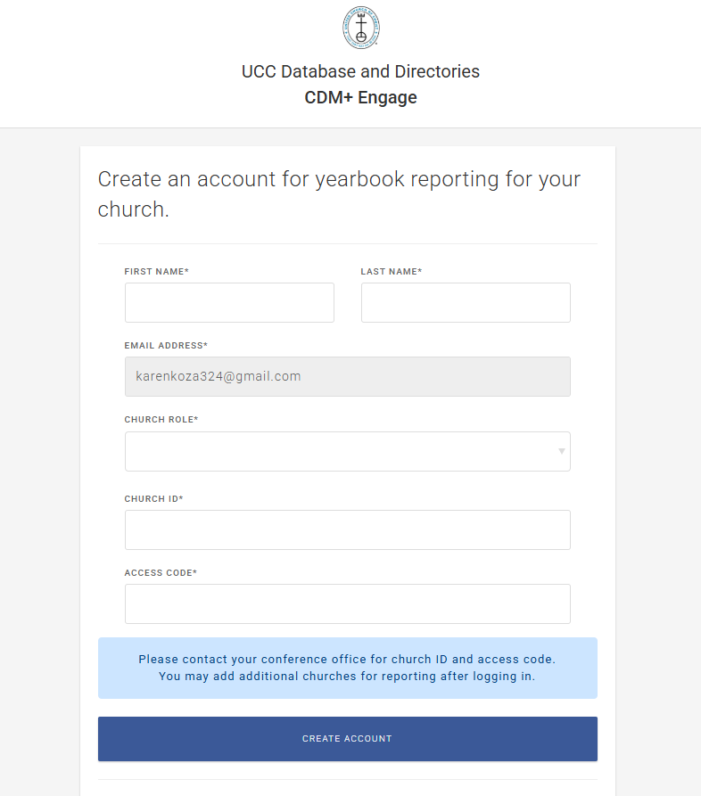
- After clicking “Create Account”, you will receive an email from Suran/Engage and then be prompted to create a username and to set your password via the emailed code or password reset link.
- After agreeing to the site’s Terms and Conditions, you will be taken to your UCC Database and Directories home page.
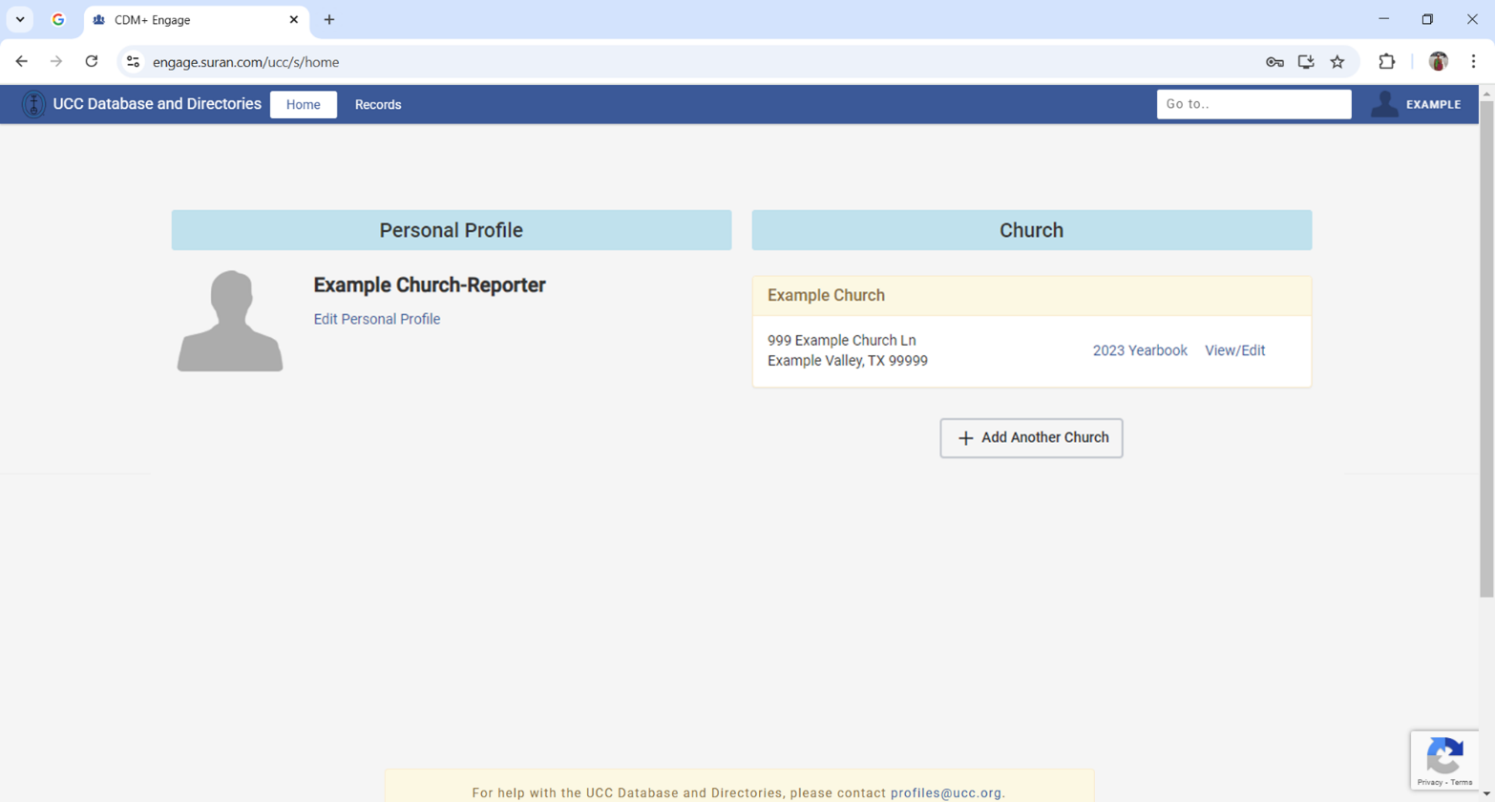
Your church will be automatically added to your Personal Profile. To review your church’s address, staff listing, and other information, click “View/Edit” next to the church listing; to enter annual yearbook information, click the “Yearbook” link. NOTE: If your church does not automatically appear on your homepage, you can find it by clicking on the Records tab at the top of the page. Your church(es) will be the only record(s) under the Records tab.
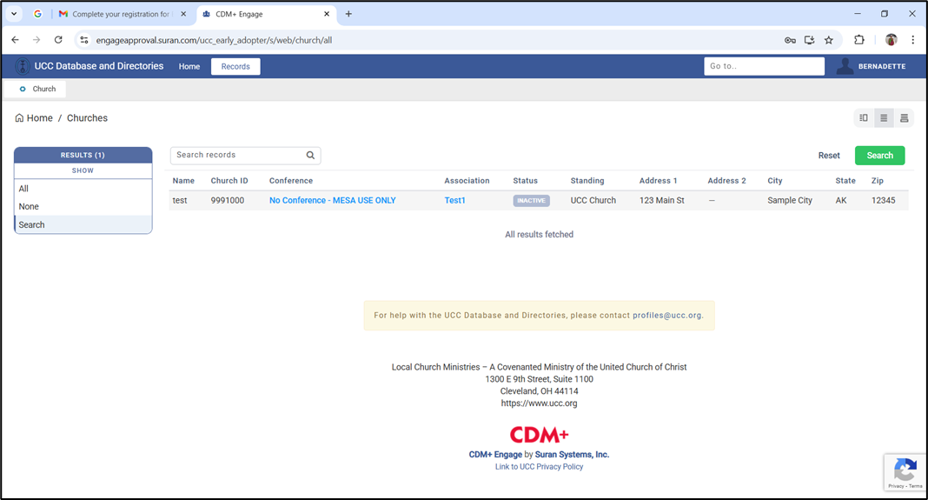

Main Church Info
Clicking on the name of your church will take you to the Main Church Info page. Here you will see all the available information for your congregation. This information is sorted into seven sections:
- Details include name, Church ID#, year organized, and other general information about the congregation
- Standing, which lists the congregation’s Conference, Association (if applicable), and Standing in the UCC
- Address includes physical location and mailing information for the church
- Contact Information includes phone number(s) and email information
- Staff lists staff, both current and historical, and can be sorted by name, position, status, and start/end year
- Yearbook displays current and previous values for membership, attendance, finance, and other metrics published in the yearbook
- Group Members, which contains information relating to Conference and Association created groups
If you would like to update one or more of the fields, click the “Edit” button in the top righthand corner and enter or edit records in the relevant sections. When you are finished, be sure to click “Save” in the upper righthand corner.
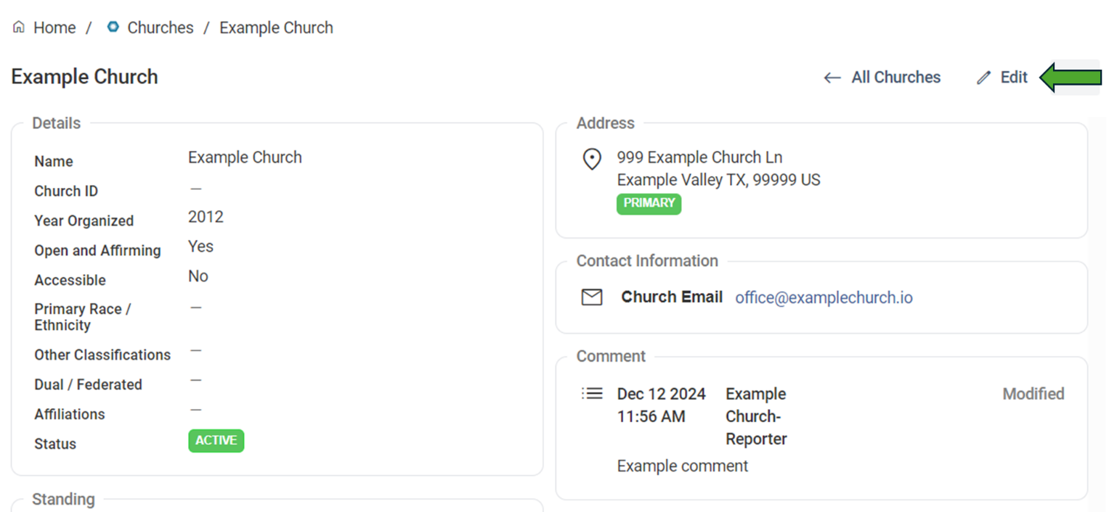
- Please note that you will not be able to edit most of the fields in the Details, Standing, Staff, or Group Member sections. Your Conference and/or Association can edit those fields, so if there are any errors in these areas, please notify your Conference or Association immediately.
- Open and Affirming status can only be modified by Data Administrators at the National Office. This data is updated upon notification from the UCC Open and Affirming Coalition. If your church has completed the ONA process with the Open and Affirming Coalition, please email us at research@ucc.org with your church’s name and location. Include ONA Church in the subject line. We will work with the Open and Affirming Coalition to verify this and update your record appropriately.

Addresses
- We currently track three types of addresses for churches: mailing, location, and campus.
- Location is the physical location of the church. This address is used on the Church Finder on ucc.org to provide a map of your church location. Please note that this address is required.
- Mailing is the address that is used for all church mailings. (Please note, when mailing and location address are the same, both addresses must be entered.)
- Campus is the physical location of any additional campus of your church. This address is also used on the Church Finder on ucc.org
- To add a new address, click “Edit” on the main information page (see below) and then “Add Address” in the address section.
- To edit an existing address, click the “Edit Details” link to the right of the corresponding address.
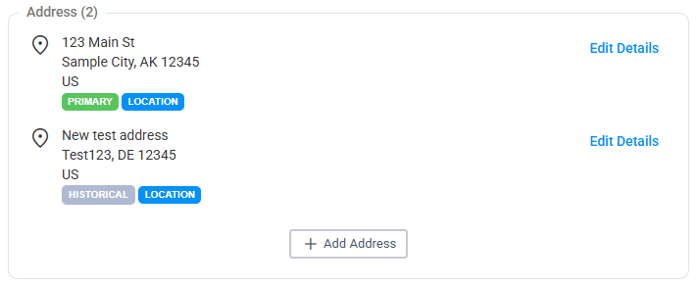
- Be sure to provide Address, City, State, Zip, and Address Type.
  - Please only use the United States Postal Service-approved abbreviations in all addresses. Please do NOT use any punctuation. The abbreviation guide can be accessed at: http://pe.usps.gov/text/pub28/28apc_002.htm
- Once the information is entered, click “Confirm Change” in the lower lefthand corner of the box, and if you are finished with all other edits on the church page, click “Save” in the upper righthand corner of the screen. Note that “Save” must be clicked for all changes to be logged.

Contact Information
- There are two kinds of contact information that can be logged in the present system: phone and email.
  - Phone may include any phone numbers associated with the church. More than one may be entered. If so, the phone number marked as “Primary” will be used for the UCC Church Finder.
  - Email may include all email addresses used by the church to field inquiries and conduct correspondence. If your church has more than one email address (e.g., one public and another for internal or administrative work), both may be entered. Those marked as “Primary” will be used in the Church Finder on ucc.org.
- To add a new phone number or email address, click “Edit” on the main information page and then “Add Email” or “Add Phone” at the bottom of the contact information section. To edit an existing phone number or email address, click the “Edit Details” link to the right of the corresponding phone number or email address.
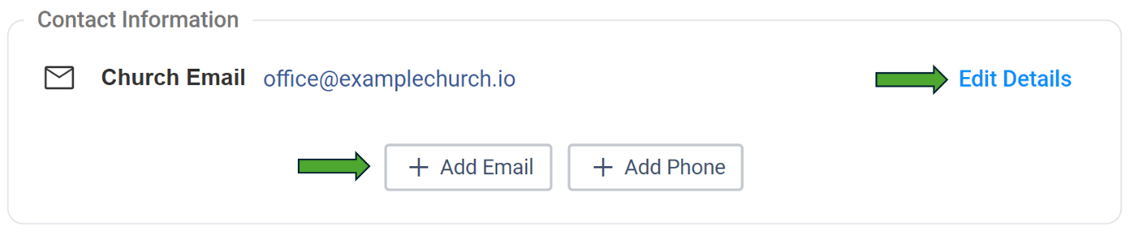
- For both email and phone, please indicate the type of contact it is and whether you would like it to be listed in the yearbook. Once you are finished, click “Confirm Change” in the lower lefthand corner of the box and “Save” in the upper righthand corner of the screen.

Staff Listings
- This section displays ministerial staff for your church according to Database records. This section can be grouped by Name and Position. Please report inaccurate information to your Conference or Association.

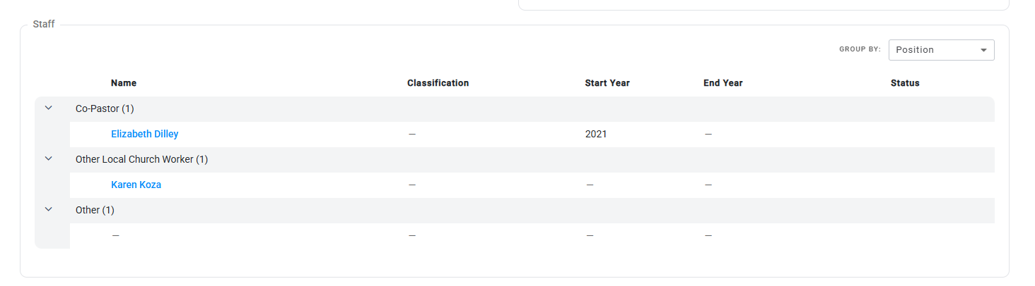

Yearbook
- This section displays your congregation’s yearbook data going back to 1992.
- To input current yearbook data, click on the link for the corresponding year, and you will be taken to the yearbook reporting section (see below).
- If previous years’ data needs to be corrected, please contact your Conference or Association.
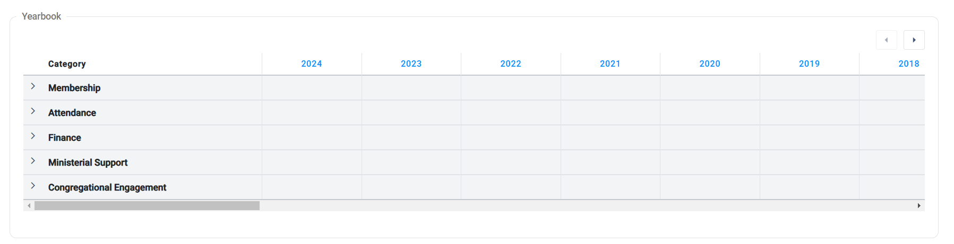

Group Members
- This section displays group membership records made by your Conference or Association. Please report inaccurate information to your Conference or Association.

Yearbook Data Entry
- There are several ways to begin entering yearbook data. The first and most direct is to click on the yearbook link next to your church on the landing page.
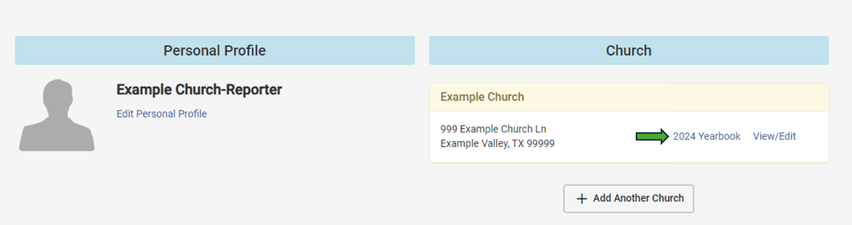
- The second is to click on the link for the current year in the Yearbook section of the Main Church Info page.
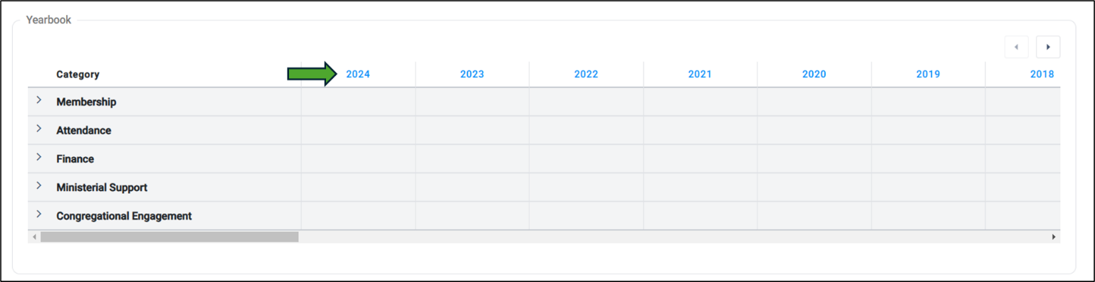
- Finally, from the Main Church Info page, you can click on the ellipses button in the top righthand corner and select “Start Reporting” from the dropdown.
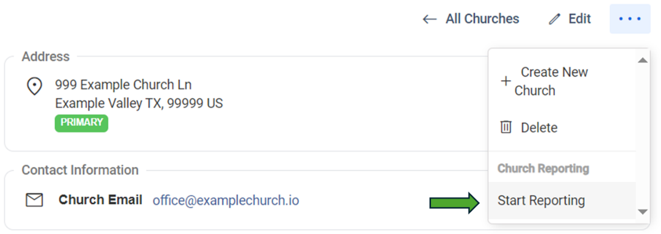
- This will take you to the yearbook reporting section, which is comprised of five sections: Membership, Attendance, Finance, Ministerial Support, and Congregational Engagement.

Membership
- Enter data for the year’s Additions, Removals, and Baptisms here. When doing so, please be sure not to leave any blank values and to input zeroes when no change has taken place over the last year.
- Subtotals will be calculated automatically for Additions and Losses, which will be combined with the previous year’s membership to calculate your Total Membership.
- If this number is incorrect due to the previous year’s membership being inaccurate, please enter an adjustment number in the adjustment field. **DO NOT enter the correct membership total in this adjustment field; enter only the number you need to adjust the calculated total to be correct.** (Negative numbers can be entered here.)
- When you are satisfied that everything is correct click the “Save and Continue” button. If you need to return later, please click the “Save and Quit” button.
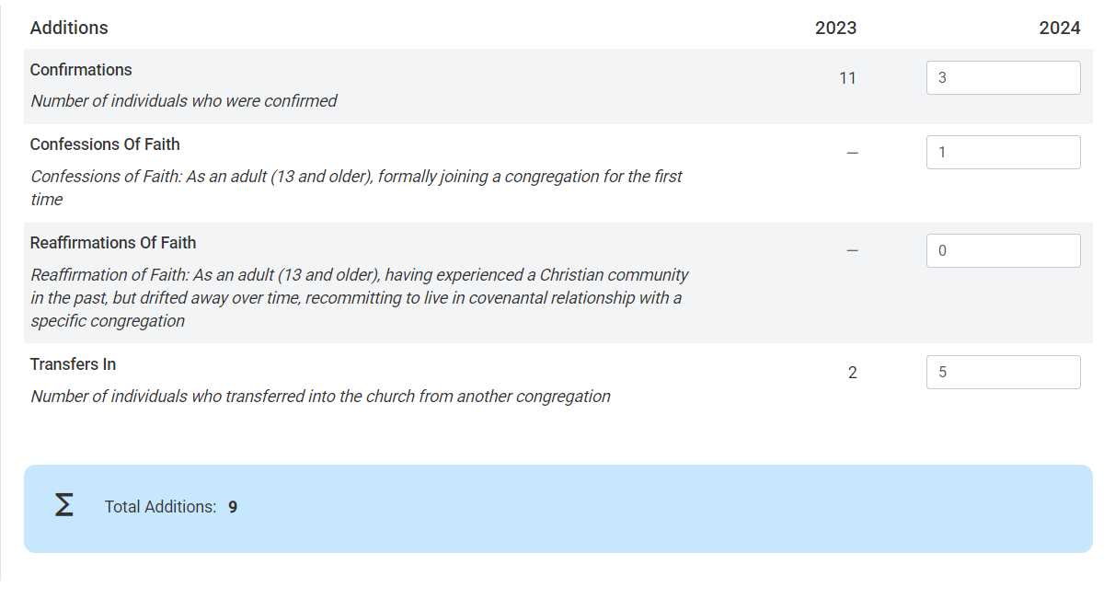

Attendance
- This section includes fields for Average Weekly Worship Attendance, Community Engagement, Participants in Mission/Immersion/Service trips, Virtual Worship, Youth Programs, and Christian Education/Faith Formation. To help ensure the precision and accuracy of our records, we have divided the attendance category into in-person and several forms of virtual attendance.
- Average Weekly Worship Attendance (i.e., In-Person Worship) is the average number of individuals attending services at the church building
    - To log these values, follow the same procedures as were used for membership
    - Below weekly worship attendance, you will also find fields for community engagement, total church participants, and mission/immersion/service. These should be filled out in the same manner.
      - If you have questions about Church Participants and Community Engagement please see the “Guide to Yearbook Community Engagement and Total Church Participants Categories” posted on the Yearbook webpage.
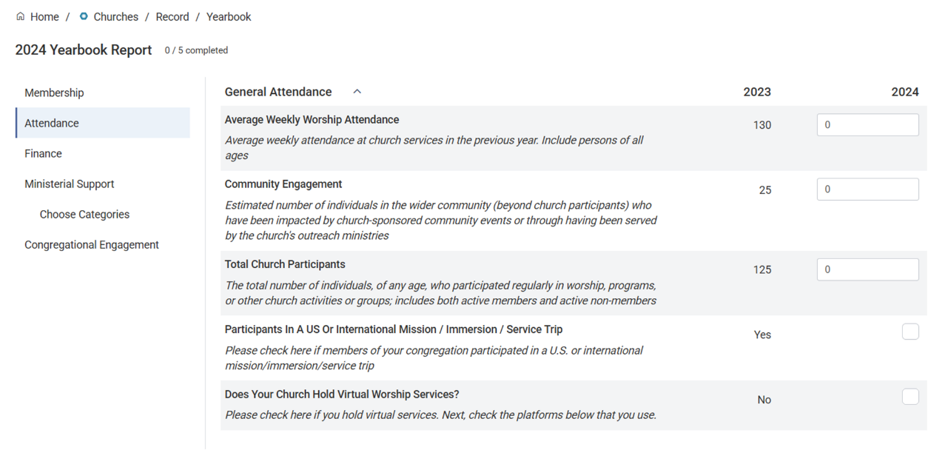
  - Virtual Worship includes the average number of views, listeners, or devices logged per service, depending on the platform. To accommodate differences in the way worship attendance is tracked across platforms, we have divided virtual worship into 5 sub-categories. These categories will not appear unless the checkbox for “Does Your Church Hold Virtual Worship Services” is checked.
    - Video-conferencing platforms such as Zoom or Skype, which log devices
    - Video hosting platforms such as YouTube, Boxcast, and Vimeo, which log views
    - Multi-stream platforms such as Restream or Streamyard, which log viewers
    - Audio platforms such as podcasts, radio broadcasts, or a 1-800 number, which log listeners
    - Social media platforms such as Facebook Live, which log views
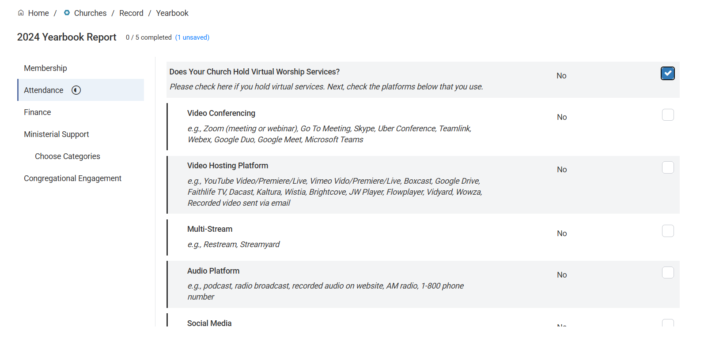
- To log virtual attendance, click the checkbox next to the category of attendance you would like to report and enter the corresponding number of devices, views, viewers, or listeners estimated for that category.
- When calculating averages, please include only those weeks where worship was conducted in the form indicated (in-person, video-hosted, etc.). If services were put on social media for only half of the year, for instance, then the average social media views should be calculated only for that half of the year and not for the full year.

- Youth Programs and Faith Formation
        - To report participation in youth programs or Christian education/faith formation, follow the same steps as virtual attendance, clicking the box next to the relevant category and entering relevant participation numbers below
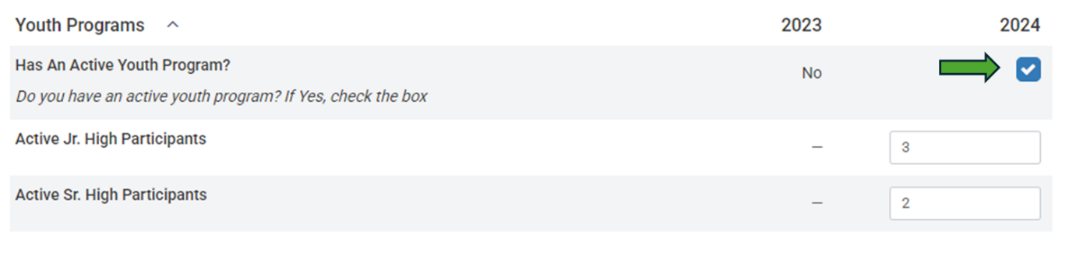
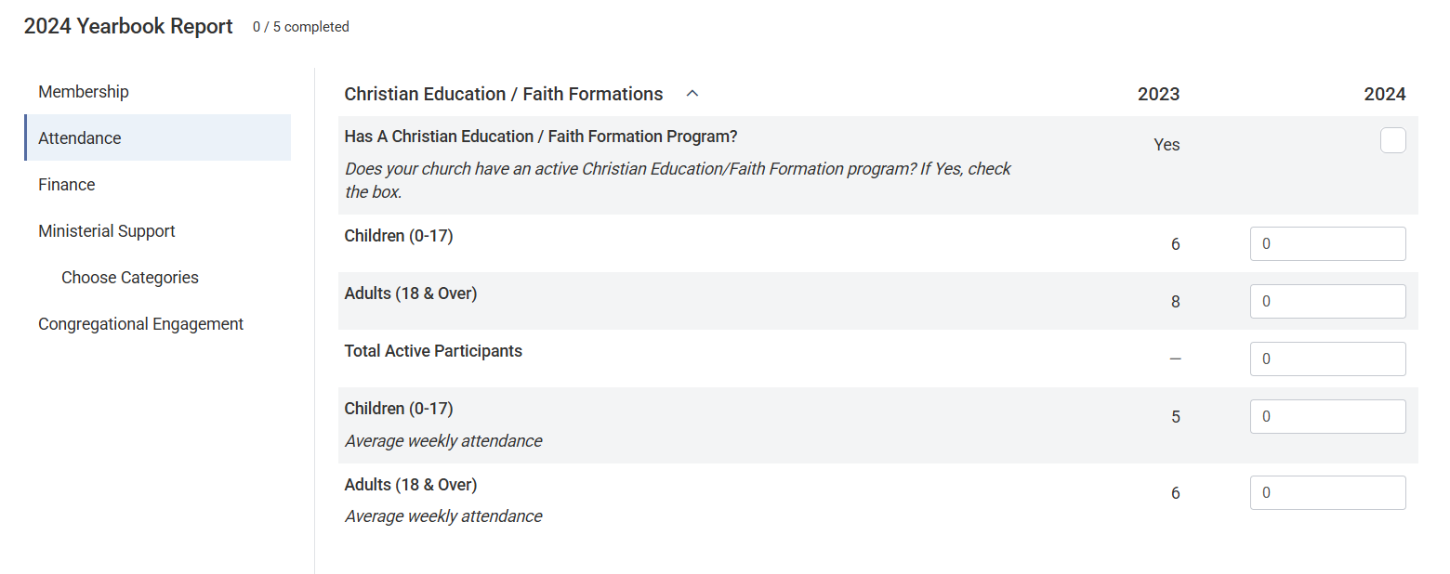

Finance
- This section covers Income, Expenditures, Endowments, and Our Church’s Wider Mission offerings for the year.
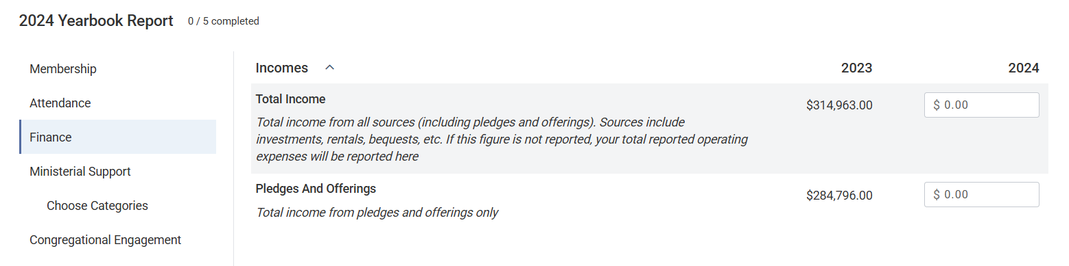
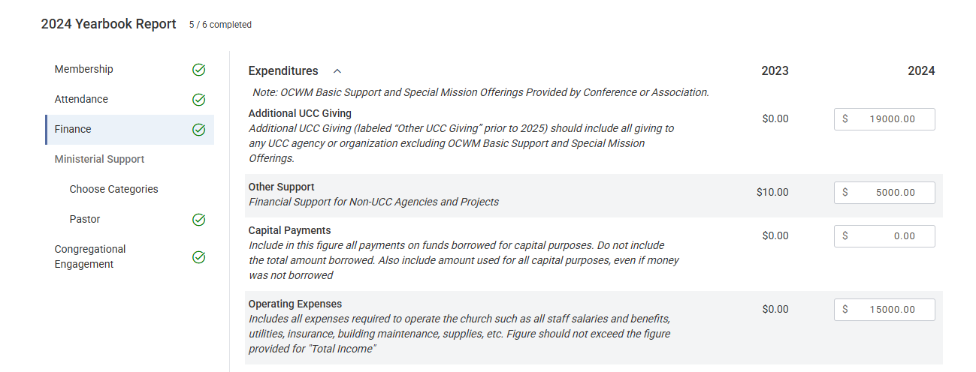
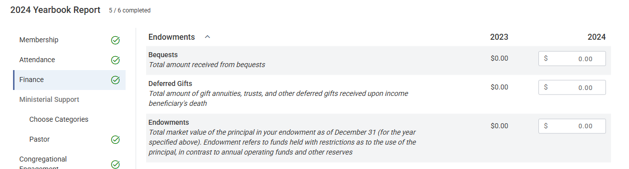

Notes:
- All salaries should be included in your Operating Expenses, even if reported in the Ministerial Support tab.
- For information on Additional UCC Giving, see our Additional UCC Giving Guide

Special Notes
- Southern New England Conference churches should NOT include their Proportional Gifts as Additional UCC Giving (previously Other UCC Giving). Your Conference will report Proportional Gifts in the Basic Support Giving column. Since it is shared with the National Setting, it is analogous to Basic Support for this report.
- New York Conference Reformed Association churches should NOT report your Assessment as Additional UCC Giving (previously Other UCC Giving). Your Conference will be reporting this giving on your behalf.

Ministerial Support
- Start with “Choose Categories”. Select all the positions that you want to report financial support for in your congregation.
- If you have additional ministers of a given type (e.g., co-pastors), go to the dropdown labelled “New Category” and select the category you would like to report multiple of. Once you have selected, it should appear on the screen with a number next to it (e.g., co-pastor 2). Repeat this process as needed until the number of positions matches the number you would like to report.

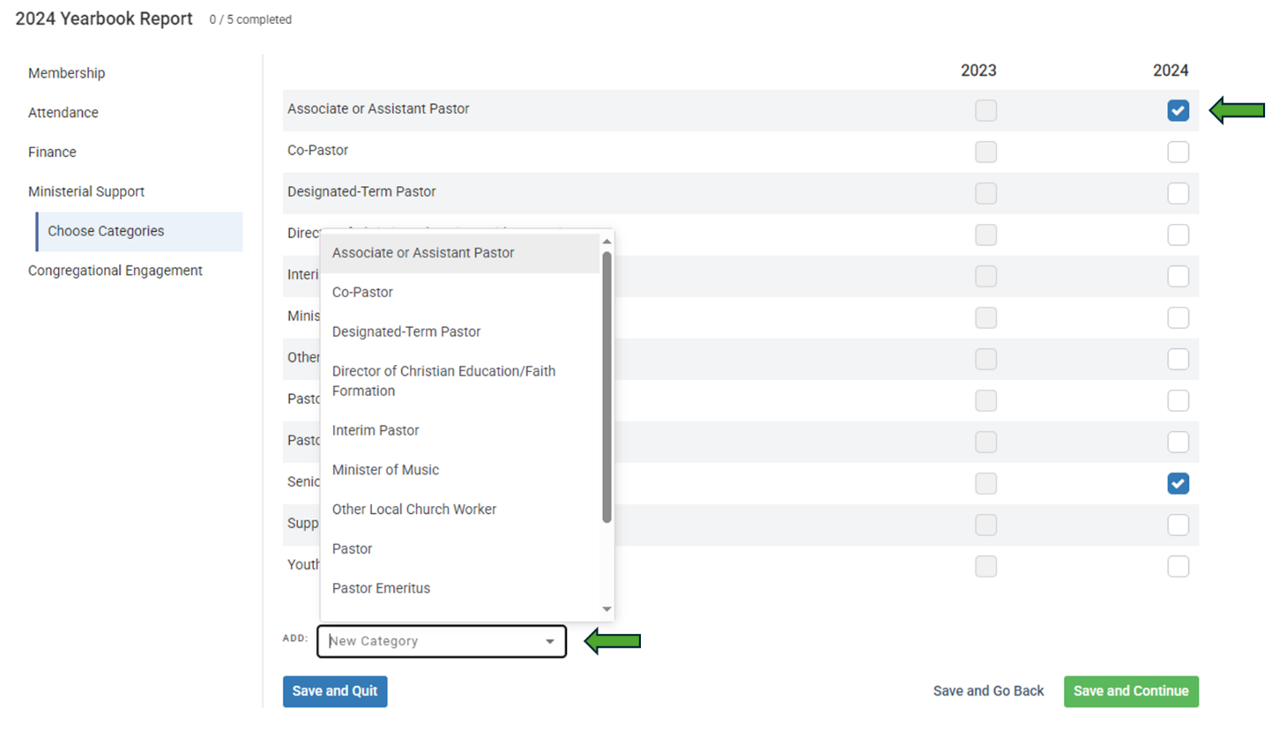
- A congregation with one Senior Pastor and two Assistant Pastors would see a screen like the following (note the double Associate or Assistant Pastors):
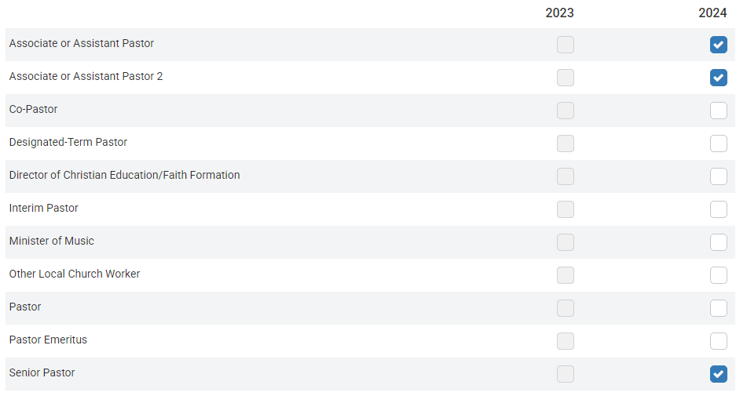
- From here, you will be asked to enter allowances and expenses for each person. This section operates very similarly to the Membership section, with dollar values being entered for each category. Please be sure to indicate if this is a full-time position.
- All data provided in this report should be annualized. If your church only had a pastor for part of the year, the compensation should be computed on an annual basis. This will ensure we can compare across churches. This is not an actual accounting of the amount your church paid, but rather what the church would have paid for this position for an entire year.
- This data is only used in providing summary reports of average compensation packages of numerous churches. Your church’s ministerial support data will not be released.
- All actual staff and ministerial compensation should also be included in your Operating Expenses reported on the Finance tab.

Congregational Engagement
- This section is new with the updated database and is meant to reflect aspects of our churches’ work and missions not captured by attendance, membership, or other measures. The questions pertain to building ownership/usage and volunteer activities in and around the church.
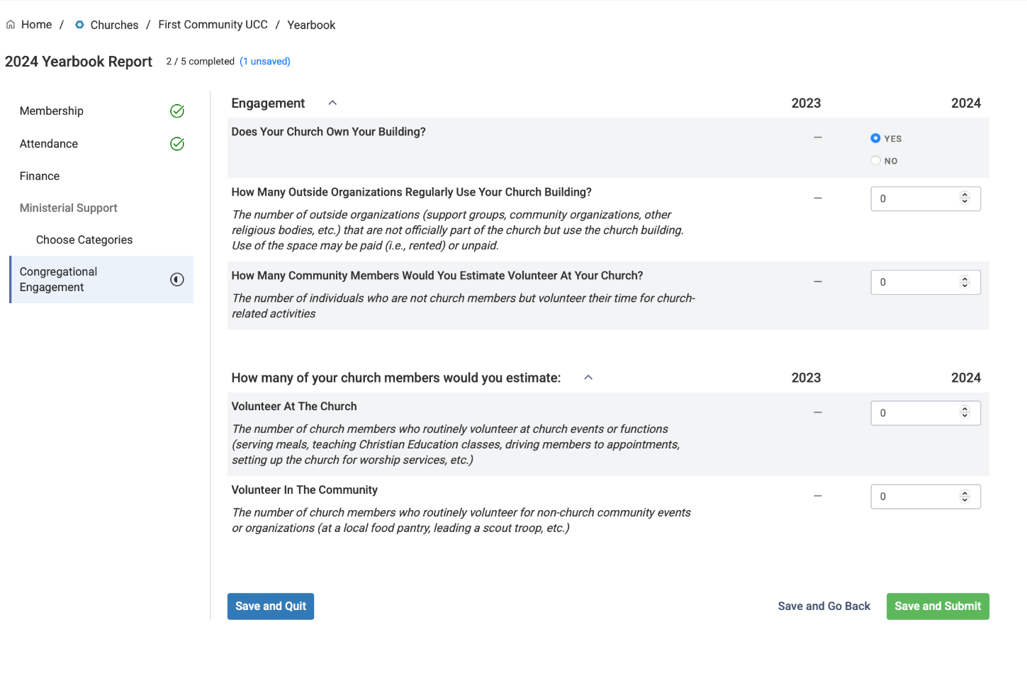

Supplemental Survey
- Due to exceptional circumstances surrounding our transition to the new Database and Directories site and the production of the 2025 yearbook, we will not be conducting a supplemental survey this year.
- We plan to renew the survey for 2027.

REMINDERS
- The Church Field Guide, also posted on the Yearbook webpage provides descriptions of most of the data you will be entering. Refer to this as needed.
- Change your password immediately. Make a note of your updated password.
- Use only USPS-approved abbreviations in addresses.
- All questions, concerns, or comments should be directed to your Conference or Association.
- All inaccurate data should be reported to your Conference or Association for correction. Please report any errors to your Conference in the manner they asked to be notified.
- A Reporting Guide is provided at the end of this document to assist you in gathering data before submitting it. You may print this to assist you in gathering your data.
- Explanatory notes may be found under most entry fields in the Database and Directories Yearbook Reporting section. You can also find the Church Field Guide and on the Yearbook webpage.
- Please feel free to reach out for assistance if your Conference or Association is unavailable to assist you.

Yearbook Reporting Assistance
Dates: January 26th – April 10th (excluding holidays)
Email: research@ucc.org

DATABASE AND DIRECTORIES REPORTING GUIDE

Membership

Additions
Confirmations
Confessions of Faith
Transfers In
Reaffirmations of Faith

Removals
Deaths
Transfers Out
Other Removals

Baptisms Total 2024 Membership
Child Baptisms (12 & younger)
Adult Baptisms (13 & older)

Attendance
Average Weekly Worship Attendance (in person only)
Community Engagement
Church Participants
Have your members participated in US or international mission/ immersion/service trips? | Yes No

Virtual Attendance
Video conferencing (e.g., Zoom)—Average devices logged per service
Social media (e.g., Facebook Live)—Average views/visits/downloads for a service within a month of sharing
Video hosting (e.g., YouTube)—Average views/visits/downloads for a service within a month of sharing
Multistream (e.g., Restream.io, Streamyard)— Average views/visits/downloads for a service within a month of sharing
Audio platform (e.g., podcast, radio broadcast,
1-800 number)—Average listeners per service

Youth Program
Active Jr. High Participants
Active Sr. High Participants

Christian Education/Faith Formation Program

Active Participants
Children (0-17 years)
Adults (18 years & over)

Average Participants
Children (0-17 years)
Adults (18 years & over)

Financial

Income
Total Income
Pledges and Offerings

Endowments
Bequests
Deferred Gifts
Endowment

Expenditures
Additional UCC Giving
Other Support
Capital Payments
Operating Expenses

Ministerial Support

Full-time |  | Yes No
Minister Category
Salary
Additional Amount Paid by Other Church
Parsonage
Rental Allowance
Utility Allowance
Social Security
Annuity
Insurance
Other Expenses
Business Expenses

If you have multiple pastoral staff, please complete additional ministerial support reports.

Full-time |  | Yes No
Minister Category
Salary
Additional Amount Paid by Other Church
Parsonage
Rental Allowance
Utility Allowance
Social Security
Annuity
Insurance
Other Expenses
Business Expenses

Full-time |  | Yes No
Minister Category
Salary
Additional Amount Paid by Other Church
Parsonage
Rental Allowance
Utility Allowance
Social Security
Annuity
Insurance
Other Expenses
Business Expenses

