Health Corner – Calmness

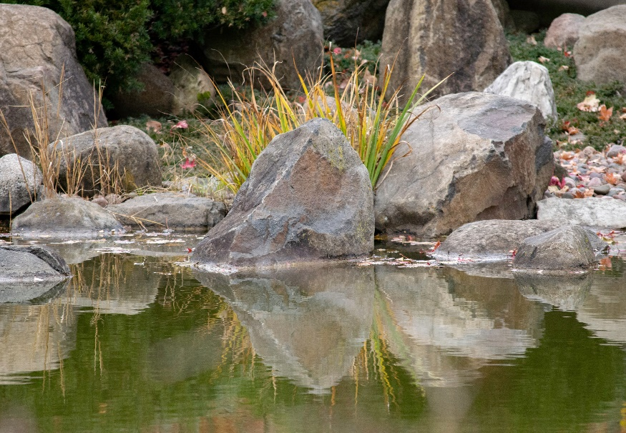

Calm like a still lake. Can you picture it? Not a ripple, it reflects like a mirror. No rapids or waterfalls. All is quiet. Scripture says, “He leads me beside still waters; he restores my soul.” Psalm 23:2-3

Remember the storm in which the disciples found themselves? One word from Jesus and the seas calmed. Proverbs 17:27 “They who have knowledge spare their words, one of understanding is of a calm spirit.” That is God’s goal for us. To remain unruffled.

When our spirit is overwhelmed we lose our focus. We might make rash decisions or become angry. We become distracted by our problems and fail to see or hear God’s direction.

With all of the uncertainty in the world right now, this is a good time to find ways to quiet your soul. There are several apps for your phone or computer that lead you through calming techniques. The sound of water, music, even storytelling to slow down your pace even for one minute helps refocus your thoughts, slows your heartrate, lowers your blood pressure, and calms your spirit.

Perhaps have a peaceful picture pop up several times a day for meditation. Many apps have you stop for one minute and just breathe. It sounds so simple and yet we need reminders. Download one of these apps and try it out. Some people find that lighting a candle or inhaling a certain scent helps them. Sitting in a certain position or looking out a window at a beautiful view. Doing stretches that relax your shoulders and neck. Repeating a verse of Scripture.

Start today and make a practice of creating calm for one minute three times a day. Then increase to one minute an hour. You’ll be surprised at how much more productive you will be and how much better you will feel. Jesus doesn’t want us in chaos. His journey through life never reflected that. He took his time. He sat in stillness and prayer. He took time apart from others to quiet his soul.

We would do well to adopt his practices.

