Plan ahead/read ahead! Here are book selections for upcoming months:

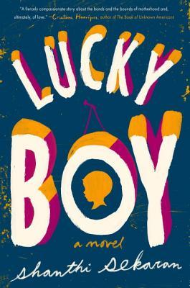

January 24, 2021

Lucky Boy by Shanthi Sekaran

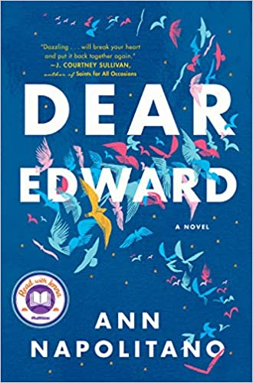

February 28, 2021

Dear Edward by Ann Napolitano

