Happy Numbers Tutorial
- You will be given access to Happy Numbers in one of two ways:
  - A link directly to your class – you will only need your password
  - A link to Happy Numbers where you must provide your class code and password.
Your teacher will provide you with this information and it will look like this:
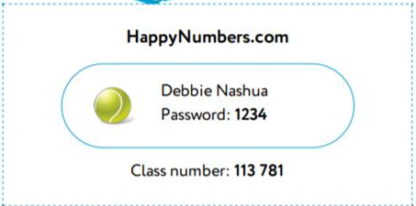
- If your teacher has given you a Happy Numbers assignment in Google Classroom, open the assignment and then click the link.
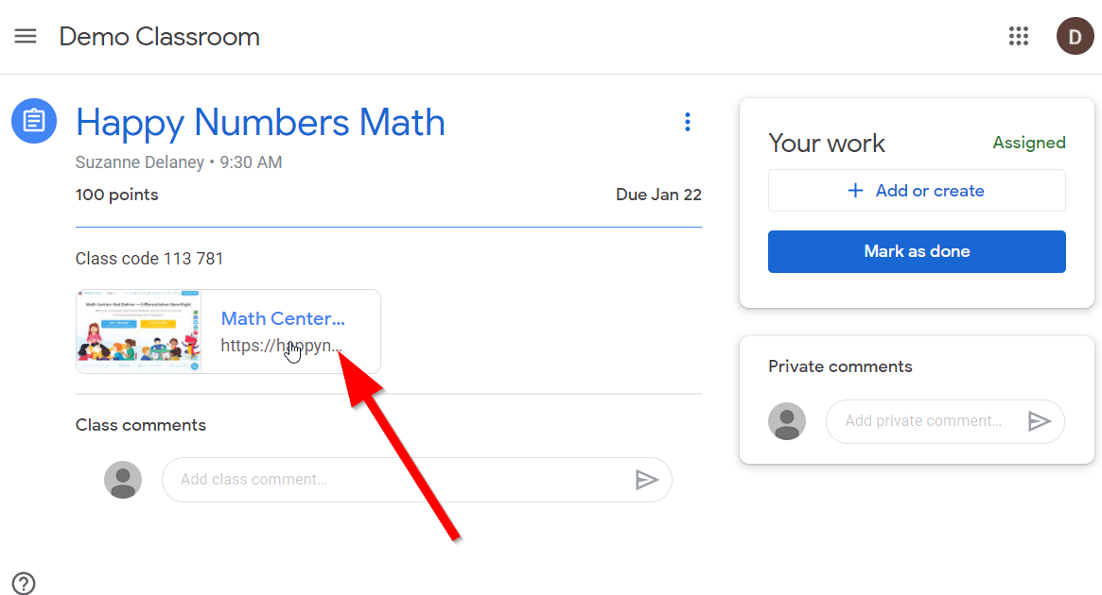
- Click the “I’m a Student” button.
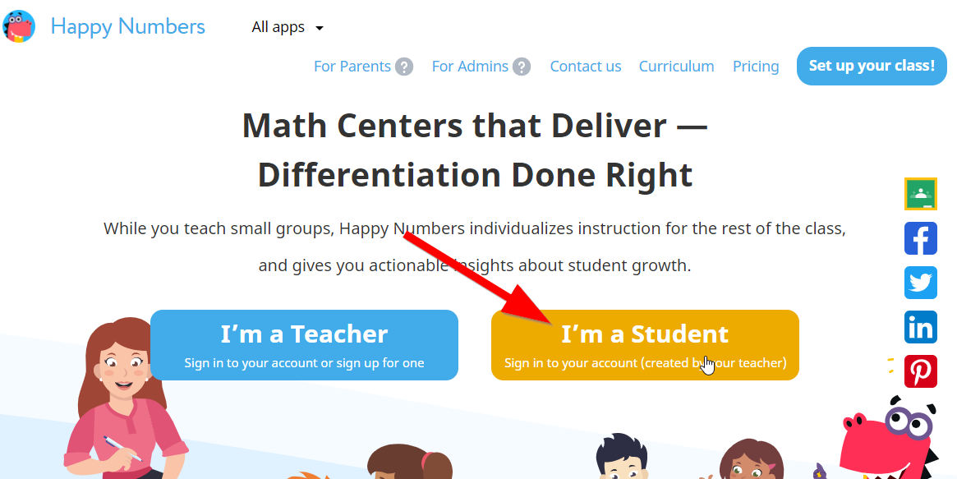
- Enter the class number provided by your teacher, then click “Go”

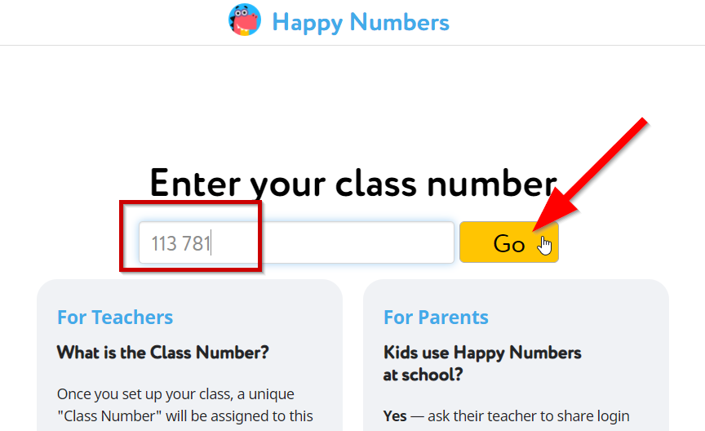

- Click on your name.
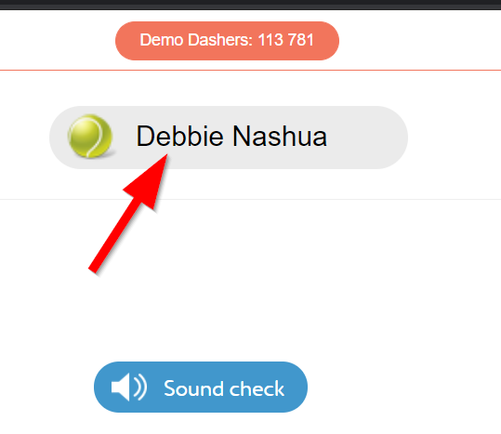
- Enter the password provided by your teacher. Then click “Go”.
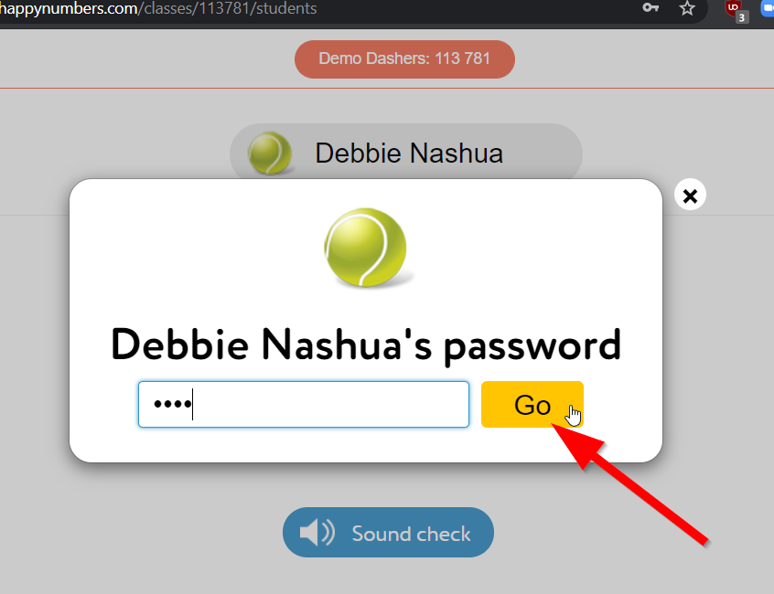
- You will be brought to the Happy Numbers website. “Dino” will walk you through a quick tutorial of how to use Happy Numbers. Click the “Go” arrow to begin, then follow the instructions at each step.
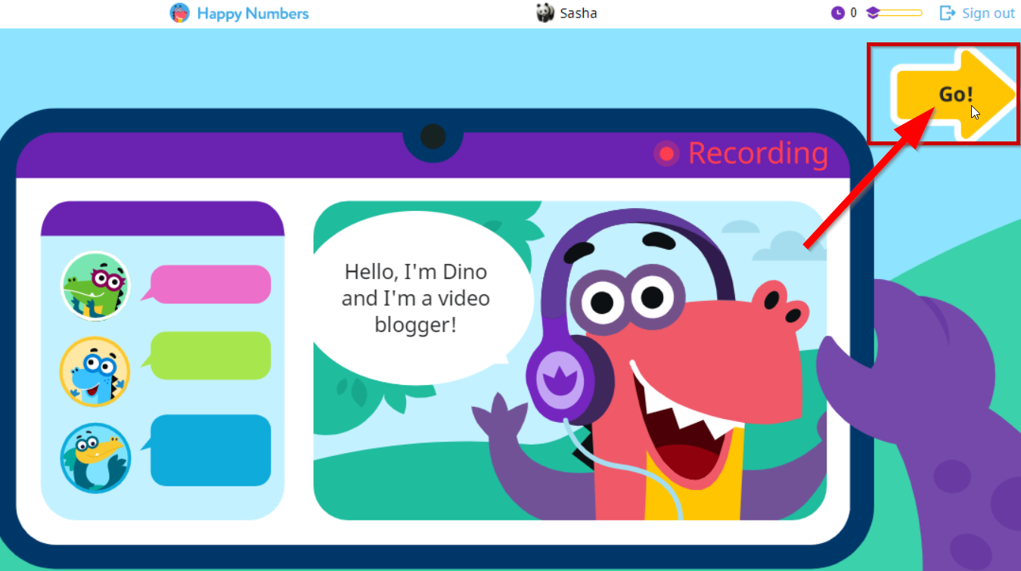
  - Click the play button to start the tutorial
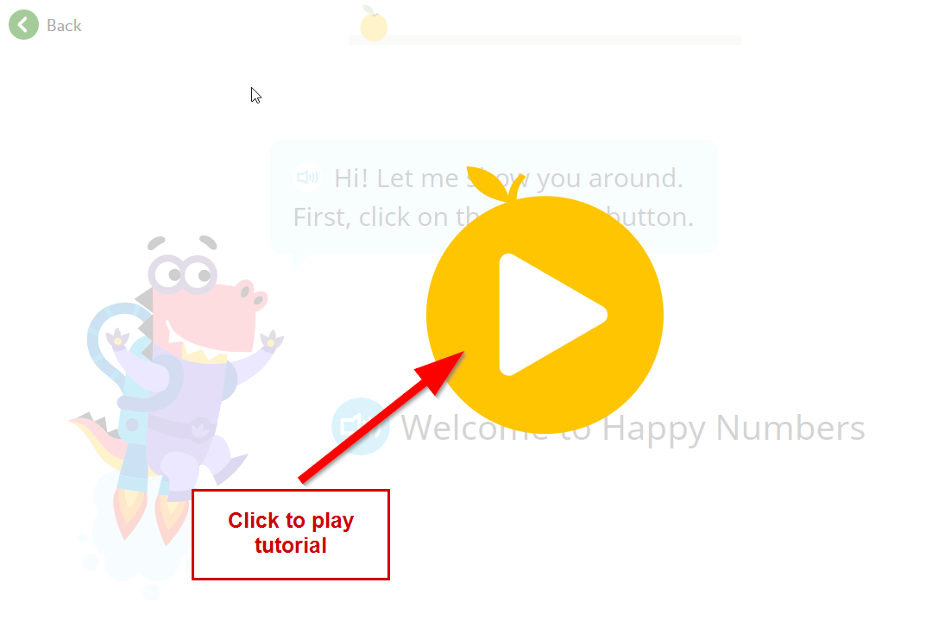
  - Switch to Spanish by selecting “Español” from the drop-down menu at the top right of the page.
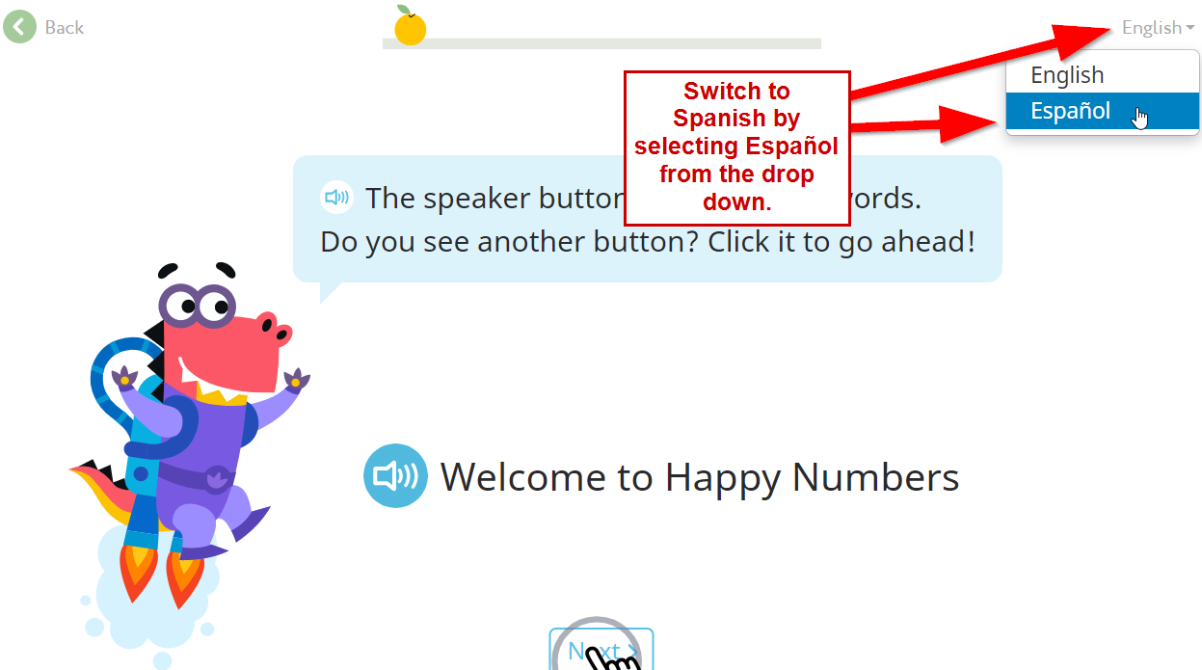
- Once the tutorial is complete, you will be brought to a placement test. At any point you can click the audio button to hear the instructions, or question, again.
  - Click “Next to begin”.
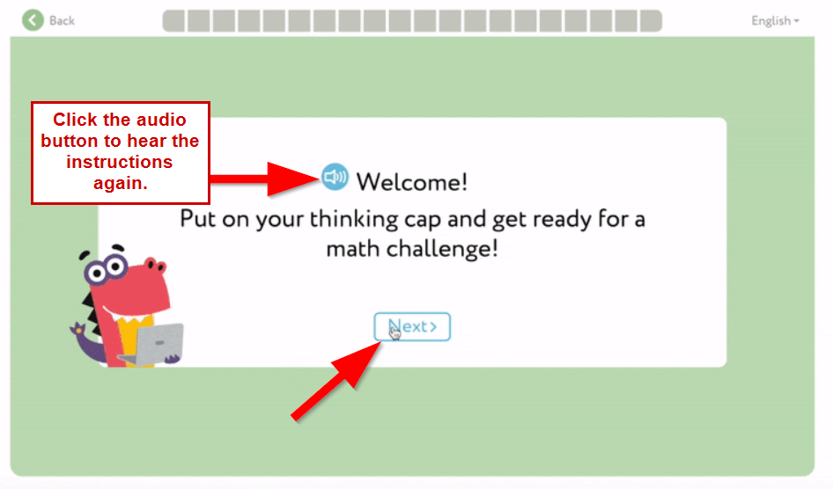
  - For each question, choose your answer and then click “Done” to move to the next question. Do your best, but do not worry if you don’t know the answer. This is simply gauging where you should start in the curriculum.
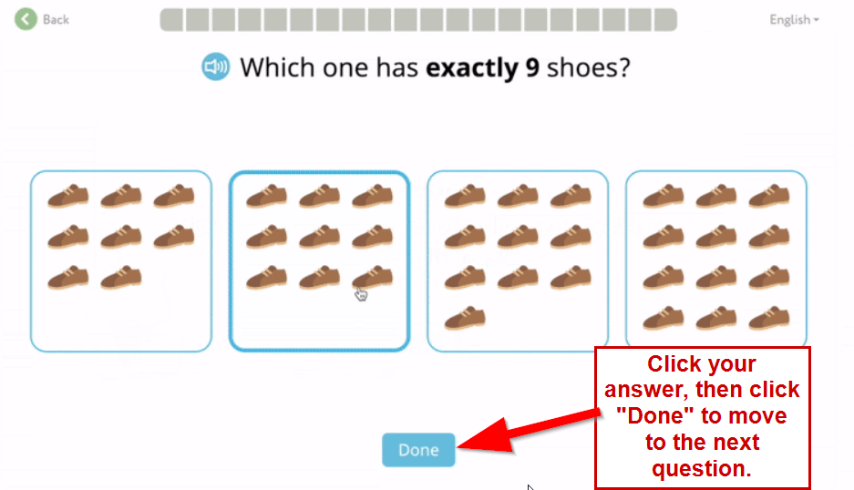
  - Complete all 20 questions. You can see your progress at the top of the page.
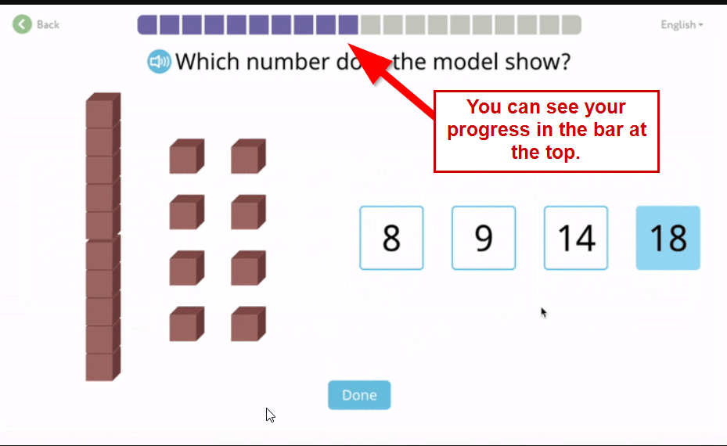
  - Once the placement test is complete, click Next.
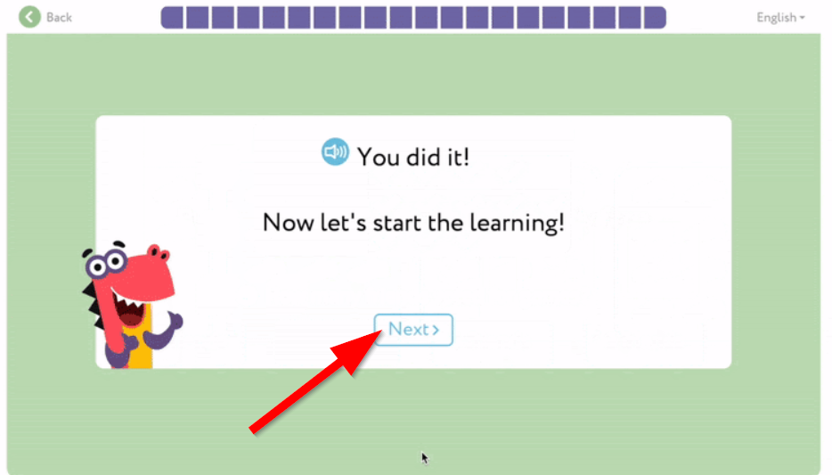
- As soon as the Placement Test is completed, you will be placed on a map with various locations from which to choose. It will look different for different grade levels. Click on the first area of the map to begin learning.
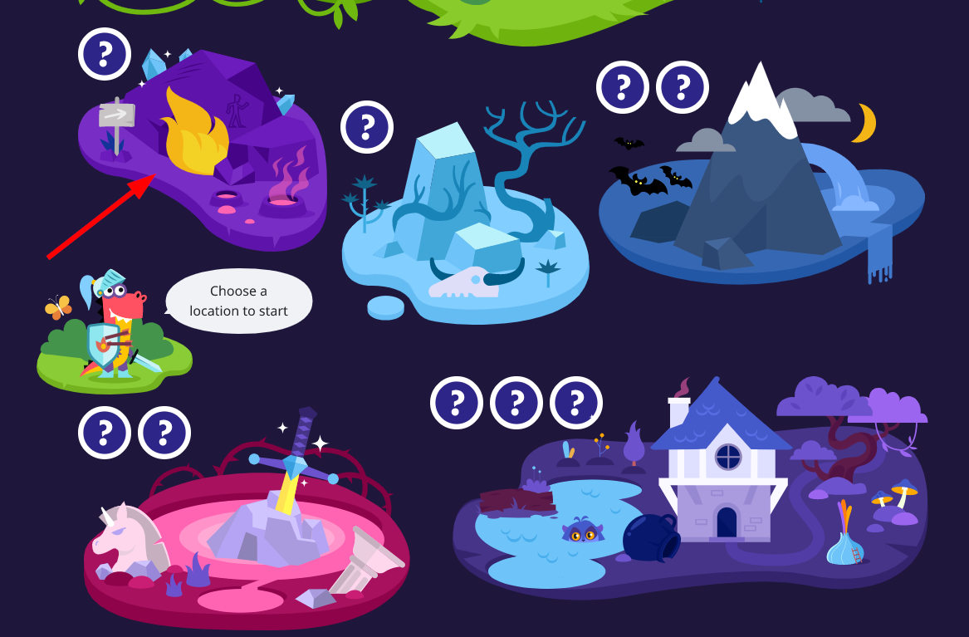
- Click the play button on the first circle to begin the first lesson.
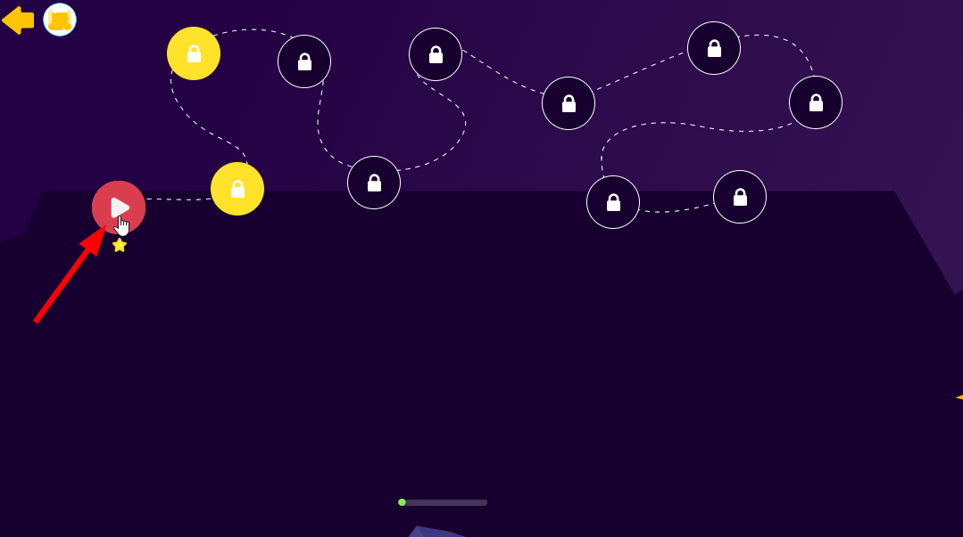
- Work through each question, like the one below.
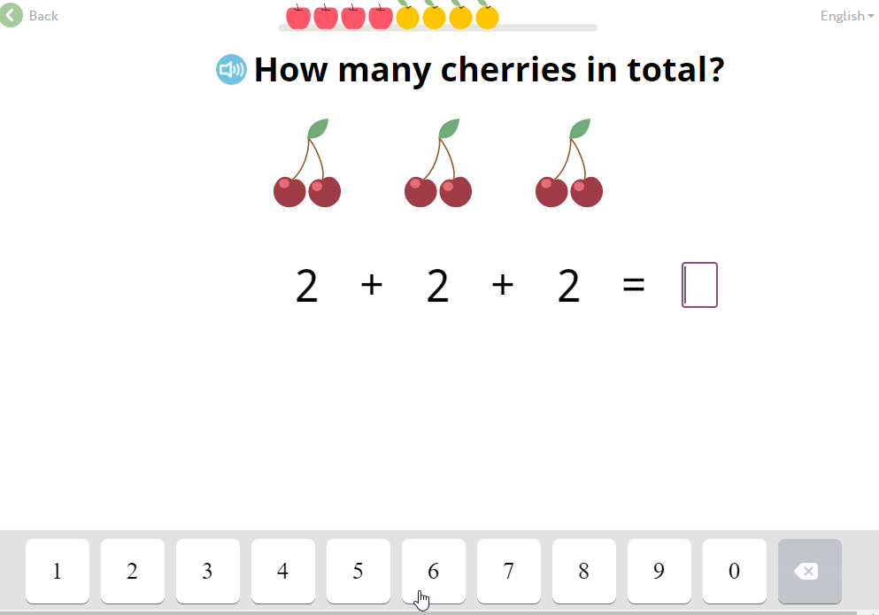
  - If you get a question wrong, the program will help you find the correct answer.
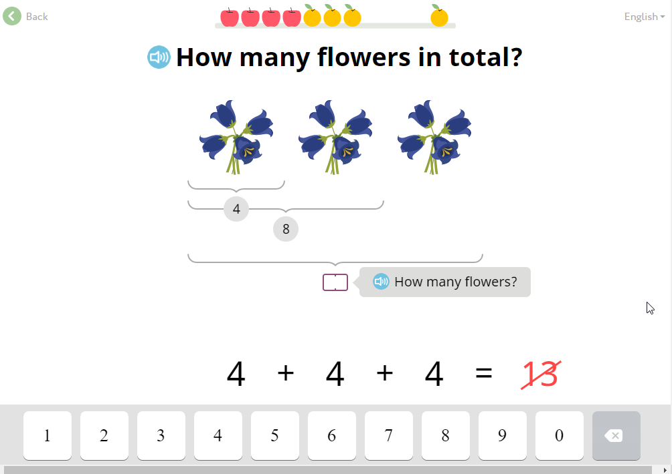
  - You can see your progress at the top of the screen.
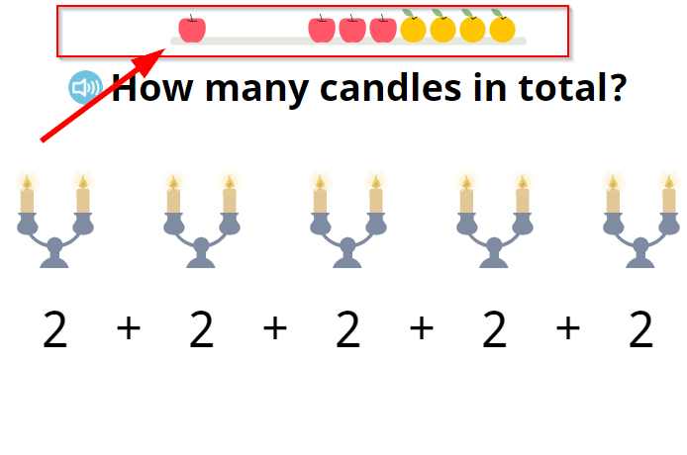
  - Some questions require you to enter a number, others are drag and drop.
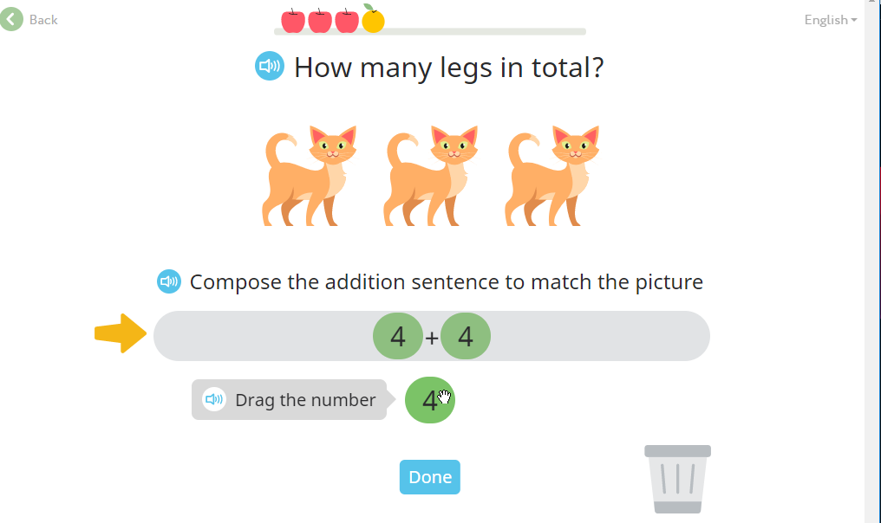
- As you progress through each step, you will see your progress on the map. Depending on the grade level, characters change, and you receive different rewards for completing lessons. You can see your progress by clicking the cap. The progress bar will show you how close you are to completing the weekly goal set by your teacher.
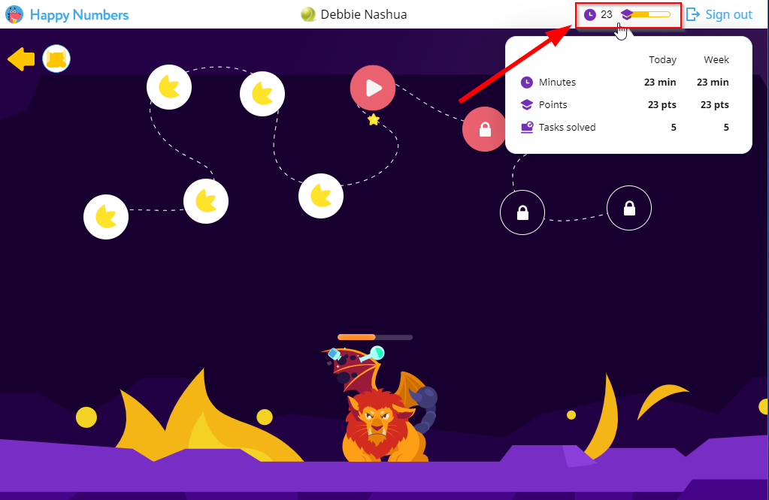
- You can click the arrow at the top left of the page to return to the map. Click “Sign out” at the top right to sign out of Happy Numbers.
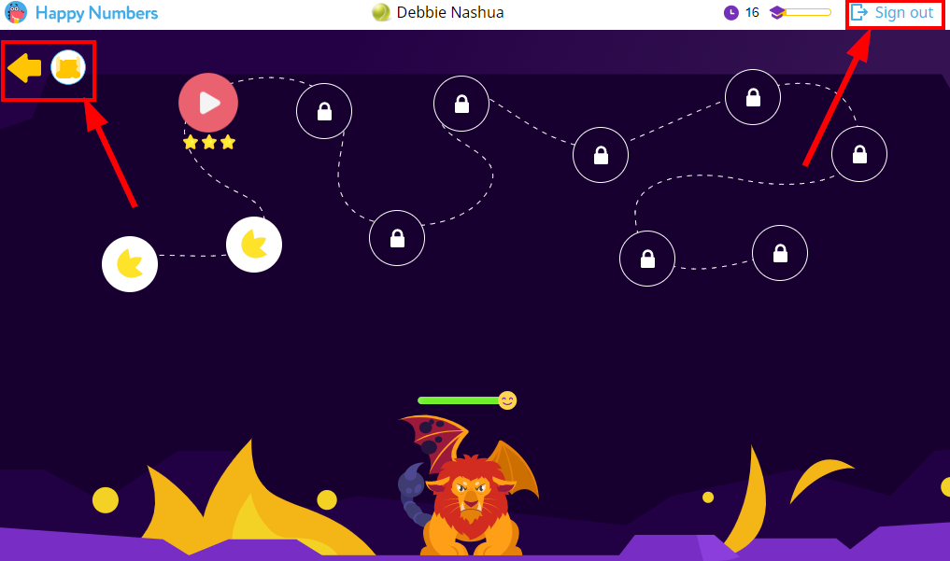
- Complete the assigned number of minutes each week. Return to the Google Classroom assignment (if applicable) and click “Mark as done” when you have completed the assignment. You do not have to attach any work; your teacher will be able to see it through Happy Numbers.
