Completing Activities in Seesaw

- Login to Seesaw through the Clever portal.
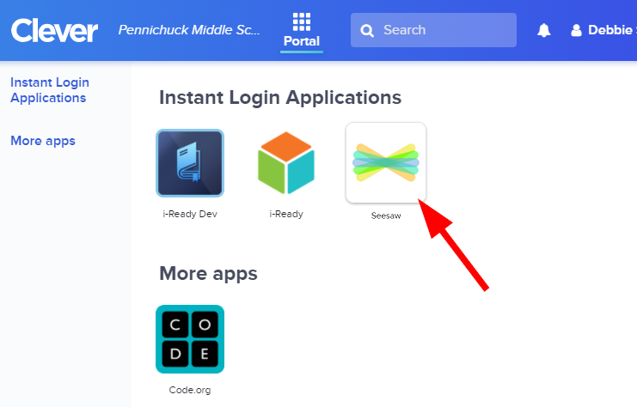
- You will be brought to the class set up by your teacher. Click on “Activities” to view assignments.

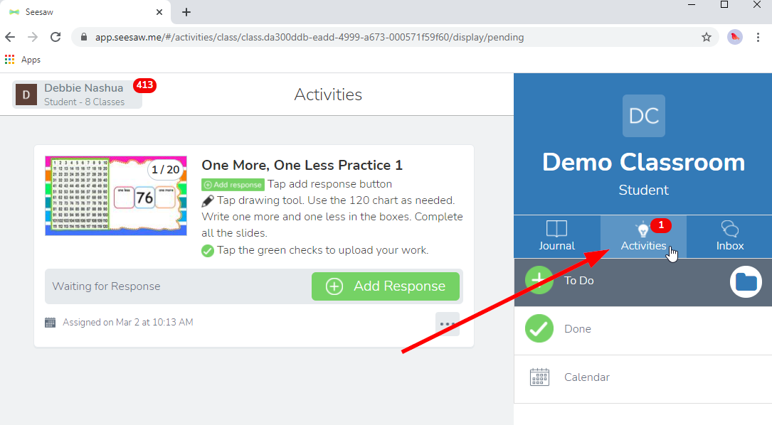
- Some teachers will keep a daily schedule at the top of the activities page. Click the image to open the schedule.

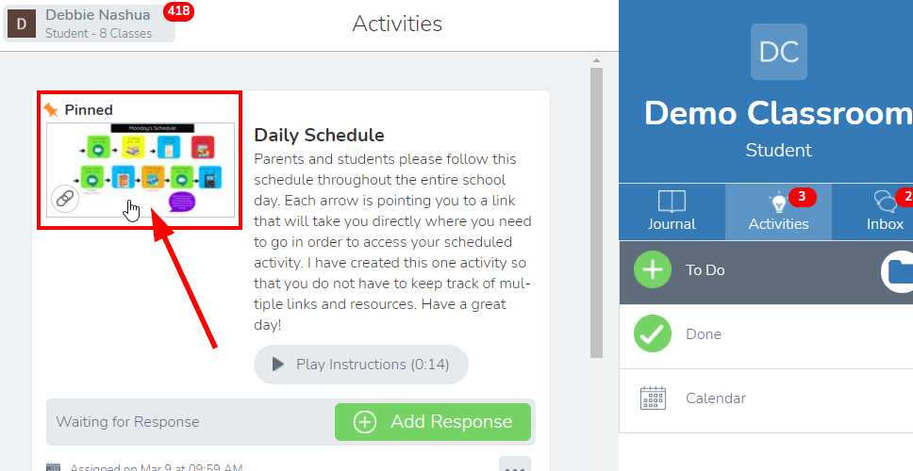

- The daily schedule will have links to each of the activities you need to complete. Click each link at the assigned time to be brought to the assigned activity.

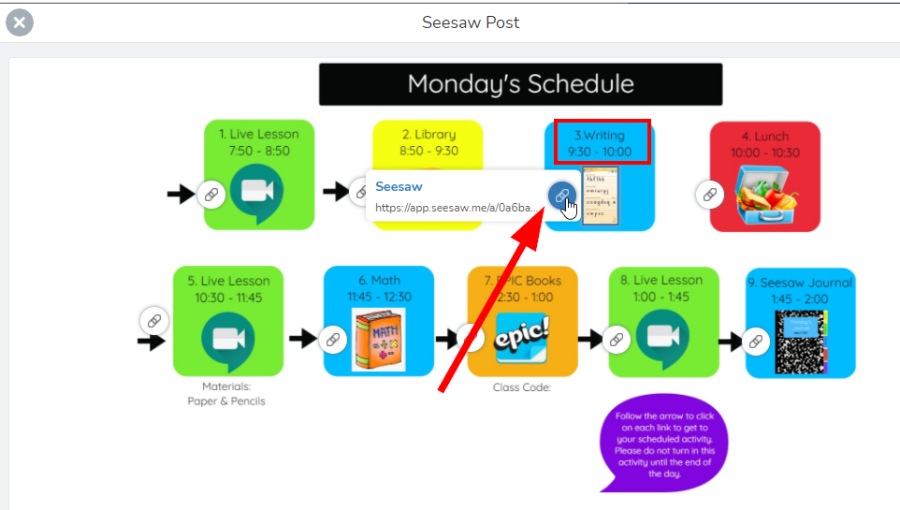

- If your teacher does not have a pinned schedule, your assignments will be in the activity tab.

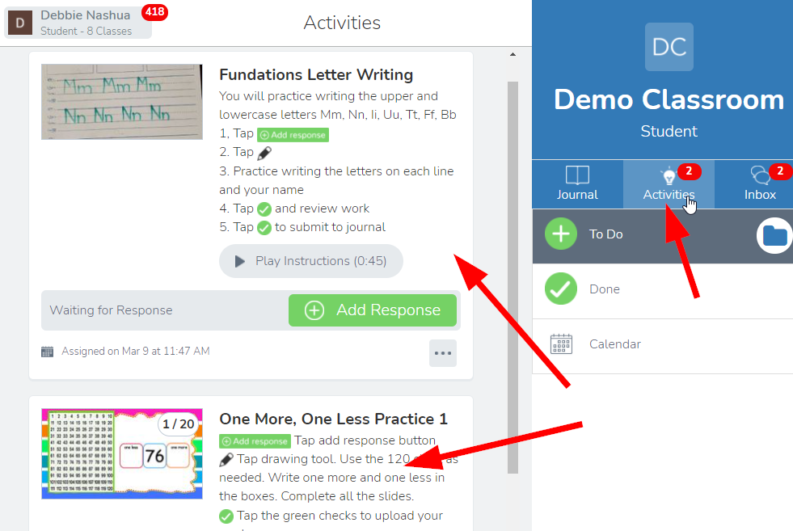

- Read or listen to the instructions (if recorded instructions provided) and then click “Add Response” to begin the activity.

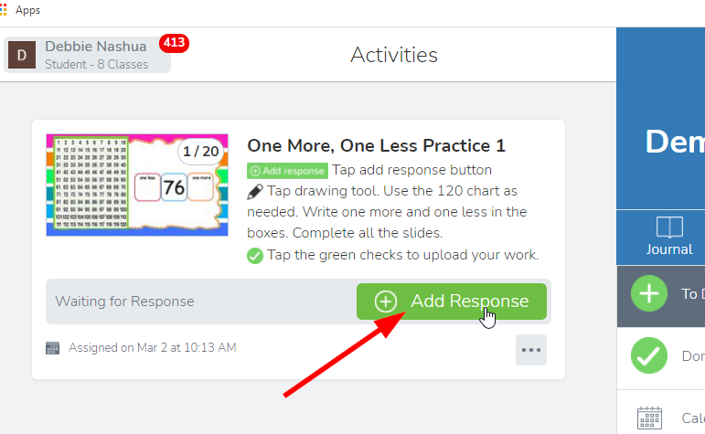
- Use these tools to complete the activity:
  - Close out of the activity.
  - Make the activity bigger on your screen.
  - Hide/show the tools around the outside of the window.
  - Undo or redo a step
  - View the instructions for the activity.
  - Navigate through different pages of the activity.
  - Create a text box.
  - Record audio
  - Take a photo or video to add or upload a photo or video.
  - Other items to add to the activity, including shapes, backgrounds, or links.
  - Add a comment.
  - Make the mouse a pointer to select items.
  - Make the mouse a writing tool to write on the activity.
  - Make the mouse an eraser to erase marks on the activity.
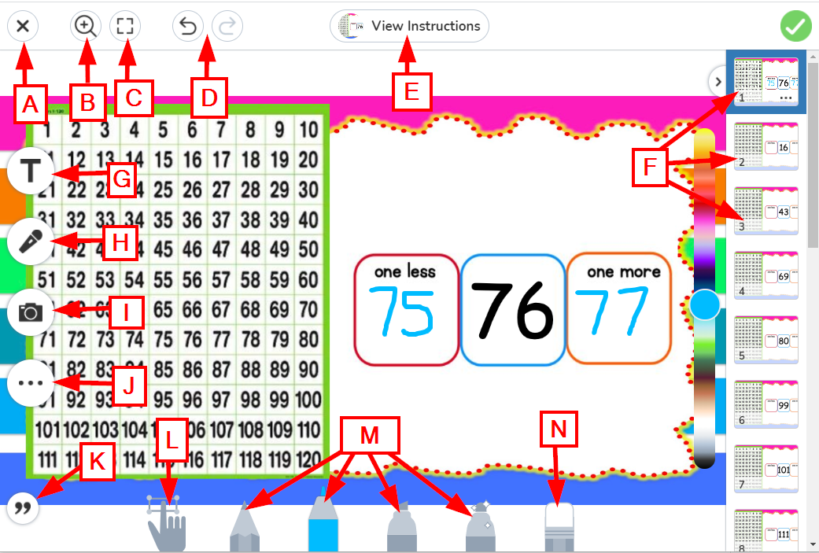

- When you have completed the activity, click on the green check mark in the upper right corner.
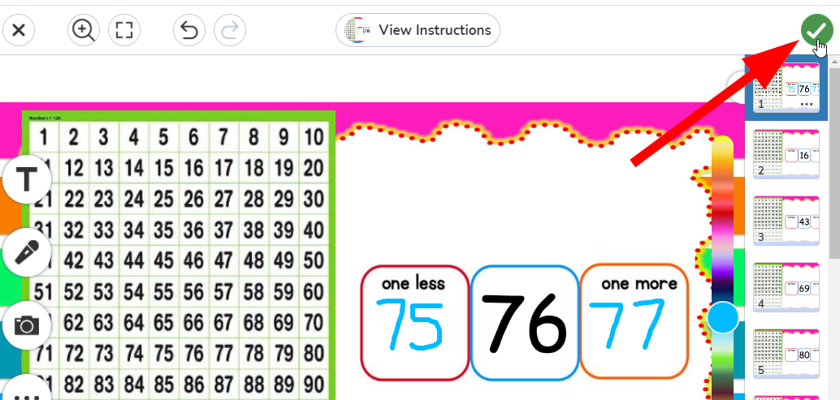
- Your response will be sent to the teacher for approval.

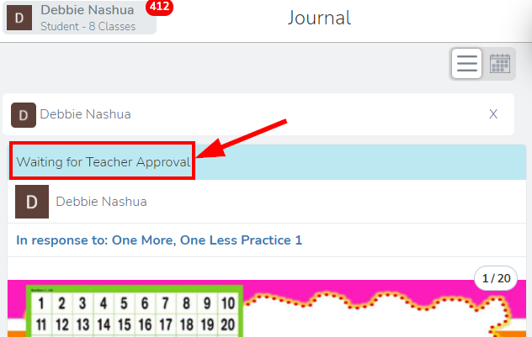

- Once your teacher has reviewed and approved your response, it will be posted to the class journal with comments and likes. You can add a comment by clicking the “Comment” button.
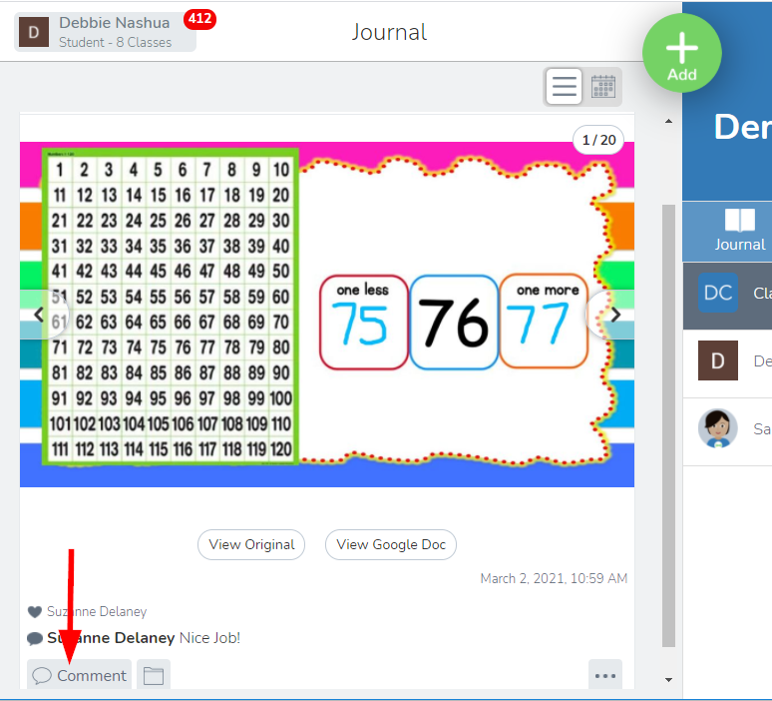
- View notifications from all your classes by clicking on your name in the top left of the screen. The number in red indicates how many notifications you have.
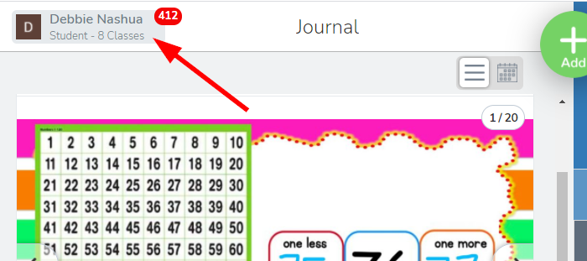
- Click on a class in the list to go to that page in Seesaw, or click on the gear wheel to find your account settings or log out of Seesaw.

