Completing an EdPuzzle Assignment
- Go to the classwork tab in Google Classroom, find the EdPuzzle assignment, and select “View Assignment”.
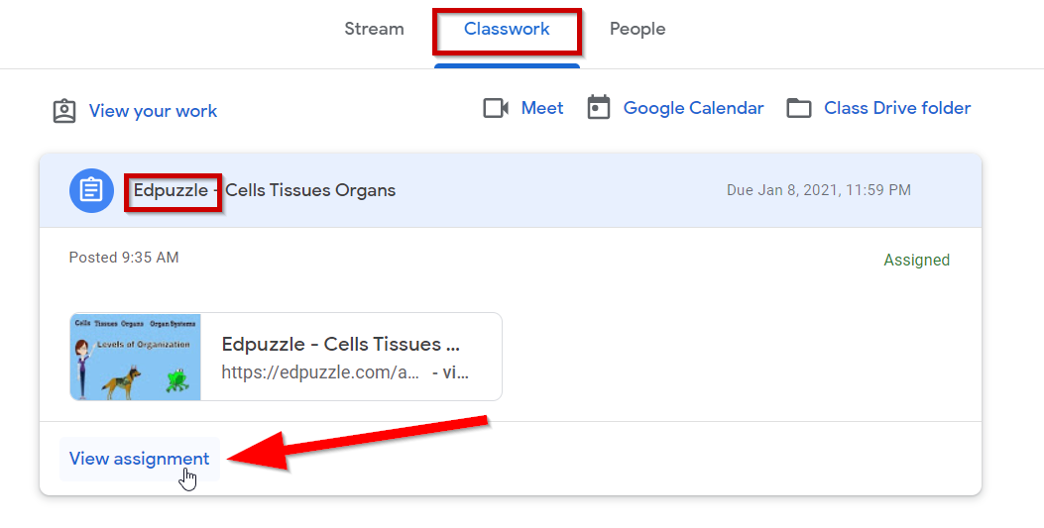
- Read all instructions and then click on the link to Edpuzzle.
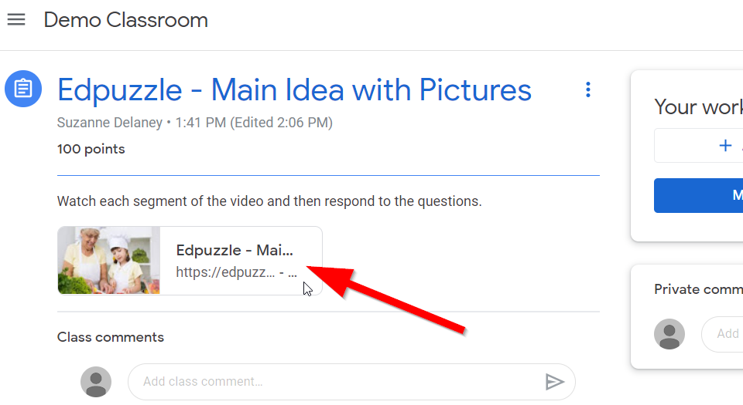
- You will be brought to the EdPuzzle login page for the assignment. Click “Sign in with Google”.
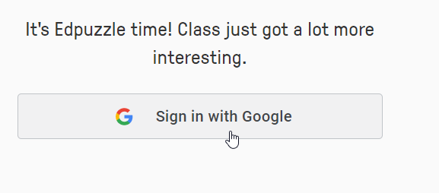
- Click on the student nsd42.net account.
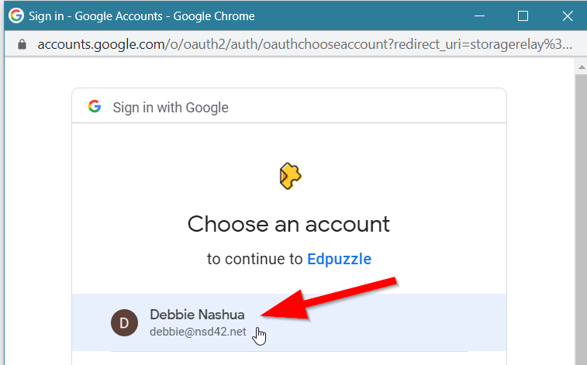

- You will be brought to the assignment. Click the play button on the video to begin watching the assigned video.
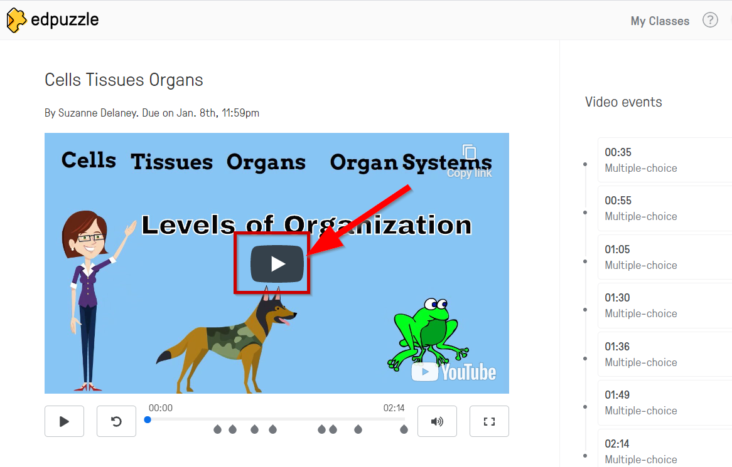

- The video will play until it comes to a “video event”. In this example it is a multiple choice question 35 seconds into the video. If you need to watch the video segment again, click “Rewatch”. When you are ready, answer the question and then click the “Submit” button.
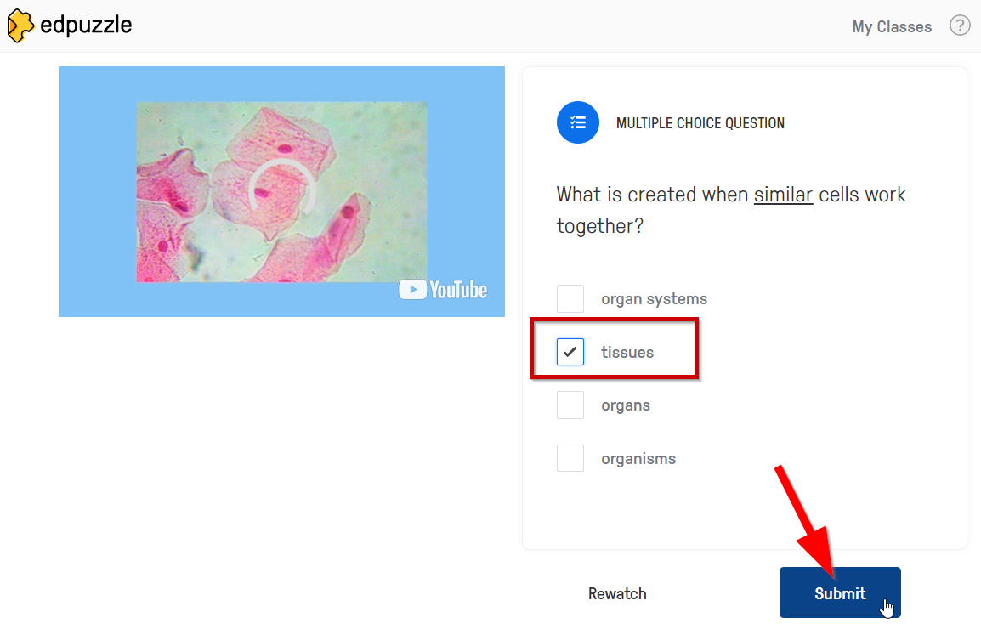
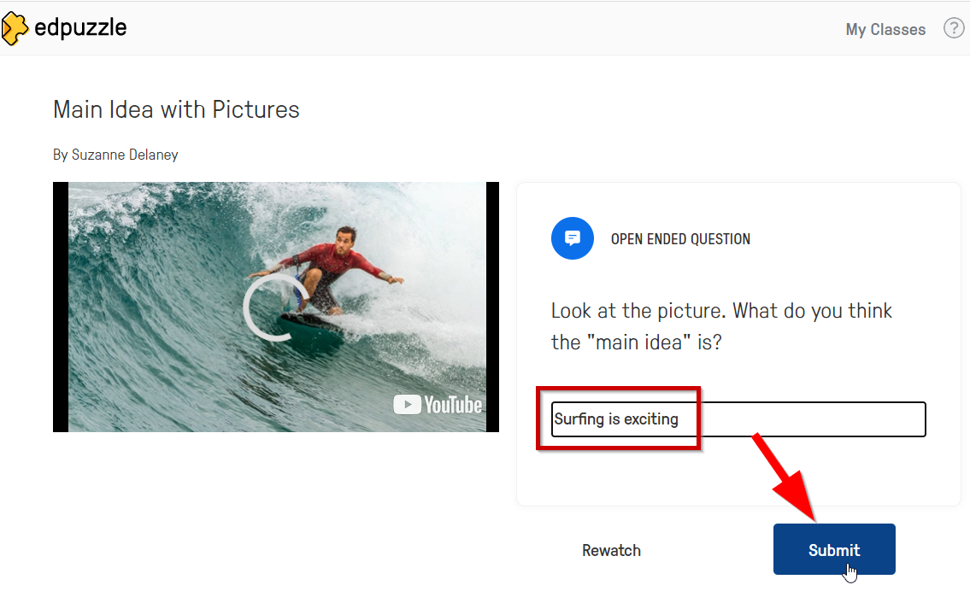
- If it is set up for automatic grading, you will see the score for that question. If not, it will be marked “To be graded”. Click the “Continue” button to watch the next segment of video.
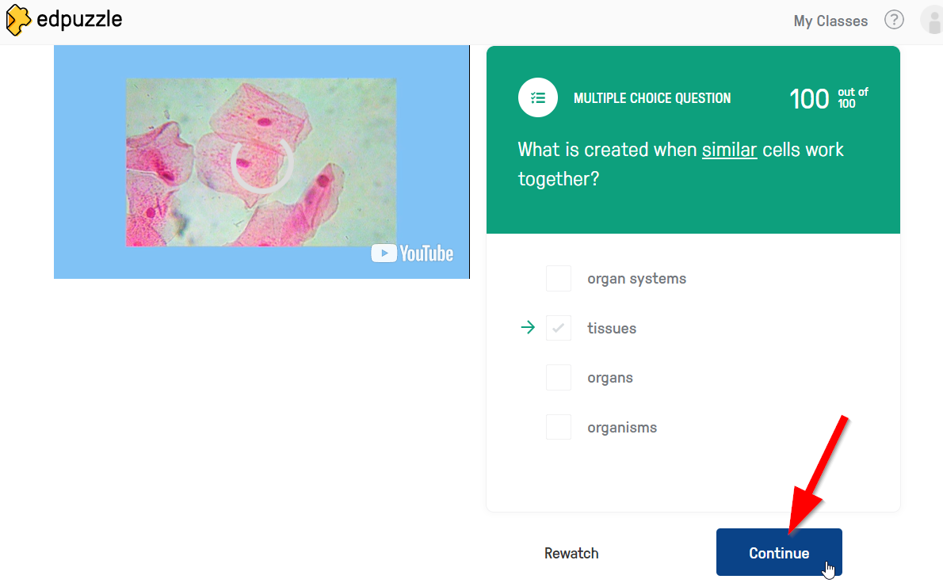
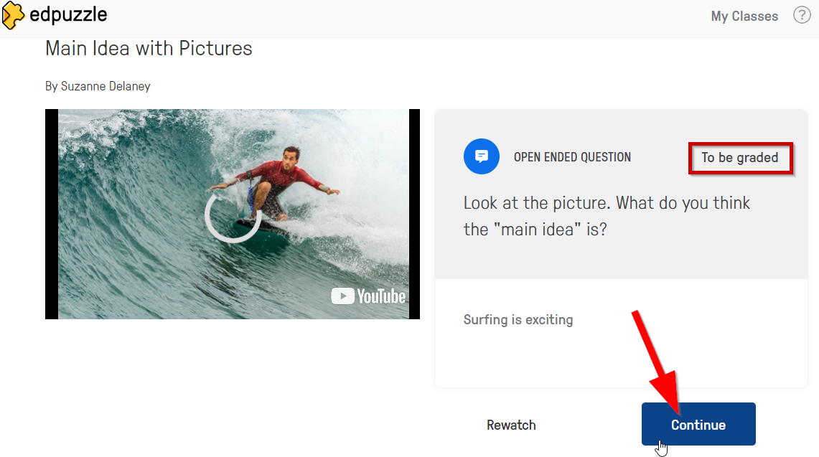
- The teacher may have included important notes in the assignment as well. When these come up, write down the note in your notebook and then click “Continue”.
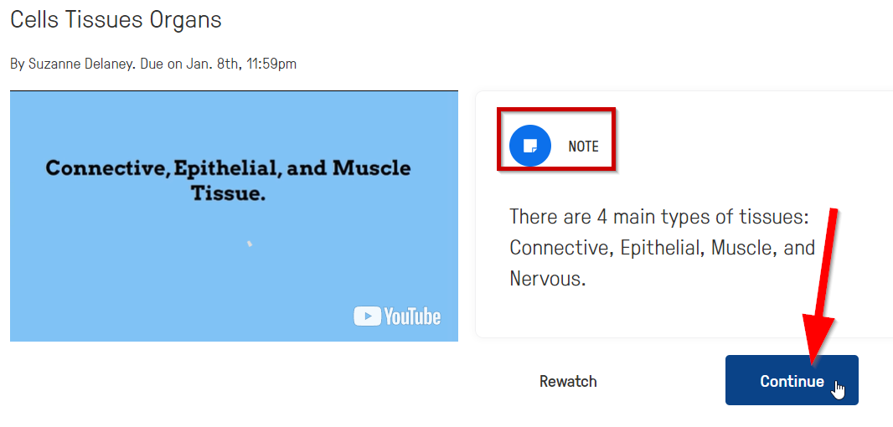
- If you get an answer incorrect on an auto-graded question, EdPuzzle will indicate the correct answer. When you are done reviewing the video segment and question, click “Continue”.
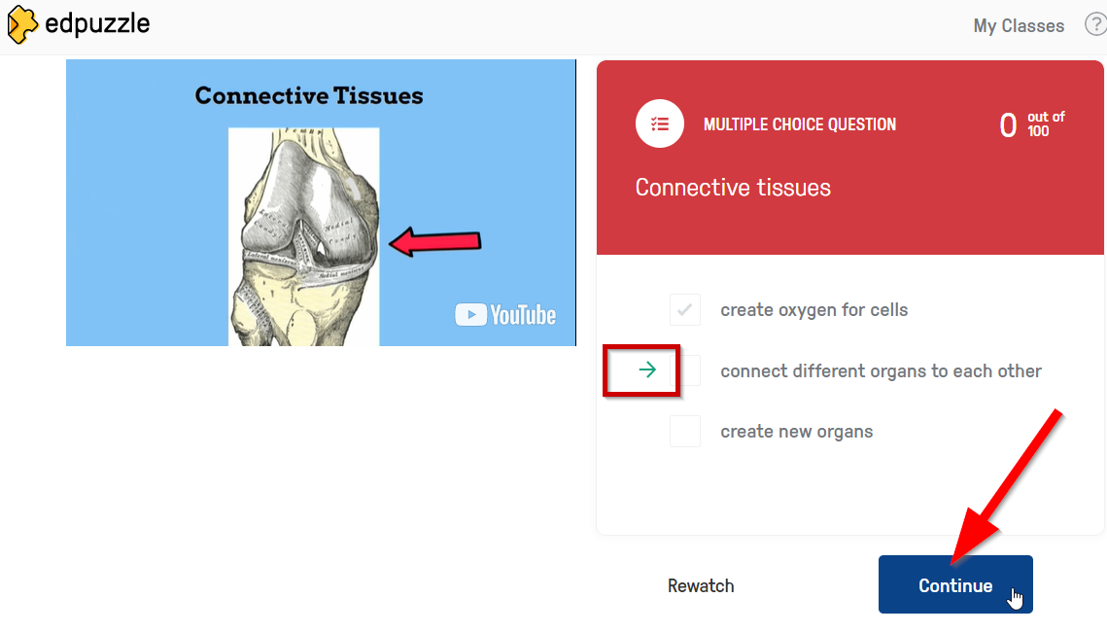
- Once you have finished the video and the questions, you can view your results.
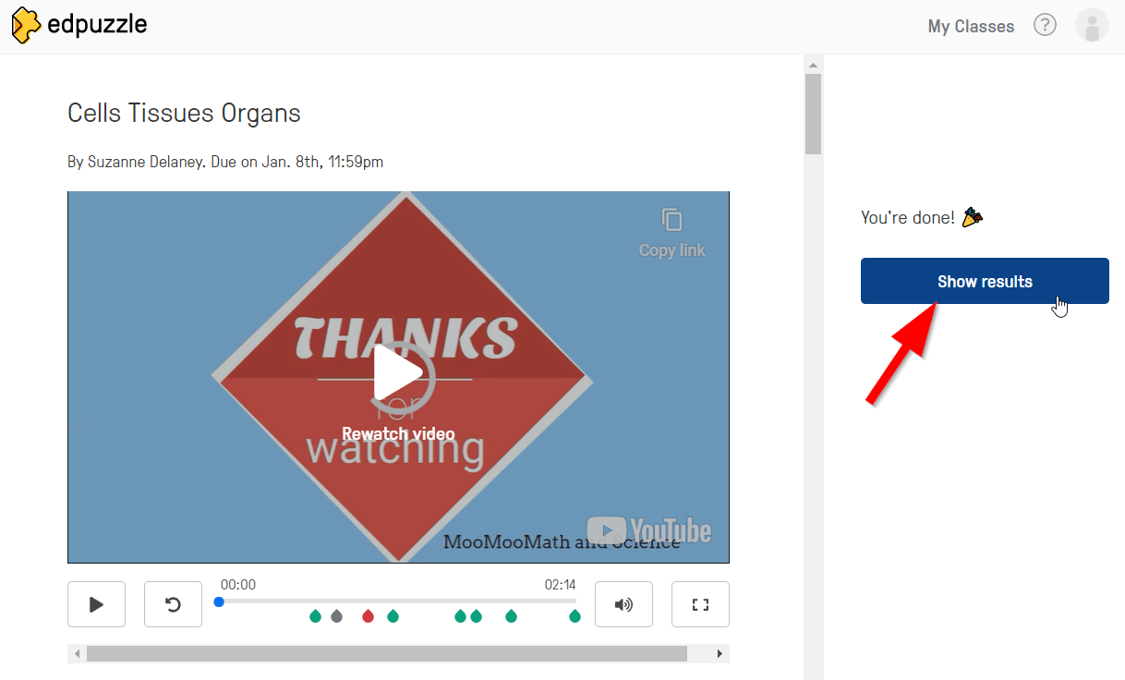

- You can see the overall results in the right-hand side panel and scroll down to see results for each individual question.
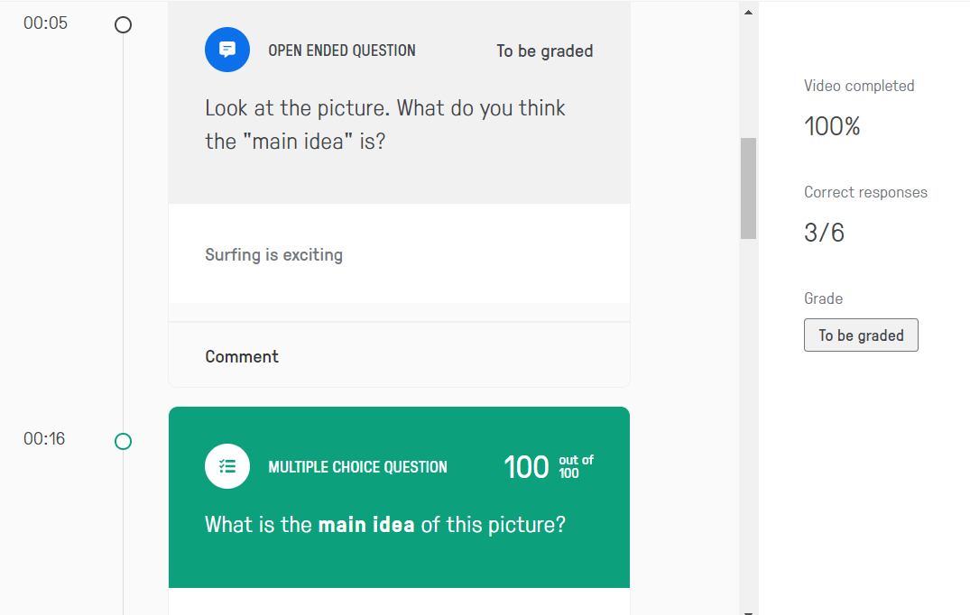
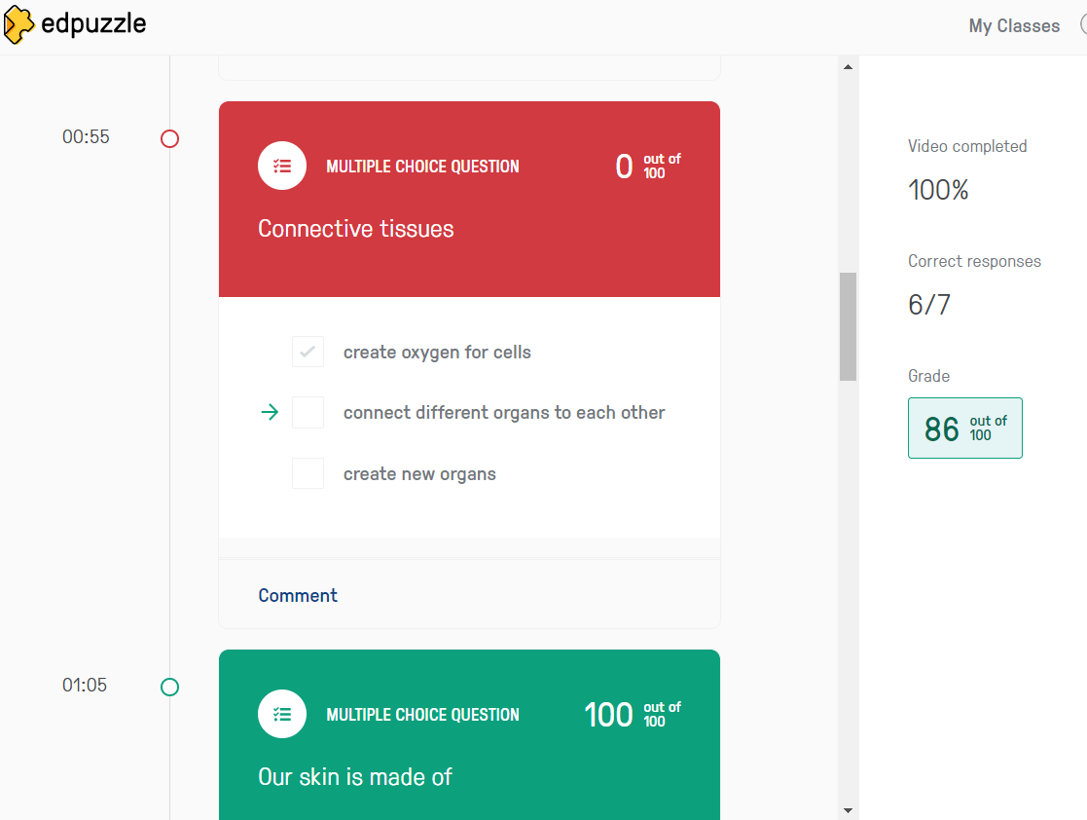
- When you are done reviewing the results, return to the assignment in Google Classroom. If it was auto-graded, you can see it has been graded. If not, click “Mark as Done” so the teacher knows you have completed the assignment and it is ready to be graded.
