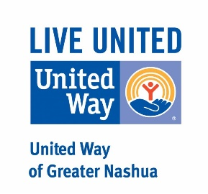
United Way of Greater Nashua Covid-19 Prevention
Micro Grant Application
Criteria: To qualify for funds from the “Greater Nashua Community Response to Covid 19 Fund”
- Your agency must be a 501(c)(3) organization.
- Your agency must be n good standing with the State of New Hampshire.
- Your agency must serve a majority of your clients from the 11 communities of Greater Nashua.
Grant requests can be up to $300 and must be for the express purpose of reimbursing extraordinary costs related to the prevention and spread of Covid-19.
Please forward grant applications to the attention of Liz Fitzgerald (lfitzgerald@unitedwaynashua.org) or Mike Apfelberg (mapfelberg@unitedwaynashua.org)
Name of Organization:
EIN #:
Person Submitting Request:
Contact Information:
Agency address:
Phone:
Email:
Website:
Date:
Date Funding Needed By:
Agency Mission Statement:
Request Amount: $
Please state the nature of the request. How will United Way Funds be used by your agency to combat the spread of the Covid-19?:

I agree to that our organization meets the stated criteria for this microgrant.

Signature of Agency Executive Director _______________________________________

