Completing Kahoot! assignments
- Open the Kahoot! assignment in Google Classroom.
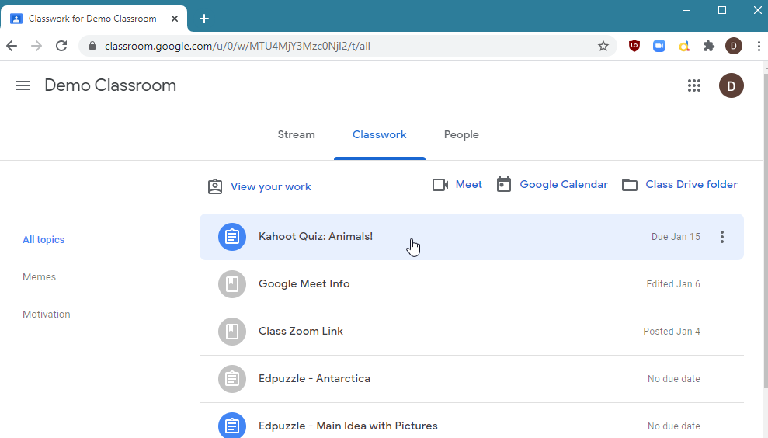
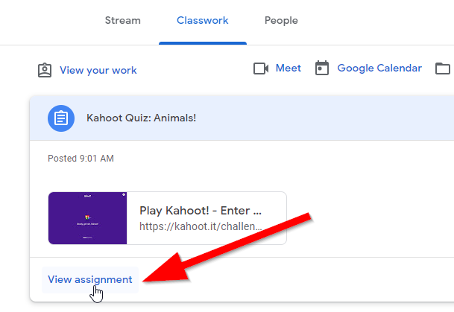

- Click on the “Play Kahoot!” link.
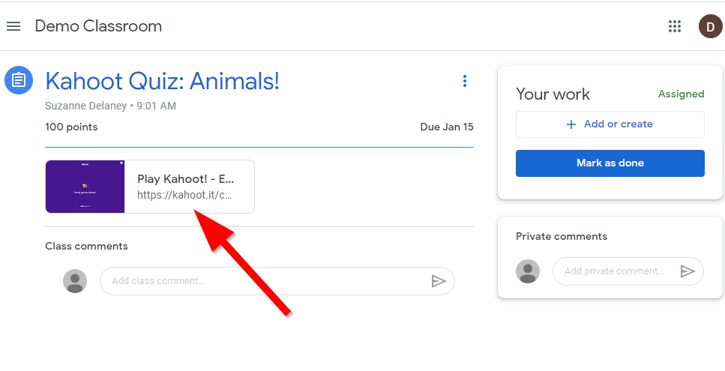
- Enter the desired nickname at the bottom of the Kahoot! screen and click “Ok, go!” to begin the activity.
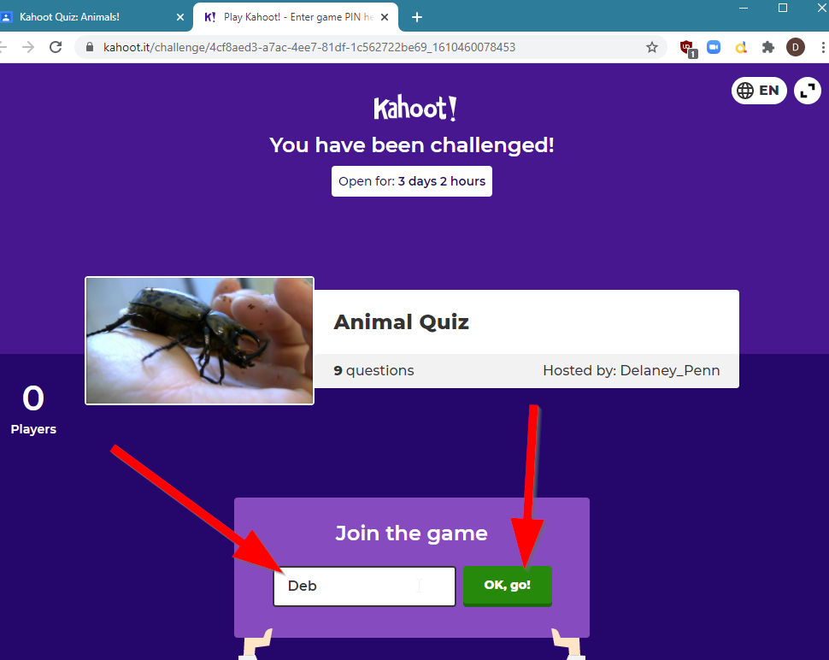
- The Kahoot! activity will begin. You will first see a title screen:
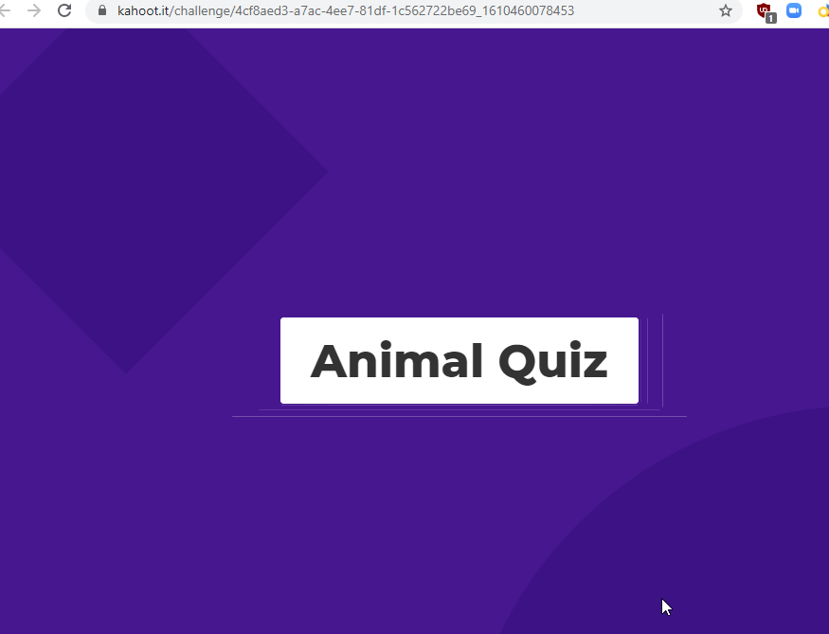

And then questions:
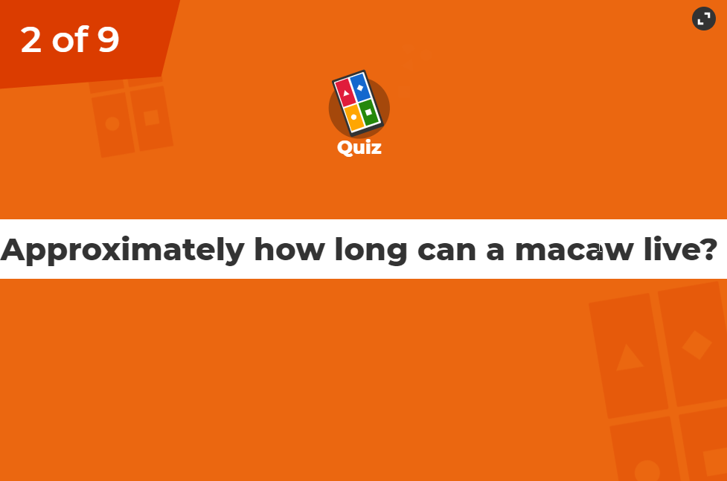
- Answer the question by clicking on the answer you would like. Kahoot! will show the answer and the amount of points earned (if correct). Click next to continue.
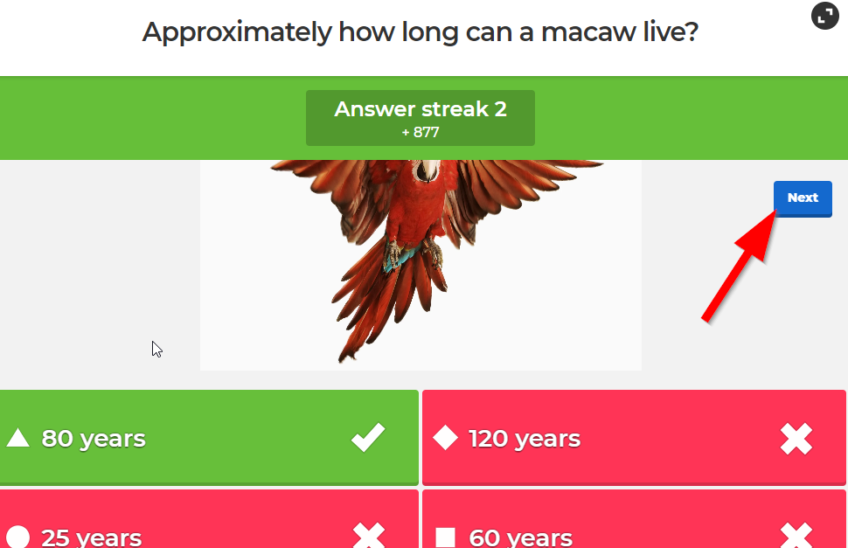
- Answer each question until you have completed the activity. You will see your final score and placement (if applicable) on the final screen.
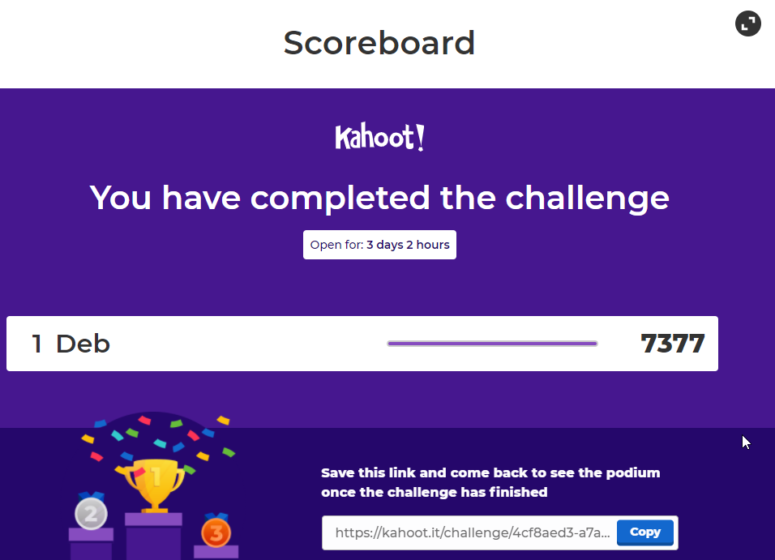
- Close the Kahoot! tab and return to the assignment. Click “Mark as done” to inform your teacher that you have completed the assignment.
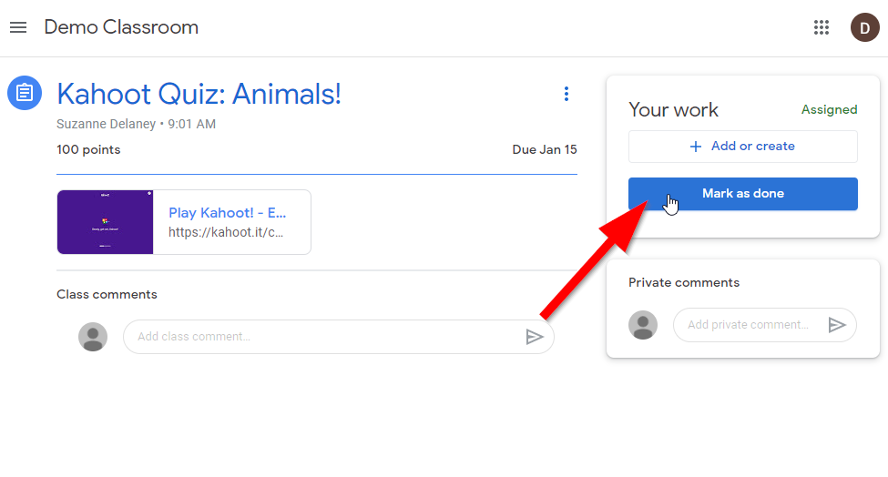
- Confirm that there is no attached work by clicking “Mark as done” again:
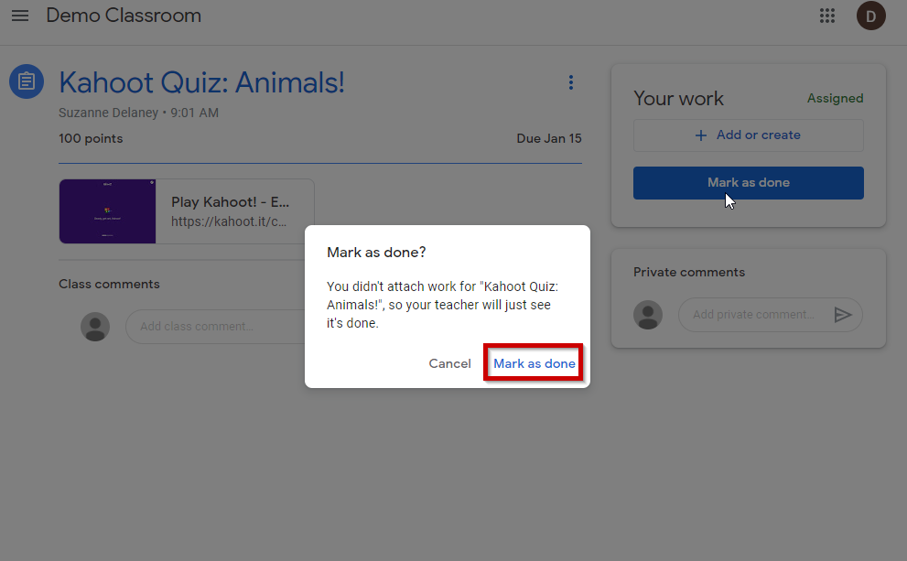
- The assignment will now be marked as “Turned in”.
