***Titus Manor at Wyman Park’s***

***Family Fun Color Run/Walk***

***Saturday, September 30, 2017***

***RAFFLE!! RAFFLE!! RAFFLE!!***

***$1 each ticket or 6 for $5***

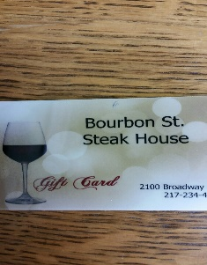

Flora Gems: Pearl necklace

John Durbin: (2) Cessna Plane Flight for 2-3 people

Dogs 24/7: Gift Certificate for 5 nights boarding valued at $50.00

Dogs 24/7: Gift Certificate for 1 small dog grooming

Finishing Touch Tattoo: $50.00 gift certificate

Trish Bingham: Perfectly Posh basket (valued at $70.00)

Copper Creek Cottages- (3) Coffee baskets

Bourbon St. Steakhouse: $20 Gift Certificate

Diepholz Chevrolet : Gift certificate for oil change and tire rotation

K.C. Summers: (2) Gift Certificate for 2 oil changes

AND MORE ITEMS ARE COMING IN DAILY! 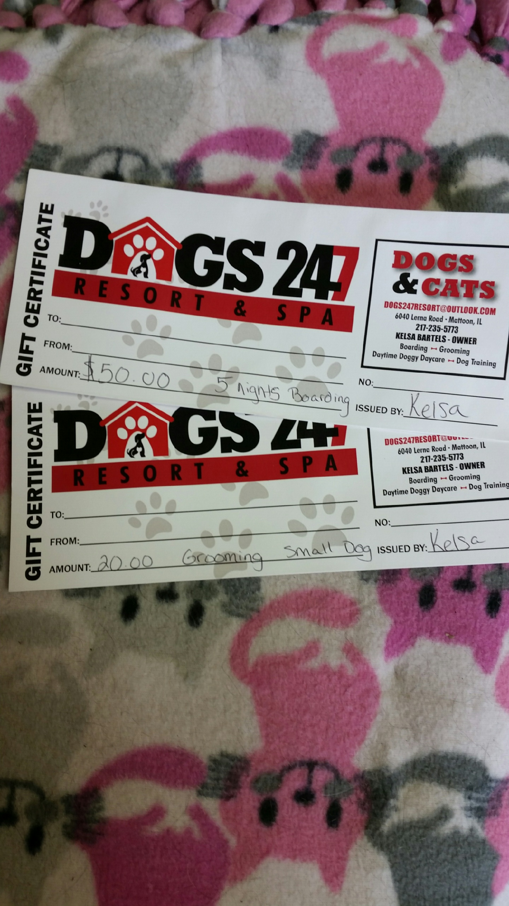

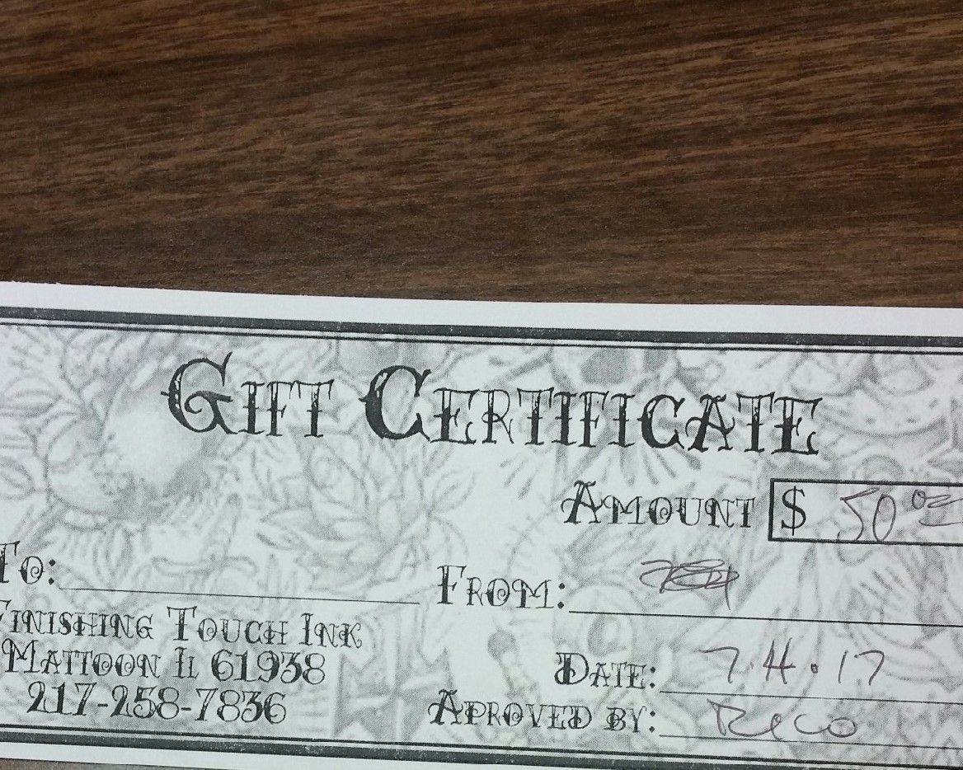

And, more raffle gifts to come!!



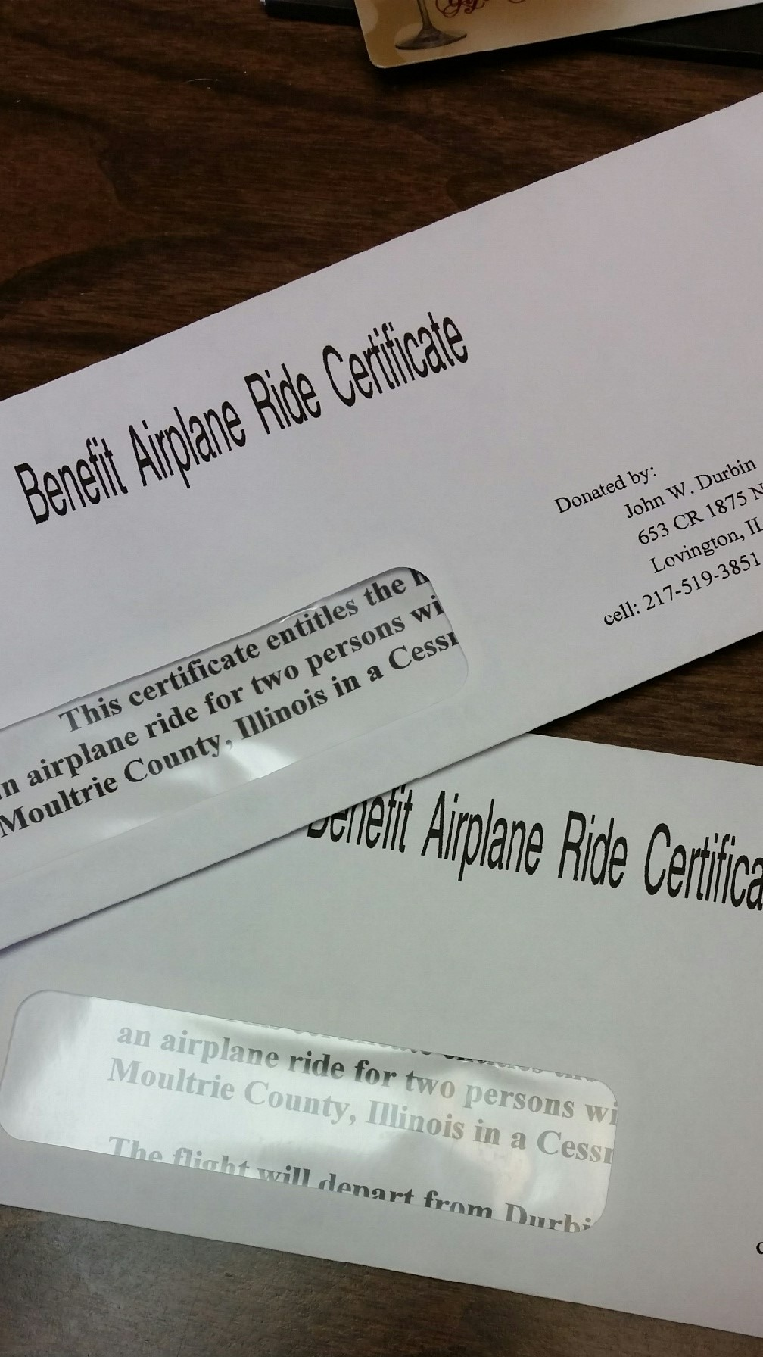

Tickets can be purchased at Titus Manor, 513 N. Worth Street, Sullivan, or by contacting any member of Titus Manor’s staff until September 30th, AND will be sold on Run Day!!

Drawing will be held at the end of our Color Run on Saturday, September 30th. Winners not present during drawing, will be contacted by phone.