Payment options on the bottom of each page of my website:
PayPal, Venmo, Credit & Debit card
(must enter a first and a last name, and $ amount)
www. AnnieNelson.Love
or
pay how you usually do, if you are a regular!
or
scan codes below

PayPal

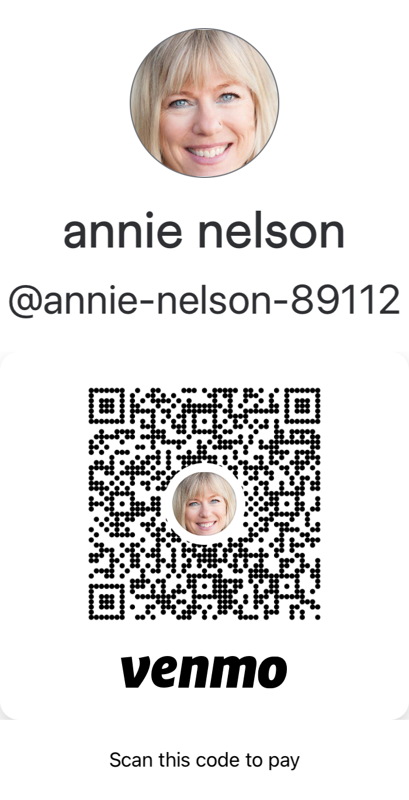
Venmo

