Tampa Catholic High School

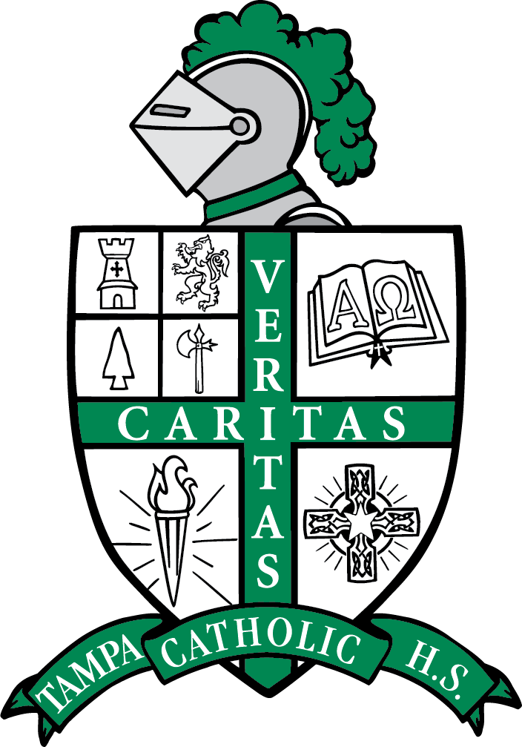

2024 Fall Semester
Principal’s Honor Roll
Grade 9

Lucas Aguerreberry
Aubrey Beauchaine
Salome Chavez
KayleeCloete
Kaytlin Orozco Cole
Ethan D'Angelo
Dominic DeMuro
Andrea Diaz
Ernesto Fernandez
LilianaHaywood
Kylie Heaberlin
Catherine Heilig
Alfred Hernandez
MagdalynnHiggins
Giavanna Lopez
Dayana Medina
Kevin Moraguez
Leah Muha
Teagan Myhre
Victoria Naumowich
Evan Pedersen
Amalia Pineda
Katherine Pinet
Sophia Rivera
John Michael Ruiz
Sloan Saavedra
Mark Samy
Natalia Santana
Ranielle Suspene
Paula Vidal
Hailey Ward

Tampa Catholic High School

2024 Fall Semester
Principal’s Honor Roll
Grade 10

Kensen Angel
Jackson Ausher
Catherine Burchett
Abigail Buyak
Dayelis Canto
Yrene Cestari
Sydney Charboneau
Andrea Doe
Gregory Doyle
Alex Etzkorn
Jackson Frome
Jayden Garcia
Dan Hernandez
Elizaveta Jarrard
Alexis Jay
Mia Loreto
Sofia Micko
Christian Mitchell
Sadella Nguyen
Sophia Photos
Bryce Ranalletta
Vera Reynolds
Olivia Ricciardi
Ava Riggio
Lucas Ruan
Aubrey Rupp
Sofi Do Espirito Santo
Andrew Shellard
Sheila Sorensen
Grace Thomas
Matthew Tra
Isabella Whitcomb

Tampa Catholic High School

2024 Fall Semester
Principal’s Honor Roll
Grade 11

Mila Battaglia
Arianna Black
Dominic Cannizzaro
Gwendolyn Heilig
Drew Henriquez
Maya Lehman
Emma Masters
Avery Michael
Kathryn Miller
Maeve Mooney
Miranda Olivera
Francesca Porricolo
John Rosenberg
Luke Stoughton
Arianna Thomas
Arianna Torres
Maya Traber
Jose Villa

Tampa Catholic High School

2024 Fall Semester
Principal’s Honor Roll
Grade 12

Sofia Aristizabal
Addison Boulnois
Mary Caufman
Alexa Gould
Melanie Keleske
Sydney Lam
Stacy Rodriguez-Liz
Grace Mercado
Nicholas Ranalletta
Mark Anthony Ruiz
Luis Sanchez
Vincent Truong
Delaney Wood

