Tampa Catholic High School

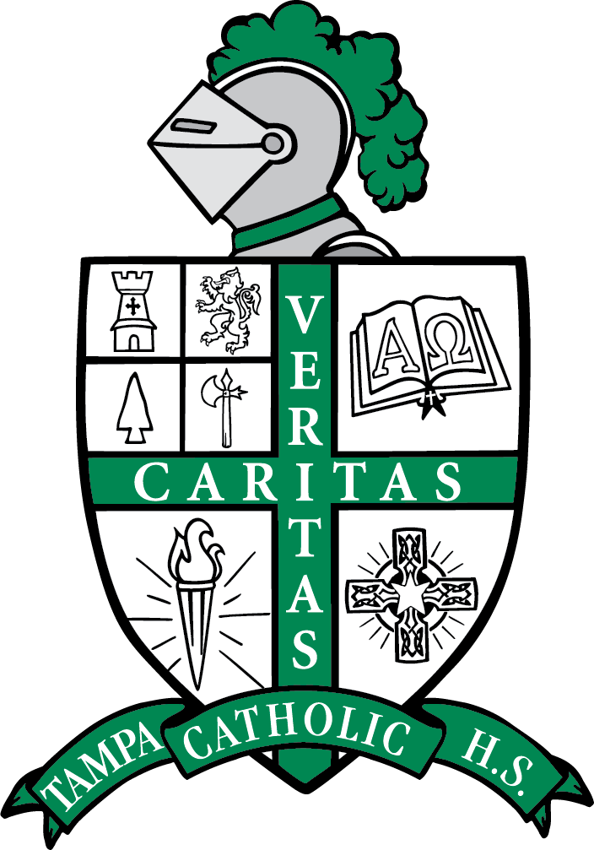

2024 Fall Semester
Honors with Distinction
Grade 9

Vivienne Moll
Yael Arroyo
James Ayule III
Jake Barrett
Aurora Bennett
Noa Bernatovich
Ian Berry
Eastyn Billingsley
Rocco Castro
Nicholas Curbelo
Brandon Fiffe Quintero
Catalina Franklin
Julianna Furones
Samuel Gonzalez
Leah Greenacre
Valeria Gutierrez
Kyler Harrington
Jaime Henshall
Evan Jimenez
Jack Johnson
Kristiana Khoury
Grayson Logsdon
Jackson Lopez
Cassidy McGrogan
Noelle Nalls
Angelyn Norindr
Analisse Paulino
Beckham Pullaro
Diego Quintana
Michael Ramon
Khloe Santana
Carson Thomas
Emma Torres
Gianni Townsend
Zuriela Travieso
Hailey Tyson
Jillian Valladares
Simon Viamonte Alvarez
Hannah Willing

Tampa Catholic High School

2024 Fall Semester
Honors with Distinction
Grade 10

Isabella Abboud
Gabriela Barcelo
Brayden Beauchaine
Mattingly Bendig
Mary Berkowitz
Brenan Bower
Gabriella Brock
Siena Brock
Scarlett Burgos
Kamryn Christy
Delaney Dickerson
Brianna Dunphy
Zahria Dykes
Elaina Edwards
Robert Edwards
Matthew Estrada
Liam Gallagher
Sara Gonzalez
Ariana Goyanes
Morgan Herce
Sophia Heydrich
Ethan Highsmith
Renee Hively
Zoe Karkour
Trey Klinger
Aniella Lavandeira
Luke Ledford
Charley Malouf
Viviana Marrero
Shania Martins
Grace Mendieta
Emerita Muzi
Bryan Neylan
Tatianna Nunez
Gavin Oliveira
Lillian O'Neill
Gianna Patierno
Jonah Phillips
Isabella Rein
Christopher Riker
Kieran Roberts
Monica Romero
Vanessa Saa
Mia Sanchez
Anabella Segui
Michael Serrano
Sadie Sumner
Isabella Torres
Alexandra Tully
Alexander Wilson
Giles Wise
Julia Wood

Tampa Catholic High School

2024 Fall Semester
Honors with Distinction
Grade 11

Amaya Alberdi
Sophia Aljure
Sohan Alla
London Arthur
Analisa Avedikian
Lauren Badertscher
Angelina Banoob
Eden Boutros
Gaizka Bryant
Summer Bryant
Daisy Carrillo
Sophia Castillo
Autum Castro-Sanchioni
Jiselle Chinea
Johannes Cloete
Ellie Collins
Aubrey Creedican
Gabriel D'Angelo
Charlotte Daum
Peyton Fisher
Zachary Freeman
Kaylie Glover
Justin Gomez
Morgan Greaux
Natalie Greenacre
Giavonna Guasp
Isabella Hannant
Aaron Hoyos
John Jackson Jr.
Lizbeth Jimenez
Sophie Lamia
Chelsea Larson
Katherine Martelli
Joly Masoud
Madeline McBride
Andrew Meyer
Liliana Miniet
Angelina Murray
Anna Mushani
Jayden Ostrowski
Joseph Paine
Jeremy Popielarcheck
Ryan Rodriguez
Chatdana Satjaporntape
Nathan Sergomichael
Christian Serralles
Ella Shankman
Christian Shannon
Matthew Suarez
Madyssen Suspene
Daniel Talaat
Grace Tamura
Aislinn Thomas
Paulo Uribe
Wesley Waidler
Noelle Woods
Armando Yanez
Camden Young

Tampa Catholic High School

2024 Fall Semester
Honors with Distinction
Grade 12

EmeliaAlverio
Haley Andux
Gianna Arenas
Dayanne Baldauf Rivera
Gabriella Barranco
Julia Bisesi
Eden Blevins
Lillian Bridges
Lily Brinez
Colby Cannizzaro
Sophia Caruso
Francesca Chillura
Marissa Chillura
Nina Clauberg
Ysabel Cunningham
Cade Davis
Paul Espinosa
Nicholas Estrada
Olivia Farina
Matthew Farkas
Kobey Hall
Garrett Hart
Ryan Hoes
Payton Kelly
Graysen Kemp
Audrey Kopp
Ava Kopp
Karis Louissaint
Mia Medina
Meredith Mendenhall
Fabiana Monasterio
Allie Monsour
Finley Myhre
Mya Petersen
Andrea Poll
Mia Quevedo
Caden Rheaume
Justin Saba
Maya Samy
Molly Smith
Daniel Smythe
Caden Tate
Charlotte Thompson
Katya Tipps
Markus Toomey
Giovanna Townsend
Ana Uzdavinis-Reichard
Noah Wazni
Lexi Wier
Cam'ryn Williamson
Cordelia Wise
Dominic Woodward

