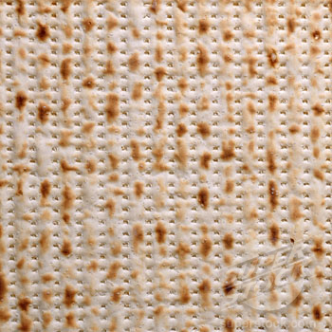
PASSOVER SERVICES SCHEDULE 5778
March 30-April 7, 2018

PASSOVER YOM TOV FIRST DAYS
March 30th, March 31st, April 1st
Erev Pesach, Friday, March 30th
7:15 a.m., Shacharit, followed by siyyum (led by Joel Goldstein) and breakfast
Last time for eating hametz prior to 11:30 a.m.
THERE WILL BE NO EVENING SERVICE ON Friday, March 30th
Saturday, March 31st, Sunday, April 1st
9 a.m., Sanctuary

CHOL HAMOED, INTERMEDIATE DAYS
Monday, April 2nd – Thursday, April 5th
7 a.m., Morning Minyan, Shacharit, Chapel
6 p.m., Evening Minyan, Minha/Maariv, Chapel

PASSOVER, YOM TOV CONCLUDING DAYS
Friday-Saturday, April 6th and April 7th

Friday, April 6th, 7th Day of Passover
9 a.m., Shacharit, Chapel
6 p.m., Minha/Maariv, Chapel

Saturday, April 7th, 8th Day of Passover
8:30 a.m., Sanctuary.
Shir Hashirim will be read.
Yizkor will be part of the Shabbat Morning service.

