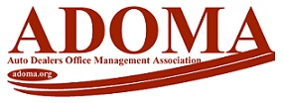

LOLA BELK SCHOLARSHIP FUND
APPLICATION FORM

One Scholarship will be awarded.

Deadline: The application deadline date is FRIDAY, June 7, 2024. The deadline is the date after which applications will no longer be accepted.

Name: Job Title:

Company:

Phone: Email:

# of years at this position: # Years total in industry:

Have you attended an ADOMA Conference before? ___Yes No
Is your company currently a member of ADOMA? ___Yes ___No
On average, how many meetings have you attended in the past 12 months: _____

Items required to be submitted with this application form include:
■ Your two-paragraph essay.
■ A brief letter of nomination from your peer (GM, BM, OM, Dealer or Colleague).

For consideration, email your application form, essay, and letter of nomination to the ADOMA Office at adomaoffice@gmail.com no later than Friday, June 7, 2024.

Questions, email ADOMA at adomaoffice@gmail.com.
appr: 011124

