# 10 Tips for Creating DD Council Annual Reports

See below for some basic tips and best practices for creating and sharing your DD Council annual report.

1. **Keep it simple:** Remember, this document is a summary of the Program Performance Report, not a federal report. The content should be easy to read and understand by all audiences.
2. **Outcomes are important**: Use outcome based content with a brief background description to give the reader context.

3) **More is not always better**: Avoid reporting on everything that happened in the past year, focus on covering a few things. Stakeholders are more likely to read a short report and remember its content. Avoid lengthy or overly detailed reports by including links to additional information.

4) **WOYA: W**rite **o**ut **y**our **a**cronyms and then use parentheses. Since this is a public report, avoid using acronyms without spelling out their meaning. When appropriate, link the acronym to the organization or program’s website so readers can learn more.

5) **Proofread, proofread, proofread!** Recruit Council staff, members or other colleagues to look over the report before posting or sending to print. Fresh eyes make a difference.

6) **Tell the story:** Use success stories collected from grantees to put a face to the great outcomes your Council has achieved. Personal stories from people with developmental disabilities, their families, employers, policymakers and other professionals in the field will help the reader understand the impact that Council related activities have on individuals and the wider community.

7) **“A picture is worth a thousand words.”** When possible, use photographs from Council related activities, events, meetings and conferences. Collect the images throughout the year so they will be handy when it comes time for the annual report. (See example on page 3)

8) **Quick and clear:** Infographics are an abbreviated way to share information and show outcomes. A combination of images, quotes, facts and percentages are used to engage readers and summarize data. (See example on page 3)

9) **Formats and accessibility:** Evaluate your state/territory individual needs with regard to culture and linguistic competence, formats and accessibility. Do you have a language access plan that includes strategies for creating and disseminating the annual report?

* Does your publication offer an alternative formats blurb? For example, “*This report is available in alternative formats or languages upon request.”* (Don’t forget to offer contact information with an email and phone number for those who do not use or have access to the internet and email.)
* Try a video format to share the annual report. Recruit a Council staffer or member to create a video of them explaining the highlights of your annual report. Don’t forget the captions.
* Utilize an interactive web-page with images and links to more information, for example, see the [Georgia Council on Developmental Disabilities 2016 Annual Report.](https://gcdd.org/gcdd-2016-annual-report.html)
* Prezi is a dynamic way to share the annual report. See the [Oregon Council on Developmental Disabilities Semi-Annual Report](https://gcdd.org/gcdd-2016-annual-report.html).
* Use a chart to display Council investments. (See investment chart below)
* If posting a PDF or Word version of your annual report to your website, ensure the documents are accessible to people who use screen readers.
* Snail mail: Utilize hard copy list-serves for populations that do not have access to the internet. If feasible, send a link or a hard copy of your annual report to NACDD and AIDD as well as your grantees, stakeholders and colleagues. We all want to know about your great work!

10) **Do not stop here!** Visit DD Council websites and search for annual reports to gather additional ideas for organization, layout and design.

**INVESTMENT CHART**MD Developmental Disabilities Council

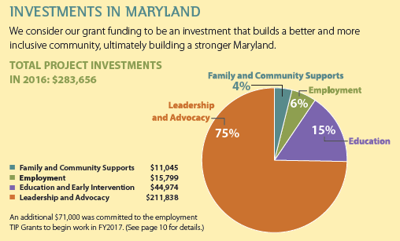

**INFOGRAPHIC**GA Council on Developmental Disabilities  
A chart from the GA Devleopmental Disabilities Council showing the number of students who participated in the ASPIRE program. 

**PHOTO  
Council activity: Take Your Legislator to Work Day**WI Board for People with Developmental Disabilities

