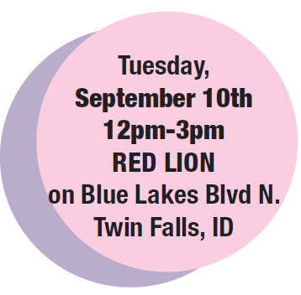

INSTRUCTIONS: Tab through gray boxes to fill in information & email back to: employ@magicvalley.com

Name of Business
Mailing Address City State Zip
Phone Email
Web Address Contact Person

RESERVE BOOTH SPACE FOR: (All booths Include: 8’ table/table cloth, 2 chairs
Setup begins at 11am (all booths must remain open until 3pm).
NO product of sales permitted

Pick Package(s)
Basic PKG ($599) (Includes: booth, 2x6 FC ad, Interactive video, & float bar)

Sponsorship PKG ($850) (Includes: Booth, 2x6 FC ad, interactive Video, 24 Hr
Reveal online ad, Email Blast)

EARLY BIRD Special: Reserve your space and submit application/waiver by
August 15, 2019 and receive a Free 2x4 Full color print ad
to run the following week of the event.

Both Space only (no promotional ads) AND NON-PROFIT
Booths Space only ($399) Booth Space for non-profit ($299)
(Must be 501(c)3 recognized)

CHOOSE YOUR SPACE
Choose top 3 booth choices from attached layout?

Electricity: YES NO (*Bring own extension cords)

PAYMENT METHODS REQUIRED TO HOLD BOOTH SPACE

Bill my Times News Account Card (Rep will call for card number)

*REQUIRED INFORMATION: this information will be used in your print & online advertisements included with your booth space package, Campaigns may promote the event and/or your current open positions you are recruiting for:

*Provide Brief Booth Description (Including signage, boards, offers etc.)

*Open Positions: for promotional advertising tell us what positions you have open?

*Company Profile: For promotional advertising tell us about your company?

*Job Online Links: Links to see job descriptions and/application or resume submissions?
RESERVATION DEADLINES:
Early Bird Deadline: August 15
Print deadline for Magic Valley Messenger: Wednesday August 29
Print Deadline for Times News: Wednesday September 4
Final Booth Reservation Deadline: Thursday September 5

