If you do not have login information already please contact the office via email (ankenyccdoc@gmail.com) to get your information.
If you do not want to use the CTRN app on your phone for the directory you can use the web address below to access it as well.
https://accdoc.ctrn.co/directory/index.php

How To Find the App:
Step 1
Go to either your App Store or Google Playstore
Step 2
Search Online Member Directory
Step 3
Download the app (see the photo for what it will look like to make sure you have the correct app)
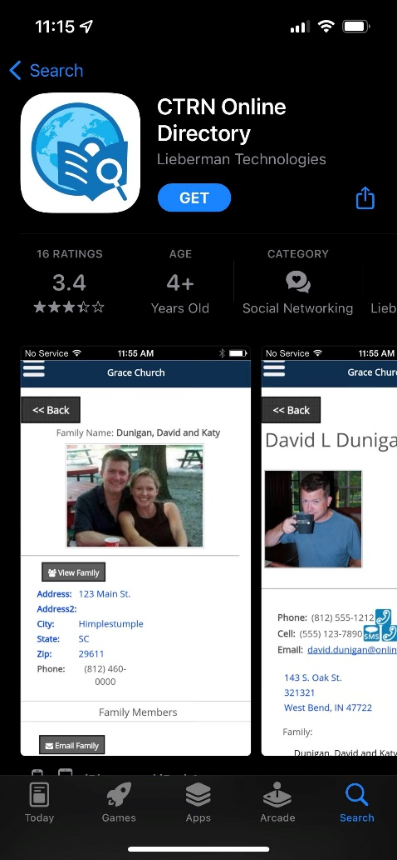
Step 4
After the app has finished downloading on to your phone you will choose your notification settings if on an iphone. Then choose the “Add New Directory” button
Step 5
It will ask for a mobile code. Our Mobile Code is ACCDOC
Click Submit
Step 6
Click on Ankeny Christian Church
Step 7
Enter your username and password
Step 8 (optional)
Click the Remember Me box
Step 9
Click Submit

You are now in the Church Directory. If you have any issues please do not hesitate to reach out to Kasey in the office. Thank You!

