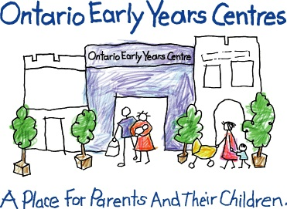

**150 Queen St. S., Bolton, ON L7E 1E3 giving@cp-cc.org | www.cp-cc.org**

**Charitable Registration # 12353 8050 RR 0001**

I would like to make a donation of: ❑ $20 ❑ $50 ❑ $75 ❑ $100 ❑ $200 ❑ Other: _________________________

My donation is payable by: ❑ Cash ❑ Cheque (payable to the Caledon Parent-Child Centre)

**Name:** ❑ Miss ❑ Mr. ❑ Mrs. ❑ Ms. ❑ Dr. **First: ______________________________ Last: _________________________**

**Address: ________________________________________________________________ City: ____________________________**

**Postal Code: _______________________ Phone: _____________________ Email: _____________________________**

***Date:***

***Please dedicate this donation:***

**❑ as a gift in memory of:** _ ____________________ **Please send Notice of Memorial gift to:** _ ____________  
**Address:** _ ­_city: _ postal code: _

**❑ as a gift in celebration of:** _ _ **Please send notification of the gift to:** _ ___________________ ­_

**Address:** _ ___ ­_ city: postal code: _

*Tax receipts will be issued for gifts of $20 and above unless otherwise specified.*

* *By providing your email address you acknowledge your understanding that we will periodically send you communications highlighting our programs and initiatives;*
* *Occasionally, we share a list of our supporters with the public. Should you wish to be removed from this list, call us at 905-857-0090.*

Thank you for your support!

February is “Love Your Centre” Month

**Make your tax deductible donation today...**

**Client Compliments**