Graham Swamp Lehigh Canal Trail ride
Join the St Johns River to Sea Loop Alliance
Saturday, November 29th at 8AM
Casual Trail ride featuring the new trail bridge spanning route 100 in Flagler
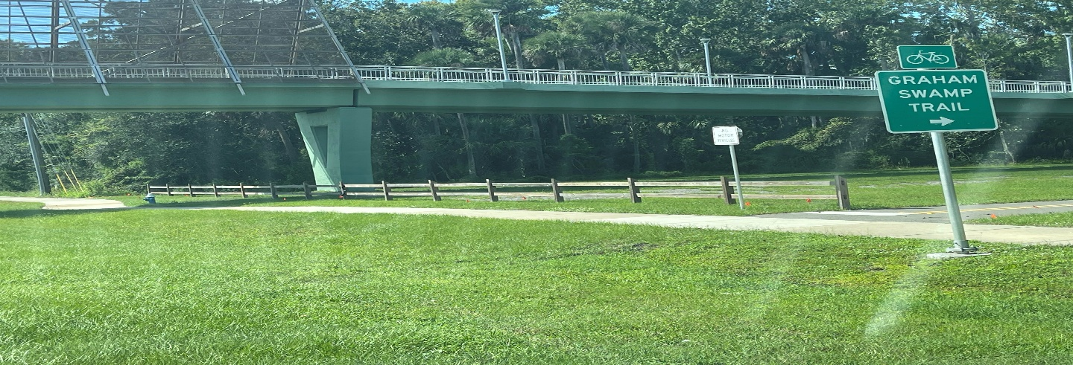
No pace lines for this ride! The start will be in The South West corner of the at the intersection of route 100 and Old Kings road (Winn Dixie parking lot) in Flagler county. Take side walk to trail bridge crossing over route 100 to Graham Swamp and Lehigh Canal Trails for an out and back loop. 19 miles total round trip. This is a social paced ride, to see one of the newest trails in Flagler. This is a free event. Water & Snack at the start. Register at https://river2sealoop.org/event-registration/
