Pre-Turkey Trot 5K Walk/Run
Join the St Johns River to Sea Loop Alliance
Saturday, November 22, 2025 at 8AM
Beresford Lake Park Trail 2100 Fatio Rd, DeLand, FL 32720
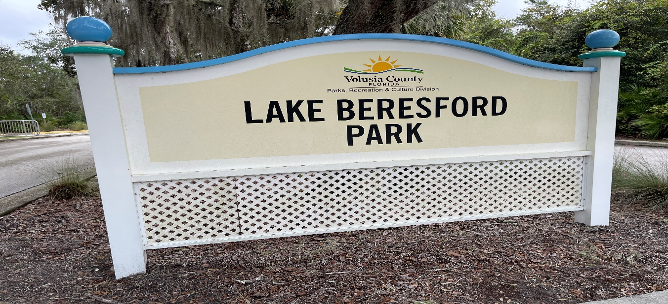
Get outside and enjoy the crisp fall air and the magic of the Trail!!
This is a free event. A self-timed out and back course. Water & Snack stations at the start/finish and turn around point. Sign in at the pavilion next to the trail. Register here https://river2sealoop.org/event-registration/ 