2016 CASA Education Foundation Scholarship Recipients

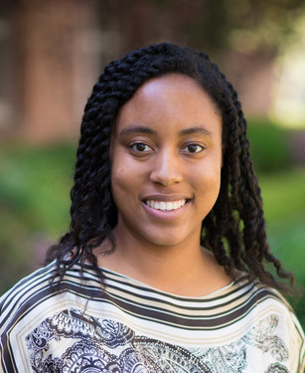 | Cheyanne Harris recently completed her junior year at the University of the Pacific. Cheyanne is a member of the National Society of Black Engineers, the American Society of Civil Engineers, and CWEA’s Student and Young Professionals Committee. Honors include UOP’s Dean's Honor Roll, Tau Beta Pi (Engineering Honor Society), Schwab-Rosenbouse scholar, and others. Cheyanne is currently an intern at Central Contra Costa Sanitary District. She intends to work as a civil engineer in the area of wastewater treatment and aspires to work on projects.
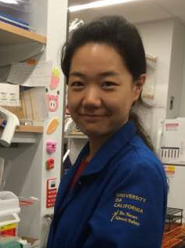 | Shu Zhang is a graduate student at UCLA, completing a Ph.D. program in civil and environmental engineering. Shu is a member of the Society of Women Engineers and UCLA’s Engineering Graduate Students Association. Honors include the Peking University Award for Academic Excellence, third prize for student research from Shell Energy and Sustainable Development, and Tianjin University Dean’s Award for Academic Excellence. Shu’s goals are to provide novel scientific knowledge and develop practical and effective technologies to solve environmental problems facing modern society.
 | Trenton Saunders recently completed his junior year at UCLA, majoring in civil engineering with a minor in environmental engineering. Trenton has been accepted into the summer 2016 UCI-Water PIRE: UPP Down Under Research Program. He is a member of Chi Epsilon (civil engineering honor society) and the Henry Samueli School of Engineering and Applied Science. He is the recipient of an AWWA southern California scholarship and Alumni of the Aaron Price Fellowship program. Trenton is on a path to becoming an urban water resource engineer and plans on attending graduate school with a focus in water resource engineering. He is looking to carry research related to advanced tertiary filtration for potable wastewater reclamation that he knows can turn the “waste” of today into a consumable product of the future.
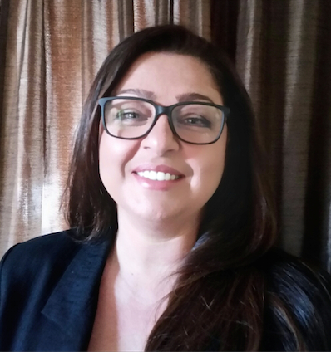 | Reem Nabwani Habib holds an undergraduate degree in architecture and is currently a second-year master’s student in civil engineering/urban planning at U.C. Irvine, projected to graduate in the fall of 2016. Honors include 2nd place in an engineering competition for USDOE Solar Decathlon, the Jean Roth Dirskel Award for Academic Excellence, and others. Reem is writing her master’s thesis on the impact of water policy on small agricultural communities in developing countries already stressed for water. She believes that the world can benefit from knowing the experience of California and its neighbors with regard to provision of water, negotiation of water rights, and best management practices to help alleviate water scarcity and improve water quality.

