
The Commonwealth of Massachusetts
Operational Services Division
Office of Vehicle Management

E-ZPass MA Transponder Info

Mounting Your E-ZPass MA Transponder:
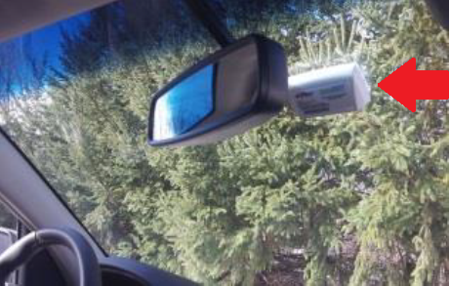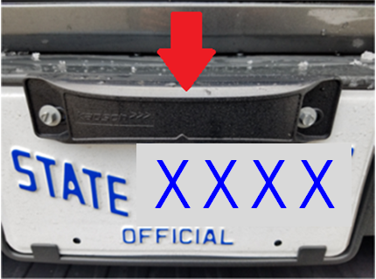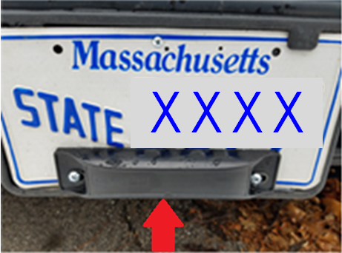
Interior transponders must be mounted to the windshield, just to the right of the arm holding the rear view mirror and below any tinting. Ensure the arrows on the transponder are pointing upward. Situate the transponder under any tinting, peel back the plastic film on the fastener strips and attach it to a clean, dry windshield. Installing the transponder on top of window tinting, or holding it while driving, will make it more difficult to get an accurate toll read, which may result in higher toll charges and additional fees.

Exterior transponders can be fastened to the front license plate using the existing mounting bolts and the knock-out holes on your transponder. Identify the flat side of the transponder – this side should face inward to your vehicle. Remember to tighten the bolts securely.
Note: Your license plate exterior transponder should be attached to the center of the front bumper, even if your license plate is in a different location.

Transporting a Vehicle (e.g. Towing a Disabled Vehicle):
A transponder that has not been removed from a disabled vehicle, to prevent it from reading, will incur a toll.

Useful Life of a Transponder:
Typically E-Z Pass transponders have a life of about 10 years. Specifically, it’s the battery inside that wears out after about 10 years and since the entire device is sealed, the battery cannot be easily replaced.

Defective E-ZPass transponders must be brought or sent to a Customer Service Center for testing and evaluation. At the discretion of MassDOT, defective E-ZPass transponders may be replaced free of charge. If the E-ZPass transponder shows signs of misuse or abuse, drivers will be required to pay a fee.

Agencies are responsible for any costs associated with any and all uses of the E-ZPass transponder(s) assigned to their account(s).

Returning a Transponder:
If a transponder is no longer required, it should be mailed back to the address on the device. Be sure to mail it back in the foil bag it came in, or wrap it in household aluminum foil. Alternately, it can be dropped off at a Customer Service Center. Note: If the returned transponder is damaged or defaced, a fee will be assessed.

Use this link to see all current E-ZPass MA Customer Service Centers.

