2018 Vestry Nominees
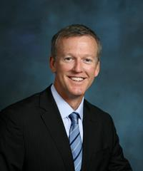
Dennis Carr
Dennis and his wife Erin moved to Tampa from Atlanta in 1999 and have attended St. John’s for over nine years. Dennis was born in Jacksonville and raised as a Catholic in the Tampa area where he graduated from Jesuit High School. He was confirmed in the Episcopal Church in 2010. Dennis has been an usher since his confirmation, has served on the Building and Grounds Committee, and has volunteered for several Outreach efforts, including the Annual Giving Tree.

Dennis earned a Bachelor’s degree from the School of Architecture at Auburn University. He is a licensed architect in the State of Florida, a LEED Accredited Professional, and founding principal of Elevation Architecture. Dennis has served on Tampa Downtown Partnership’s Planning & Management Committee, designed homes for Habitat for Humanity, and volunteered at St. Joseph’s Children’s Hospital and the Humane Society of Tampa Bay. He is a devoted college football fan, avid runner, and enjoys fishing in his free time.

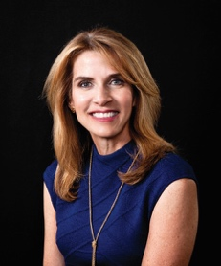
Denise Cassedy
Our family started attending St. John’s in 1994, and Fr. Peterson married my husband and me in 1995. All three of my children, Cameron (29) Katie (20) and Carolina (18) attended St. John’s Parish Day School as well as church. They served as acolytes until they went to college. In addition, Katie was very active in youth group and bible studies for many years.

With St. John’s, I canvassed for the annual campaign, drove and volunteered for the Angel Tree party, and hosted sandwich Sundays. In addition, I have served on the School’s Parent Club Board and have chaired numerous committees.

Currently, I am President of Davis Islands Civic Association, past Sustainer President of The Junior League of Tampa, and am enjoying my thirteenth year chairing the Girl Scout Sweetheart Dance. I also am part of the Mary Lee’s House Ladies Auxiliary. I am a competitive sailor at Davis Island Yacht Club and Kinsale Yacht Club.

I graduated with an accounting degree from University College Cork and received an MBA from USF. From there I started a financial services career in London with Yamaichi Securities and later continued with Raymond James and Cassedy Financial Group.

St. John’s has been a wonderful, nurturing environment for my faith and has played an important role in my life. It has sustained me through life’s ups and downs and has provided amazing strength for me. I would be honored to give back and be on the vestry.

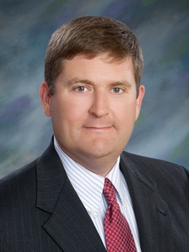
Carleton Compton
Carleton is a 4th generation Tampa native, raised in Hyde Park United Methodist Church. He is a graduate of HB Plant High School (’95) and went on to get his degree in finance from the University of Alabama. Carleton met his wife Anne in Tuscaloosa and later married in 2002 at St. Paul’s Episcopal Church in Mobile, AL. As they settled in Tampa as newlyweds, they began their quest in finding a church home, frequently attending St. John’s. In 2007, Carleton and Anne became members and Carleton was later confirmed at St. John’s. They also have two children: Kathryn Mitchell (10 in January) and Davis (6).

Carleton currently serves on the Fathers Ministry which holds/assist several events throughout the year such as: Shrove Tuesday Pancake Supper, Parish Picnic, Dayspring Event, Canoe Trip, Camping and other events throughout the year.

Outside of the Church, Carleton is an active member in the community in which he lives. He served on the Board of Directors for the Children’s Cancer Center for over 12 years, where he previously held the Chairman position. He has also been involved with the Greater Tampa Bay Area Council for Boy Scouts where he served on the Sporting Clays Committee and is the former President of the local University of Alabama Alumni Association.

Professionally, Carleton is Vice President of Brokerage for Equity, LLC., specializing in corporate real estate services to the healthcare sector. Based in Equity’s Tampa office, Carleton is the go-to agent in the Greater Tampa Bay market for all healthcare-related real estate services. He is also a member of the CCIM Institute and currently holds a position on the local Chapter Board as Chairman of the Events Committee.

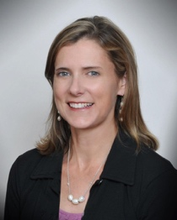
Kim French
St. John’s parishioners for more than 16 years, Kim and her husband Stephen have two children—Virginia “Bradley” (St. John’s alumna and Robinson High School IB senior) and Emerson “Carter” (St. John’s 8th grader). The St. John’s Church and School community has been a constant blessing in their lives since moving to Tampa in 2001.
At St. John’s, Kim has served as a Sunday School teacher, Outreach Committee member, coordinator for The Circle, Parish Life Commission member, Youth Program helper, and teller for Vestry Elections.
In the community, she has served on the boards for the St. John’s Episcopal School Parents’ Club, Robinson High School Foundation, and The Junior League of Tampa, as well as in leadership roles with the Girl Scouts of West Central Florida, Washington & Lee University Alumni Association, Guardian Ad Litem of Polk County, and Amaryllis Garden Circle.
An Atlanta native, Kim graduated from Washington & Lee in 1994 and built a career in marketing, advertising and public relations. She currently works as a communications consultant and copywriter with Publix Super Markets, Hillsborough Community College, and other clients. Her hobbies include tennis, travel, and outdoor time with family.
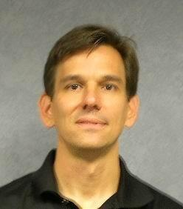
Lockwood Gray
Lockwood is a 5th generation native Floridian from the panhandle. He grew up in Pensacola, being baptized and confirmed in the Episcopal Church at Christ Church Parish. He is a graduate of the University of Florida College of Business, Stetson University College of Law, and the University of Florida Graduate Tax Program. Lockwood and his wife, Shannon, have been attending St. John’s for almost 20 years and were married in the Church in 2001.

Lockwood’s involvement at St. John’s includes participating in the Fathers ministry, annually serving as a host family of Sandwich Sunday, and recently co-chairing the Every Member Canvass in both 2016 and 2017.
Professionally, after moving to Tampa in 1994, Lockwood spent 6 years in private practice with the law firm of Annis, Mitchell, Cockey, Edwards & Roehn before moving to a position of in-house counsel with GATX Financial Corporation. For the past 12 years, Lockwood has been Associate General Counsel of PODS.
Lockwood and Shannon have been blessed with two daughters, Sophia (age 12) and Olivia (age 10) both of whom were baptized at St. John’s and have been active in the children’s ministries since kindergarten. Sophia started acolyting last year.

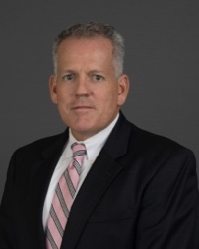
Greg Hearing
Greg is married to Kamra and they have four boys who have graduated or are still attending St. John’s Episcopal Parish Day School. Greg grew up in Tampa and has attended St. John’s Church since 1972, serving in the choir for six years. He graduated from St. John’s in 1978 and, after graduating law school, has been an active member of St. John’s through his service as Vice-Chancellor of the Tampa Deanery for the Episcopal Diocese of Southwest Florida for over 25 years, service as a member of the School’s Board of Trustees, including serving as its Chair for several years. Greg is also a lector and occasionally an usher.

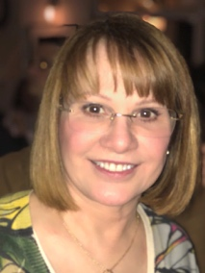
Nancy Watkins
Nancy Watkins first attended a service at St. John’s in December 1969 while visiting Tampa relatives. She moved to Tampa with her parents in 1971 and joined St. John’s at that time. She is a graduate of H.B. Plant High School and the University of South Florida, where she earned a degree in Business Administration with a major in Accounting.

Nancy and her husband Robert were married at St. John’s in 1980. They are both CPAs and have worked together at Robert Watkins & Company since its founding, also in 1980. They have two grown sons, Richard and Michael, who were both baptized at St. John’s. Both boys attended all 10 years of their primary schooling at St. John Parish Day School. Richard was also married at St. John’s in 2012.

Nancy returned to active participation in St. John’s several years ago and appreciates the opportunity to continue to be of service and contribute to our church family. She currently serves with the pastoral care team and is honored to be considered to serve as a member of the Vestry. While she normally attends the 8:00 a.m. service, she enjoys attending the 11:15 a.m. also.

Nancy serves as a member of the Board of Trustees of the University of South Florida. She is also a Professional Registered Parliamentarian and serves as State Parliamentarian for the Florida Society Daughters of the American Revolution and several other statewide organizations.

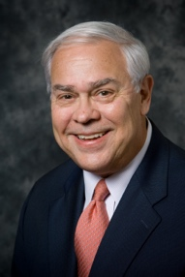
Bob Yelverton
Dr. Robert W. Yelverton and his wife Carolyn have been communicants of the Episcopal faith since 1963 and members of St. John’s Church since 1971. Their three children, Ann Kelly, Mary Rush and Bo have all attended St. John’s Episcopal Parish Day School. He has served on the School Advisory Committee and currently serves as an usher at the early church service.

Dr. Yelverton graduated from the University of Mississippi with a B.S/BA in degree and his M.D at the University of Mississippi School of Medicine in 1967, completing his internship and residency at that facility. In 1971, he relocated to Tampa, serving two years as Chief of the Dept. Ob/Gyn at the US Air Force Regional Hospital, MacDill Air Force Base. He began private practice of Ob/Gyn in 1973. In 1998 became Charter President, CEO, and recently retired as the Chief Medical Officer of Women’s Care Florida, a large single specialty group in Central Florida. He continues to serve that organization in many capacities including clinical quality and safety monitoring and government relations.

Professionally, Dr. Yelverton is past president of the Florida and Tampa Obstetric/Gynecologic Societies and Hillsborough County Medical Association. He serves as Chair of the Medical Advisory Committee for the Florida Birth-Related Neurological Injury Compensation Association, is a committee member of the Florida Pregnancy Associated Maternal Mortality Review Committee, member of the Hillsborough County Healthy Start Board and chairs the Hillsborough County Fetal Infant Mortality Review Committee. Dr. Yelverton served as faculty for many American Collage of Obstetrics and Gynecology (ACOG) sponsored seminars on quality management, medical staff leadership and practice management. He served nationally on the ACOG Task Force and Committee on Quality Assurance, as a Voluntary Review of Quality Care Team Leader, on the Committee on Practice Standards, chaired the Committee on Primary Care, and was Vice Chair of the Task Force on Changing Practice in the 21st Century. Recently he was elected to the ACOG National Executive Board and received the national ACOG Leadership Recognition Award.

Dr. Yelverton has served the Tampa community as board member and Chairman of the Berkeley Prep School Board of Directors, the St. Joseph Hospital Board of Directors, and the Board of Trustees of the St. Joseph’s/Bay Care Foundation. He has volunteered at the Judeo Christian Clinic where he has served as board member and director of gynecological services since 2003.

