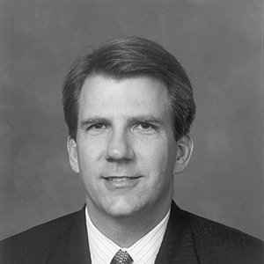

Doug Arthur

Doug first joined St John’s when he moved to Tampa with his parents in 1979. He graduated Plant High School in 1981 and moved to Chapel Hill to attend the University of North Carolina. After graduating with a degree in Economics, he moved to Atlanta to work in the financial services industry and made All Saints Episcopal Church his church home. Doug returned to Tampa in 1999, where he once again joined St John’s. Doug married Suzanne Emery in 2006 and they have two daughters Caroline (9) and Kate (8). Doug’s involvement at St John’s include actively participating in the Fathers and children’s ministry as well as recently co-chairing the Every Member Canvass in 2014 and 2015.

Professionally, Doug has spent his career in financial services with a large segment of it at The Bank of Tampa. Doug presently works for Gries Investment Funds, a specialty finance group, located in the Westshore business district.

Doug is also active in the community. His civic work presently includes serving as Treasurer for the Tampa Metro Area YMCA and Vice Chair for Gracepoint, a behavior health organization. Doug has served on several other civic boards that work primarily with child and youth development.

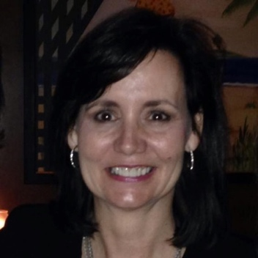

Heddy Murphey Brown

Heddy Brown was born and raised in Tampa and is a graduate of St. John’s School, Plant High School, and Vanderbilt University. Her professional experience is in marketing, newspaper reporting, and free-lance writing. She is involved in the Tampa Bay community through philanthropic work as president of the Sumter L. Lowry Foundation and the Lowry Murphey Family Foundation. In addition, she serves on the Parent Leadership Council of Samford University in Birmingham, Alabama.

Heddy and her husband, Andy Brown, an attorney, have three grown daughters: Ann Lowry, Ellie, and Emmala, all of whom graduated from St. John’s School and two of whom served as acolytes. While raising their daughters in the 1990s and 2000s, Heddy and Andy were involved in various church ministries including teaching Sunday School, Vacation Bible School, and working on Every Member Canvass campaigns. In addition, they each served previously on the Vestry. Heddy served on the St. John’s School Board of Trustees in the early 2000s, during which time she chaired the School’s annual giving campaign and served on a search committee for a new Headmaster.

She currently serves as a Lay Eucharistic Visitor, a deeply meaningful experience she has enjoyed for six years. Andy is currently a Lay Reader and Chalice-Bearer. Heddy is grateful for her lifelong affiliation with St. John’s Church and School and for her family’s unique experience of sharing Christian fellowship here for several generations.

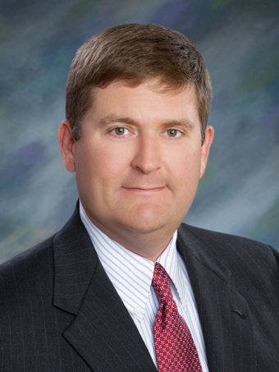

Carleton Compton

Carleton is a fourth-generation Tampa native, raised in Hyde Park United Methodist Church. He is a graduate of HB Plant High School (’95) and went on to get his degree in Finance from the University of Alabama. Carleton met his wife Anne in Tuscaloosa and later married in 2002 at St. Paul’s Episcopal Church in Mobile, AL. As they settled in Tampa as newlyweds, they began their quest to find a church home, frequently attending St. John’s. In 2007, Carleton and Anne became members and Carleton was later confirmed at St. John’s.

Carleton currently serves on the Fathers Ministry which holds/assists with several events throughout the year such as: Shrove Tuesday Pancake Supper, Parish Picnic, Dayspring Parish Retreat, Canoe Trip, Camping Trip, and most recently civic duties at Metropolitan Ministries and the holiday mail event for veterans.

Outside of the church, Carleton is an active member in the community in which he lives. He served on the Board of Directors for the Children’s Cancer Center for over 12 years, and held the position of Chairman. He has also been involved with the Greater Tampa Bay Area Council for Boy Scouts where he served on the Sporting Clays Committee, and is the former President of the local University of Alabama Alumni Association.

Professionally, Carleton is Vice President of Brokerage for Equity, Inc., specializing in corporate real estate services to the healthcare sector. Based in Equity’s Tampa office, Carleton is the go-to agent in the Greater Tampa Bay market for all healthcare-related real estate services. Carleton is also a member of the CCIM Institute and currently holds a position on the local Chapter Board as Chairman of the Sponsorship Committee.

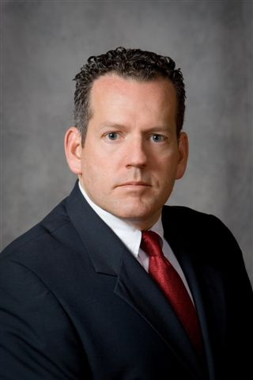

Gregory A. Hearing

Greg is married to Kamra and they have four boys who have graduated or are still attending St. John’s Episcopal Parish Day School. Greg grew up in Tampa and has attended St. John’s Church since 1972, serving in the choir for six years. He graduated from St. John’s in 1978 and, after graduating law school, has been an active member of St. John’s serving as a lector and usher.

Greg has served the Diocese of Southwest Florida as the Chair of its Resolutions Committee for the past several years, and has served as Vice-Chancellor of the Tampa Deanery for over 25 years as well as one of the Diocese’s Trustees to The University of the South since 2012. Greg has also served as a long-time member of our parish School’s Board of Trustees, most recently as its Chair for the 2014-2015 and 2015-2016 school years. Greg has particularly enjoyed his work as a Vice-Chancellor and representing the Diocese as a Trustee of The University of the South.

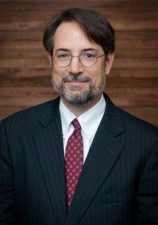

Stephen Leal

A native of Tampa, Stephen has been a member of St. John's since 1994. He is a graduate of The Berkeley Preparatory School, Florida State University, and Stetson University College of Law.

Stephen served as an Assistant State Attorney in the Hillsborough County State Attorney's Office for six years before leaving to start his own office, Stephen A. Leal, P.A., where he practiced for thirteen years. In 2013 he joined the Law Firm of McIntyre, Thanasides, Bringgold, Elliott, Grimaldi & Guito, where he currently handles criminal, family, and traffic law matters.

Stephen has served as head usher for St. John's for the past ten years. In addition to serving as an usher he has in the past taught children's Sunday school. He has been ridiculously fortunate to have been married for 22 years to his amazing wife Lisa, who serves as a lay reader, chalice bearer, and Altar Guild member. Stephen and Lisa are blessed with a wonderful son, Grayson, (age 16) who serves at St. John's as an acolyte and chalice bearer.

Stephen would consider it an honor and privilege to serve his church family as a member of St. John's Vestry.

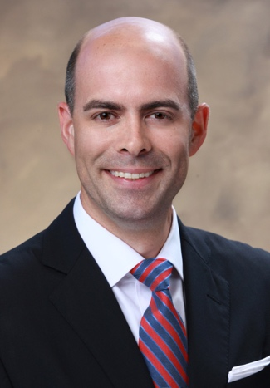

Ned Roberts

Ned Roberts and his family have made St. John’s their spiritual home since moving to Tampa in 2000. He is active in the Fathers Ministry and leads the annual Spring Family Retreat.

A native of Boston, Massachusetts, Ned grew up attending two icons of the Episcopal Church – Old North (think “one if by land, two if by sea”) and Trinity.

Ned received his Bachelor’s of Science degree in Journalism from Northwestern University’s Medill School. An earlier career as a broadcast journalist brought him to Tampa, where he was an AP, Edward R. Murrow, and Emmy Award-winning reporter for the Tampa Bay area’s CBS affiliate, WTSP-TV. Since 2005 Ned has worked in the field of commercial real estate. He currently works with brokerage firm Marcus & Millichap, where he is focused on multifamily investment sales.

Ned is married to Michelle Roberts and they have two children, Finley (8) and Georgia (4), who are both enthusiastic participants in St. John’s Sunday School program.

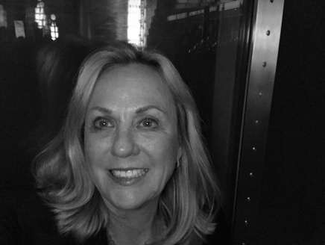

Dottie Webster

Dottie Webster, also known as Dottie Towne, has been a member of St. John’s for over twenty-five years. Born and raised in Tarpon Springs, Dottie attended All Saints’ Episcopal Church, where Bishop Hardgrave confirmed her in 1968.

Dottie previously served on the St. John’s Vestry from 2007 to 2010. She regards that time as one of the most rewarding and enlightening experiences in her time as a member of St. John’s Church. As a Vestry member, Dottie served on the Worship Commission that included Music Ministries, Choir and Liturgical Ministries, Altar Guild, Acolytes, and Lay Eucharistic Ministers. She spearheaded the committee for the fundraising for the church organ renovation and repairs. Additionally, Dottie assisted with the formation of the St. John’s Cookbook Committee in 2009. The funds raised from the sales of the cookbooks went toward the purchase of new vestments for the choir and the acolytes.

Prior to serving on the Vestry, Dottie was active in several ministries at St. John’s. She served as a Canvass Captain for Every Member Canvas, was a part of the mission teams to the Dominican Republic, and served as part of the Christian Education program under Flossie Adams, teaching Sunday school to the preschool age group. Dottie was also active in the Mother’s Ministry program, and in the ministry for parents of young children.

Dottie married Dave Webster in 1992. Their two children, John and Susan, were baptized at St. John’s. Currently, David serves as a Lay Eucharistic Minister and Dottie serves on the Flower Guild. She and David have also assisted with St. John’s Youth Group activities.

Their son John Webster is in his second year of law school at Stetson in Gulfport, FL. This past summer, John was commissioned as 2nd Lieutenant in the US Marine Corps after completing ten weeks of Officer Candidate School in Quantico, Virginia. He served as an acolyte at St. John’s for several years before he left Tampa to attend college.

Their daughter Susan Webster was a member of St. John’s Choir of Girls for many years before she left to attend the University of Florida. Susan is currently pursuing her Master’s Degree at the University of Florida and serving as Student Body President.

Dottie’s son, Joey Towne, sang in the Choir of Men and Boys for seven years under the direction of Ellie Taylor. Joey and his wife Taira live in Windermere, FL with their two children Clara Margaret, age 2, and Lucy, born Oct. 3, 2016.

Dottie is a graduate of the University of Florida and Stetson College of Law. She is in private practice as a solo practitioner and has her law practice on Davis Islands.

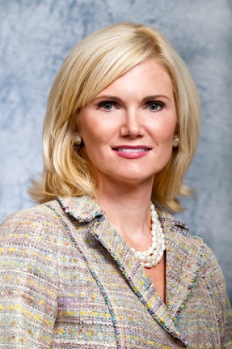

India Witte

India and her husband David have attended St. John’s since moving to Tampa in 1998, and became members of St. John’s Parish upon their confirmation by Bishop Lipscomb in 2002. They have found their Episcopal walk a perfect blend and compromise between India’s Protestant upbringing and David’s Catholic faith, and are pleased to have established such a strong church home for their family. Both of their children, Ingalls (12) and Tucker (10), were baptized at St. John’s, and are active members of both the church and school communities, having attended the Parish Day School since pre-K. During her eighteen years at St. John’s, India has been active in numerous school and Parish programs and ministries, including serving as a leader of The Circle, teaching Sunday School, and serving as a volunteer for the Angel Tree project, Every Member Canvass, and Newborn Ministry. She has served on the School’s Parents’ Club Board, and has chaired numerous committees, including varied leadership roles with the school’s Celebratio annual fundraiser, and chaired Admissions Open House for two years.

India graduated from Florida State University with a degree in English literature, and has worked for almost twenty years in the non-profit management and major gift fundraising arena. India currently serves as the Senior Director of Foundation Board Relations for the USF Foundation and Executive Director of USF’s impactful Women in Leadership & Philanthropy program. India is deeply committed to civic engagement and volunteerism and has served our community in a variety of leadership roles in diverse organizations. She currently serves as Chair of the Hillsborough County Commission on the Status of Women, is on the Board of the Florida Commission on the Status of Women Foundation, and is a member of Leadership Tampa Alumni, the Athena Society, Women in Executive Leadership (WEL), the Henry B. Plant Museum Society, Alpha Delta Pi Alumnae Association, and is a past longtime board member and current sustaining member of the Junior League of Tampa.

The Wittes are grateful for the people, programs, and spiritual nourishment provided by both St. John’s Parish and Day School, as they have played a formative role in the growth, development, and sustenance of them as individuals and as a family unit.

