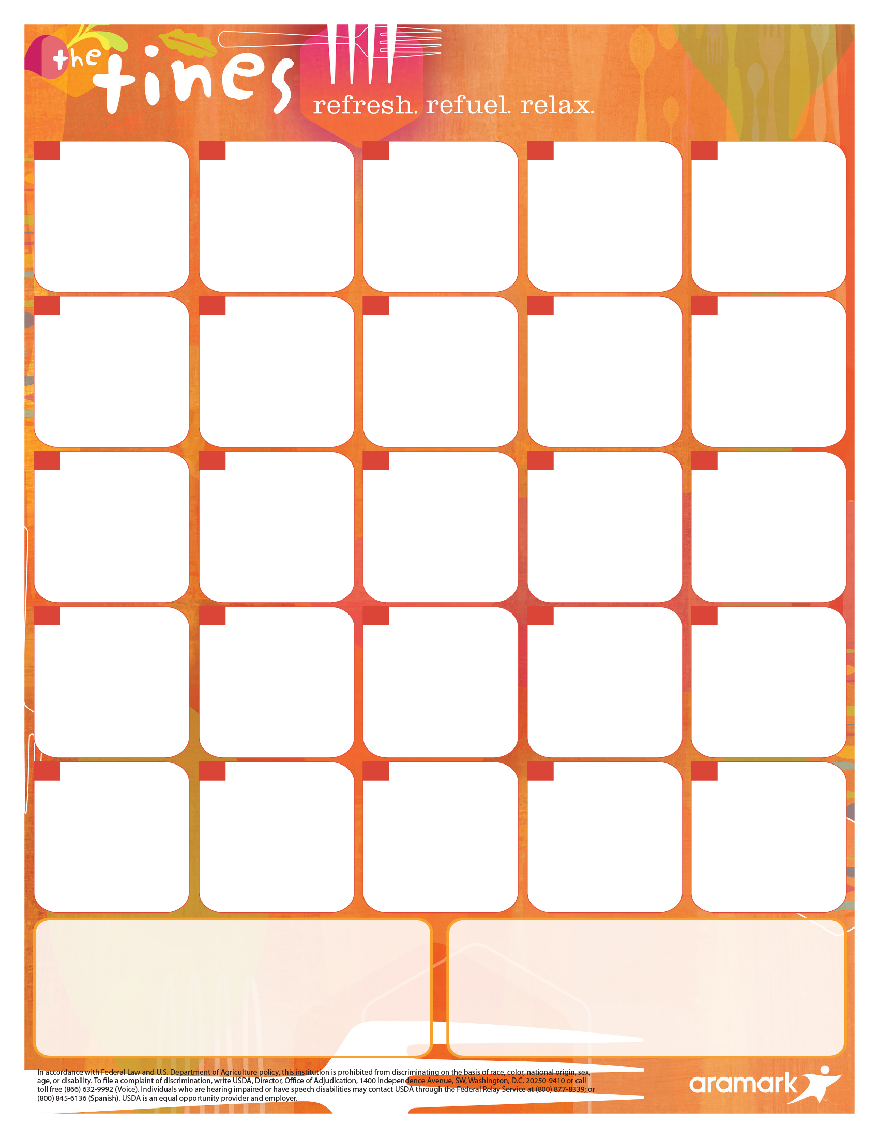

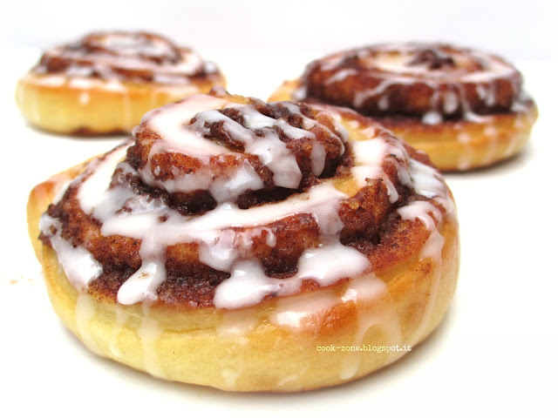

**Cinnamon Sugar Donut**

**Mini Cinnamon Rolls**

**Pancake Wrap**

**Cheesy Bacon, Egg & Tater Tot Tacos**

**Cinnamon Sugar Donut**

**Sausage Breakfast Pizza**

**Cinnamon Sugar Donut**

**Scrambled Eggs, Bacon, Cinnamon Toast**

**French Toast Sticks with Powdered Sugar**

**Chicken Sausage, Egg & Cheese Breakfast Tacos**

**Cinnamon Sugar Donut**

**Sausage Breakfast Pizza**

**Pancake Wrap**

**Cheesy Bacon, Egg & Tater Tot Tacos**

**Cinnamon Sugar Donut**

**Sausage Biscuit**

**French Toast Sticks with Powdered Sugar**

**Chicken Sausage, Egg & Cheese Breakfast Tacos**

**Chocolate Filled Crescent**

**Country Chicken Biscuit**

**Cinnamon Sugar Donut**

**Scrambled Eggs w/ Cheese, Hash Brown, Cinnamon Toast**

**Egg, Bacon & Cheddar Flatbread Sandwich**

**Cheesy Ham, Egg & Tater Tot Tacos**

**French Toast Sticks with Powdered Sugar**

**Chicken Sausage, Egg & Cheese Breakfast Tacos**

**Cinnamon Sugar Donut**

**Pancake Wrap**

**1**

**Cinnamon Sugar Donut**

**Cinnamon Toast Crunch Soft Filled Bar**

**Sausage Breakfast Pizza**

**Cheesy Bacon, Egg & Tater Tot Tacos**

**Student**

**Holiday**



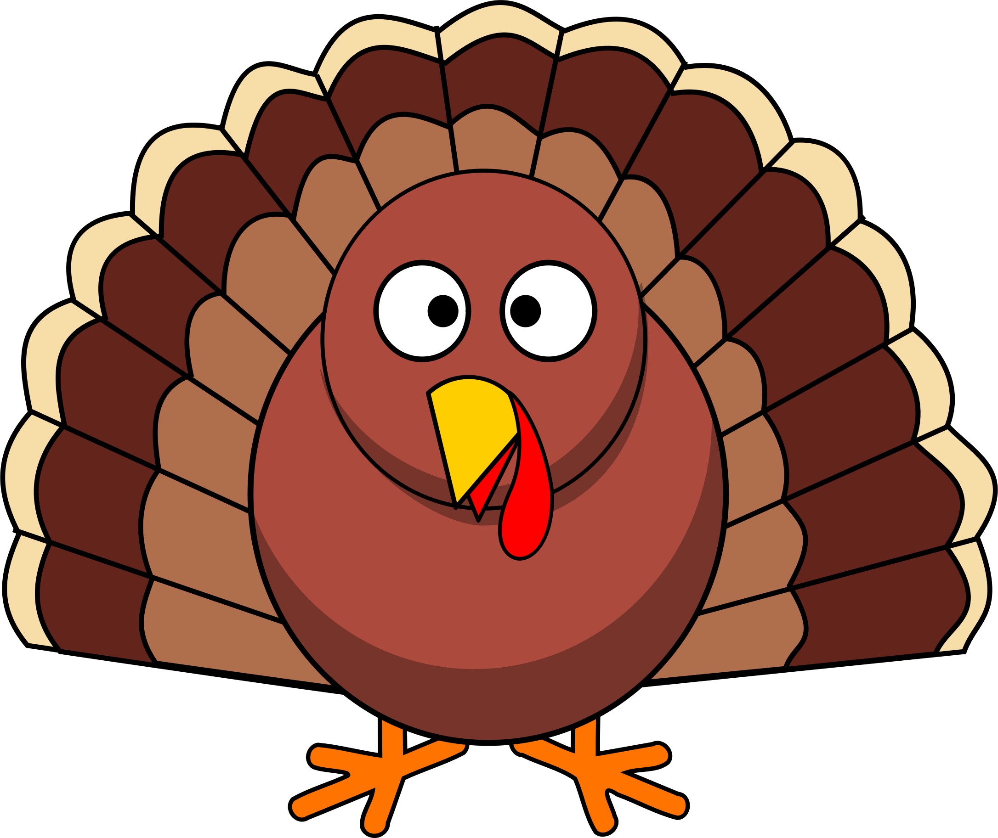

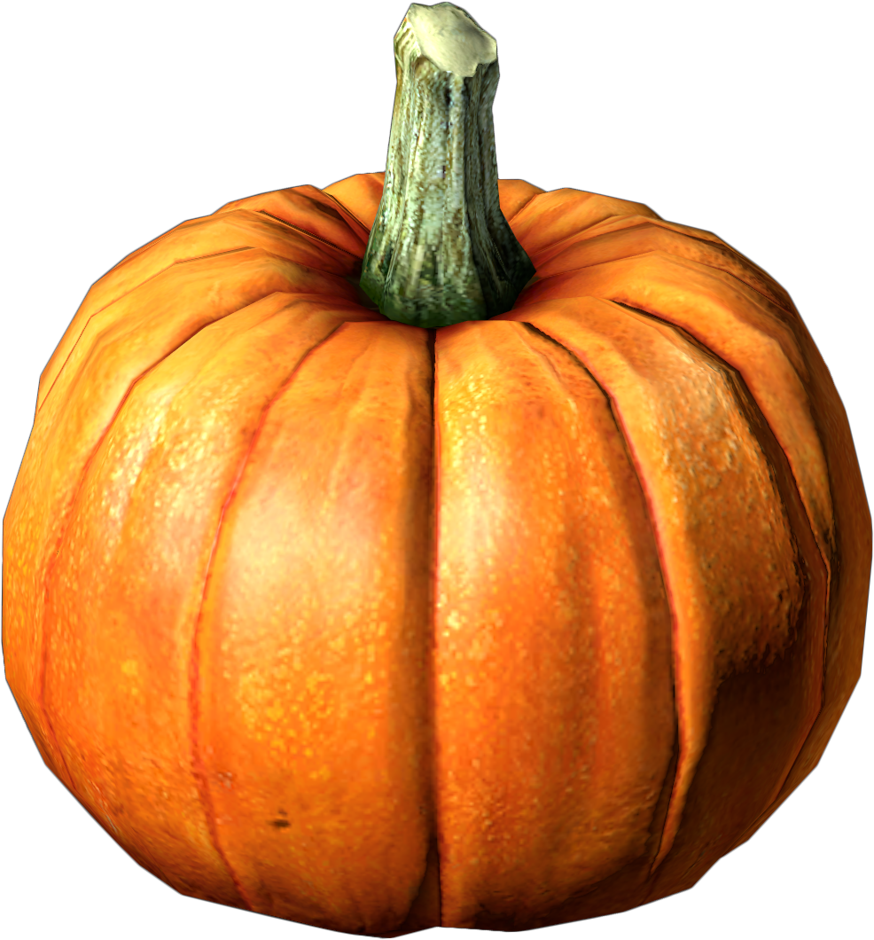

**For the 2021-2022 School Year the USDA announced program changes that will continue to provide Free Meals for all students, regardless of income.**

**A Breakfast Meal = Entrée + Fruit and/or Fruit juice**

**A BREAKFAST MEAL consists of an entree and at least one fruit and/or 4oz fruit juice. Milk is included with the MEAL, but it is optional. Any meal that does not meet the above guideline** **will be charged as à la carte for each item.**

Due to supplier constraints, menus are subject to change without notice. For the most up to date menu information please visit the menu website:

McKinney.SchoolDish.com

**29**

**Thanksgiving Break**

**30**

**26**

**25**

**24**

**23**

**22**

**19**

**185**

**175**

**165**

**155**

**12**

**11**

**10**

**9**

**8**

**5**

**4**

**3**

**2**

**Yogurt | Assorted Muffins | String Cheese | Cinnamon Toast | Fruity Cheerios | Cocoa Puffs | Lucky Charms | Cinnamon Toast Crunch | Poptart**

Pick 2 from the following items and add a fruit or juice for breakfast or save for a snack later!

**Pick 2 Options!**

**Available Daily at Breakfast**

**We are hiring!! Search “McKinney ISD Food” at** [**http://www.aramark.com/careers**](http://www.aramark.com/careers)

**Middle School Breakfast Menu**

November 2021