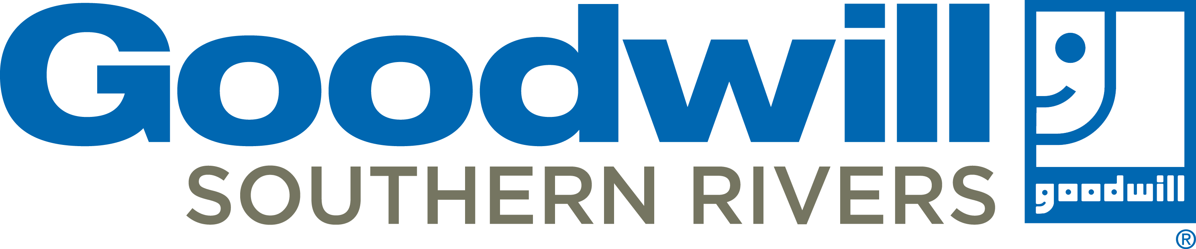

January 2022
Opelika Career Center

3740 Pepperell Parkway | Opelika, AL | 36801
334.275.4815 Option 4

Monday – Thursday 9:00 a.m. – 6:00 p.m.
Friday 9:00 a.m. – 3:00p.m.
www.goodwillsr.org

This Photo by Unknown Author is licensed under CC BY-NC
Mon | Tue | Wed | Thu | Fri |  | Sat
3 | 4 | 5 | Getting the Job  6 | 7 |  | 8
 | Keeping the Job  Time Matters 9:00am  Attitude that Works 10:00am  Communicate to Succeed 2:30pm  Workplace Expectations 3:30pm |  | Creating a Resume 10:00am  Finding your Job 11:30am  Ace the Interview 2:30pm  Social Media & Tech Check 3:30pm
 |  |  |  |  |  | VITA Tax Season begins on Feb 7th
10 | 11 | 12 | 13 | 14  Getting the Job  Creating a Resume 10:00am  Finding your Job 11:30am  Ace the Interview 2:30pm  Social Media & Tech Check 3:30pm |  | 15  Check out the  HOT JOBS Board for ready to hire positions in your area!
 | Getting the Job  Creating a Resume 10:00am  Finding your Job 11:30am  Ace the Interview 2:30pm  Social Media & Tech Check 3:30pm | Keeping the Job  Time Matters 9:00am  Attitude that Works 10:00am  Communicate to Succeed 2:30pm  Workplace Expectations 3:30pm
17 | 18 | 19 | 20 | 21 |  | 22
Career Center Closed | Open Interviews with  Rutledge State Prison  10am-12pm | Keeping the Job  Time Matters 9:00am  Attitude that Works 10:00am  Communicate to Succeed 2:30pm  Workplace Expectations 3:30pm | Getting the Job  Creating a Resume 10:00am  Finding your Job 11:30am  Ace the Interview 2:30pm  Social Media & Tech Check 3:30pm | Keeping the Job  Time Matters 9:00am  Attitude that Works 10:00am  Communicate to Succeed 2:30pm  Workplace Expectations 3:30pm |  | To make your tax appointment call 833-755-2179
24 | 25 | 26 | 27 | 28 |  | 22  29
Getting the Job  Creating a Resume 10:00am  Finding your Job 11:30am  Ace the Interview 2:30pm  Social Media & Tech Check 3:30pm | Job Fair  Opelika Library  10am-12pm | Getting the Job  Creating a Resume 10:00am  Finding your Job 11:30am  Ace the Interview 2:30pm  Social Media & Tech Check 3:30pm | Job Fair at Auburn Chamber  Office  10am-12pm | Keeping the Job  Time Matters 9:00am  Attitude that Works 10:00am  Communicate to Succeed 2:30pm  Workplace Expectations 3:30pm
31
Getting the Job
Creating a Resume 10:00am
Finding your Job 11:30am
Ace the Interview 2:30pm
Social Media & Tech Check 3:30pm

CALENDAR DETAILS
Orientation: All clients are required to complete orientation before use of services or resources. This class goes over the Career Center policies and gives an overview of the Workshops offered by GoodwillSR.
Getting the Job Series - These workshops will give you all the information you need to get the job!

Creating a Resume: This workshop teaches you how to write a resume and includes computer time with a team member. Please bring work history (Employer name and address, position titles, dates, job descriptions), and a list of everything you enjoy doing (i.e. fishing, drawing, event planning, etc).

Ace the Interview: Learn how to WIN at the interview! The interview skills class is designed for everyone preparing for their next interview.

Finding Your Job: Learn about how employers select who to interview and how to fill out application forms.

Social Media & Tech Check: Do you have a professional email address? Are there any pictures or posts on social media you don’t want an employer to see? Attend this workshop to get quick help in making sure your social media presence is ready for a good first impression.

Keeping the Job series. These workshops will make sure you have the skills to keep the job.

Time Matters: Learn about time management tips and tricks to use at work and at home.

Attitude That Works: Learn to understand the importance of having the right attitude at work & the impact that it has on your employment.

Communicate to Succeed: Learn how to communicate effectively with employers, co-workers and customers.

Workplace Expectations: Learn what behaviors and work ethics employers expect from their employees.

Goodwill Workshops Series
Let us help you Get the Job and Keep the Job.

Everyone that completes the Getting the Job Series:
- Priority assistance with job searching, job applications, and resume preparation
- Referrals to employers
- Goodwill Gift Card
- Access to Mock Interviews
- Access to Resume Reviews

See a Career Center Specialist today to learn more about our Workshops

We also offer:
Career Exploration: This lab and workshop teaches you about you! You will learn about your personality in the workplace and filter through your career interests to gain a better understanding of the best career options for you.

Computer Skills: Different computers skills will be offered throughout the year. Check your center for information on available classes.

