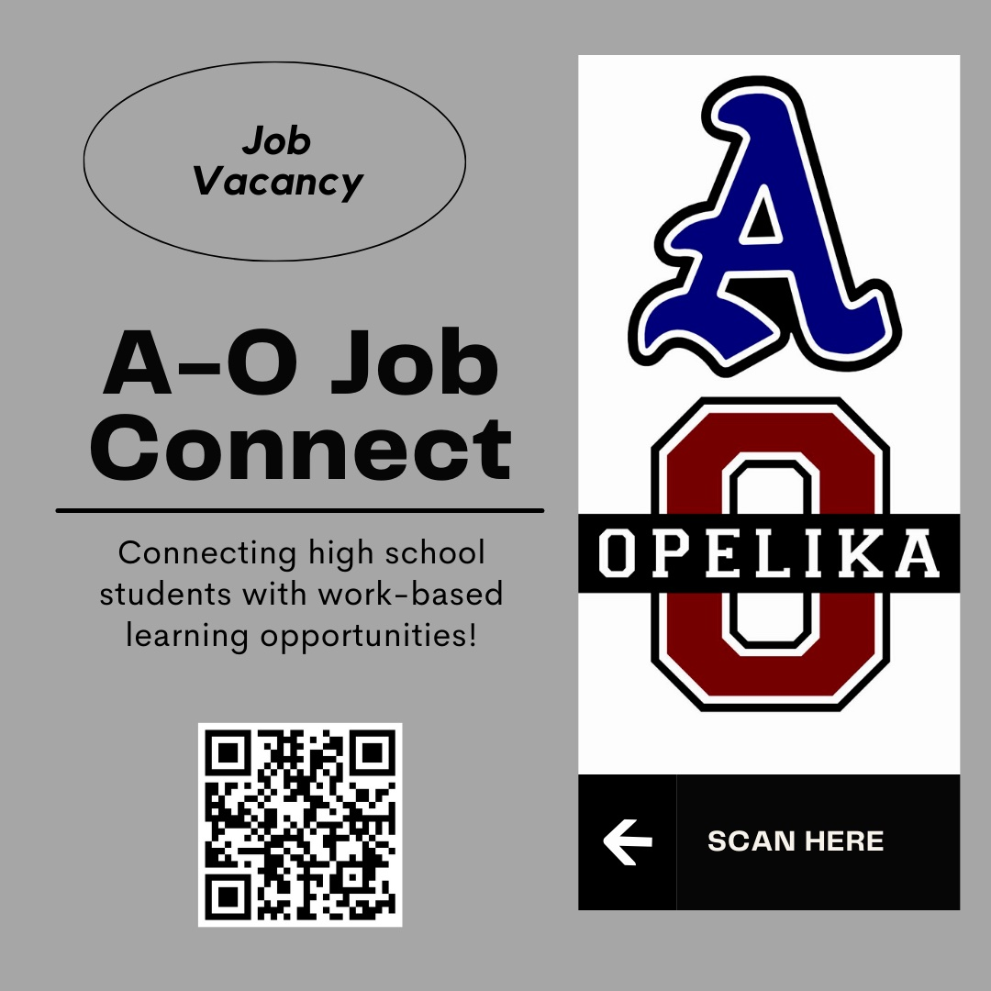

To post openings on this site, please email:
Work-Based Learning Coordinators
Audrey Marshall: amarshall@auburnschools.org
Stephanie David: stephanie.david@opelikaschools.org
or
Career Coach Amy Hanna
Auburn: ajhanna@auburnschools.org
Opelika: amy.hanna@opelikaschools.org

