Brian McCrone Visits Jim Lauterhahn

Jeffrey’s Supper Club has a tidy salad bar just off its dining room. Comes with the expected leafs and root vegetables: spinach and head lettuce, green and red peppers, onion, carrots. Three dressings. The station is directly across the bar — beers and beets. It was date night in the middle of nowhere when my partner-in-crime Heather and I walked into the joint on a Tuesday night in October. Two couples came in as we belly-upped for a beer near the end of our 1,800-mile journey.

Welcome to Kranzburg, South Dakota — pop. 172.

Jeffrey’s was not the destination. Or was it? Did we drive all the way from New Jersey for a Great Plains cold one? Technically, no. Our actual end-spot was Watertown, South Dakota. But here we were, sitting next to two cowboys, having a Budweiser far from home at dusk on a cool fall night in the year of Our Lord, 2018.

South Dakota Pic 1 (Jeffrey’s Supper Club in South Dakota)
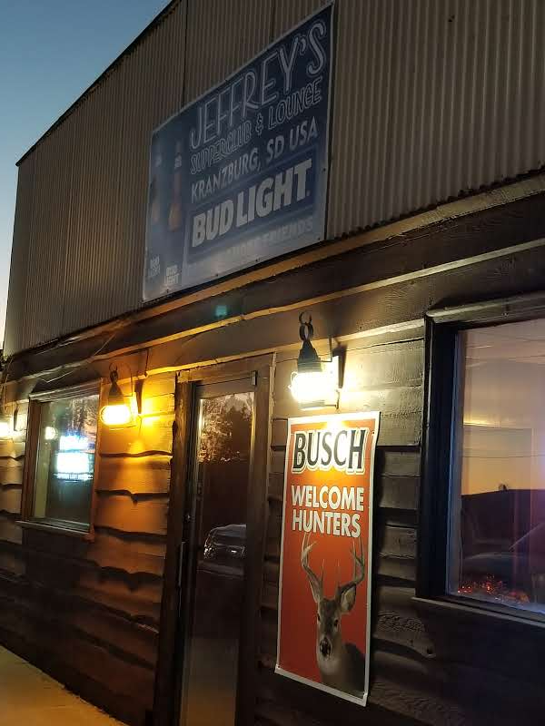

Watertown is about 25 miles west of Jeffrey’s. My old friend, Jim Lauterhahn, was waiting for us in Watertown. He and I met back in 1998 when I was a senior at Immaculate Conception High School and he was a first-year history teacher. We struck up a friendship immediately. I criticized the way he ran a detention, in a compassionate way, I believe, on the first occasion we met. He wasn’t stern enough, I told him. The atmosphere of the detention was too loosey-goosey. I’ve since come to find him the most even-tempered, thoughtful man I’ve ever met, so the detention thing is in line with who he is… and who I am. He took the criticism of a brattish 17-year-old in stride. It’s been a beautiful exchange of kindness and wisdom for 20 years now.

Jim and I had familial bonds as well: I’d grown up with his younger sisters and brothers. All of the Lauterhahn siblings — six of them — went to Immaculate. As for my family, my mother and all of my uncles — all five of them — went to Immaculate. Jim, being several years older than me, went to IC in the 1980s. Between his family and mine, graduates of the high school spanned four decades.

Since we’ve known each other, Jim and I have road-tripped to New Orleans, stayed for a week in Portland, Maine, and I was the best man for his wedding when he lived in Vegas.

Fast forward to now-ish: Jim, his wife Lisa and their son Junior moved to South Dakota and bought their first home earlier in the year — in part, to be nearer Lisa’s family on the Lake Traverse Reservation. Lisa is Native American. So here I was finally making the pilgrimage. Having read what I’ve written so far, you’ll not wonder anymore why my friend Heather and I would travel to South Dakota. Now, however: Why would we drive? That’s a fair question, and one answered with the fact that flying to South Dakota is just about as difficult. Go ahead and you look up how to get to Watertown by plane. Yeah, it turns out there is no easy way to get here. So on the road we went.

Heather came with me because, well, we had fell for each other a few months earlier, and what better way to test a relationship than hitting the road hard for a week. A car is a confined space. It’s a traveling, rambling, rolling psychmobile. Talk is often cheap — but not in the 10th hour of a bender-ride-to-the-edge-of-the-world-in-a-car. Heather was up for the challenge, the test, the epic battle between friendship and love. She’s an amazing human being. I am so-so, but have a swimming stroke to rise with the tide.

We left on a Monday morning from my house on the Jersey side of the Delaware River. It would take two and a half days to go from Trenton to South Dakota. And where Jim lives isn’t even the side of the state where Mount Rushmore is. No, the four-headed monument is nearly another day’s drive deeper west into those Plains. Watertown is in a part of the state Dakotans call “East River.” Somewhere in the middle of the rectangled expanse, so says Jim, is a river that bilaterally splits the place.

We crossed all of Pennsylvania, then rolled through Ohio, Indiana, and Illinois. We drove north into Wisconsin and turned left to Minnesota and beyond.

I like the road. Jim and I are huge Jack Kerouac fans, and Kerouac’s “On the Road” is a favorite. It inspired our New Orleans trip in 2002. It’s the best way to see the country. Essential to a good road trip is the company you keep.

Heather and I met in the spring. She had just moved to Philadelphia from New York City. She was starting a new journey: new city, new career. I was starting a new journey too: recently separated and alone for the first time in over a decade. A wife and a stepson had left within four months of each other. First, the stepson moved out, then the wife.

A mutual friend from Brooklyn introduced Heather and I, and away we went. A months long courtship showed an intense compatibility. If it’s on, it’s on. And it was on.

Still, we were trepidatious about a week on the road together. Traveling in a confined space for that long can do things to you, man. And this wasn’t a trip, say, up or down the East Coast, or along the Pacific Coast Highway in California. No, this was a ride into the Great Cornfield Abyss. We would enter into the endless corn and soy rows of the Midwest to see how big the country really is.

South Dakota Pic 2 (Heather eating at Path Valley Family Restaurant in Pennsylvania)
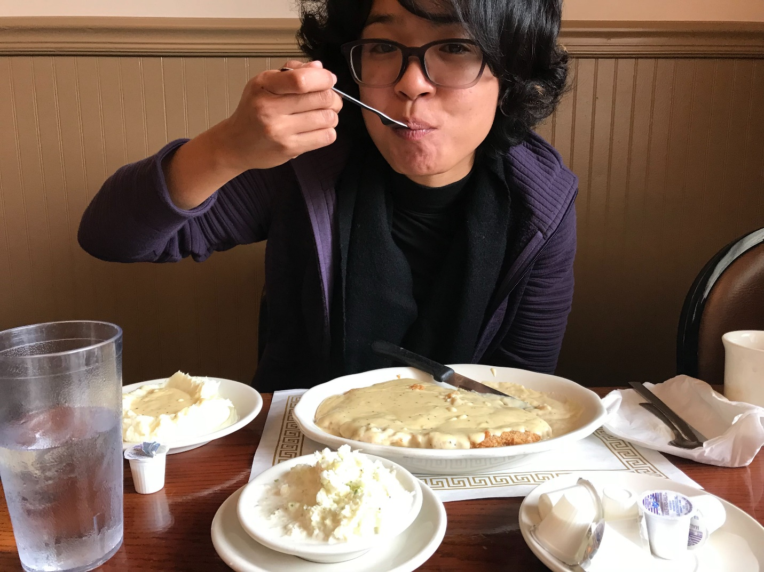

The first stop was lunch in central Pennsylvania, where the Southern-fried steak is the size of a manhole cover; it swims in a Godly salt lake of turkey gravy. A sushi stop in a town called Zanesville, Ohio, worked for dinner. We stayed in Indianapolis that night.

It was late October, so the leaves were turning into those pastoral colors of orange-yellow and red-green and bright yellow. Their trees’ patchwork collections gave depth of space to the billions of crop rows running off to infinity.

South Dakota Pic 3 (Leaves turning autumn colors in Wisconsin)
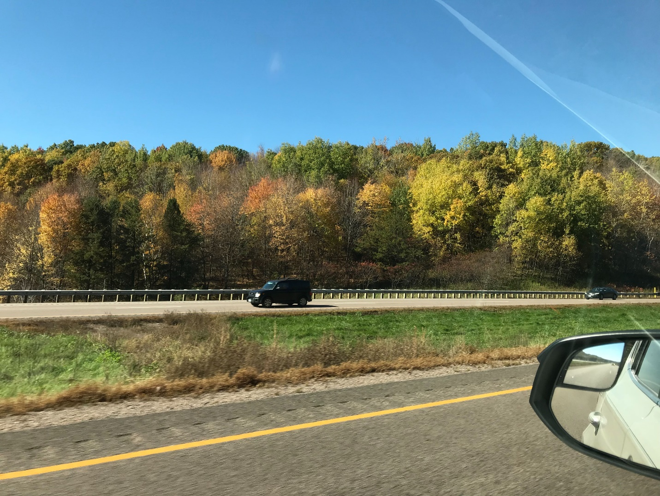

South Dakota Pic 4 (Wind turbines in White County, Indiana)
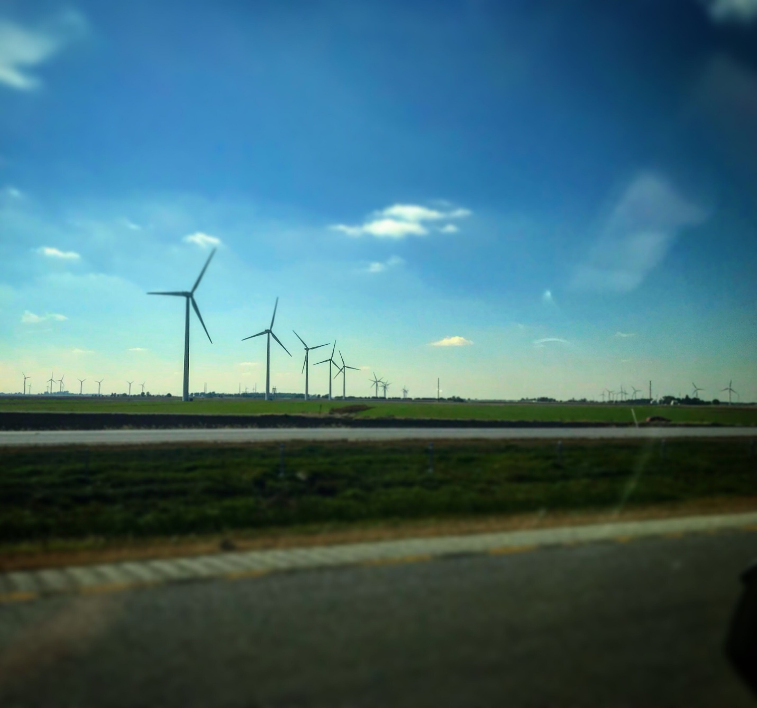

South Dakota Pic 5 (Heather, standing in front of the Wisconsin State Capitol in Madison)
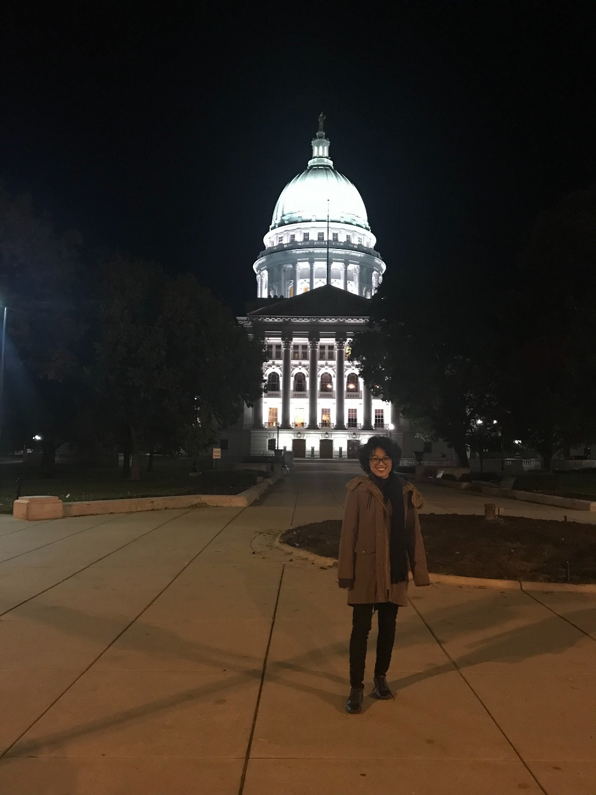

One distinctive break in — or actually, above — all that corn was Indiana’s put-you-in-your-right-size wind farms. The apartment-building-tall turbines dwarf all the rest of the landscape, and went to the horizon for an hour along the highway. We stayed the second night in Madison, Wisconsin, land of cheese curds and cheese platters and steak and beers. It was a clean town, freezing that time of year and nestled between two lakes. It seemed a nice place to live, if staying calm in Midwest obscurity is your thing. A few months later, reading Steinbeck’s “Travels With Charlie,” about the novelist’s cross-country trip decades earlier, I found that old Johnny had a similar reaction to Wisconsin: “When I saw it for the first and only time in early October, the air was rich with butter-colored sunlight, not fuzzy but crisp and clear so that every frost-gay tree was set off, the rising hills were not compounded, but alone and separate.”

By day three, we were plowing through Minnesota, stopping for some authentic Mexican food well north of the border. A good burrito is a good burrito is a good burrito.

By late afternoon, we were nearing South Dakota. The border approaching, it got a bit dustier than amid the farmlands we spent two days navigating. It was great to be away from the bustling American cities of the coasts. The land opened up to me and Heather, and the country felt bigger than ever, and freer than from where we’d come. It was refreshing. It was humbling. It was lonely. It was fearsome in the way you feel when you own something, like a chainsaw or an instant cooker, but you don’t know how to use it.

It was our land that we’d never used before.

As we got close, crossing into South Dakota on that third day of the road, the evening light recessed at dusk — only 75 miles of dusty towns with triple digit populations standing between us and Watertown. I wanted to get a drink. Heather did too. I drove by one joint that looked decent, but when you’re on the road, you get feelings for places you want to appear. Jeffrey’s popped up, half a street off the highway, and then sunk behind. I thought: “Did that say Supper Club?” I thought: “Did that have a neon Budweiser sign?”

I asked Heather, and she was sure of its legitimacy. We pulled a U-turn.

Half a mile back, Jeffrey’s was a thing indeed. It was dusty. Maybe there was asphalt under the moon dust that spit up from my tires. But I couldn’t tell. I was worried about Jeffrey’s. “Are you sure?” I asked looking up at the sign. Heather was sure. She’s an adventurous one. We went in. The charm struck us immediately.

Heather asked for a beer list. The bartender chuckled. The other two guys at the bar did too. The list was Budweiser and Coors Light and Miller High Life. Oh wait, there was a Modelo in the refrigerator! Heather saw. It took even the bartender by surprise. I got a Bud.

“You don’t like Budweiser,” Heather said to me.

“No, but sometimes it feels right,” I said.

Half an hour later, we were entering Watertown proper. “I have to get over to Kranzburg,” Jim Lauterhahn told us minutes after we hugged. “I’ve been meaning to. I wanna give Jeffrey’s a try. Date Night!”

South Dakota Pic 6 (Jim and Brian in Watertown)
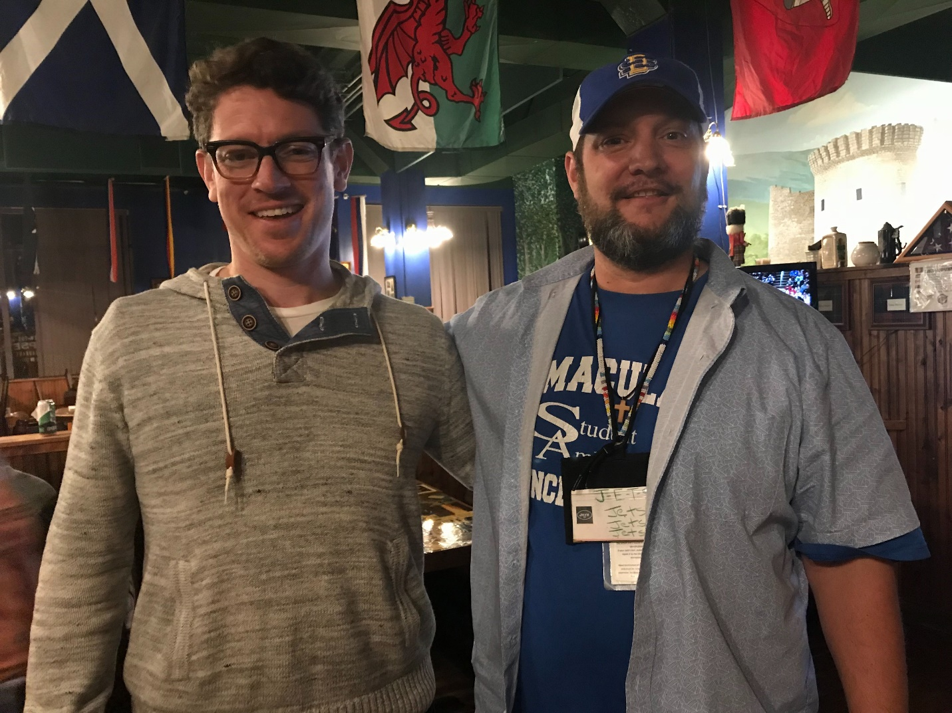

Downtown Watertown has a brewery on Main Street, and a coffeehouse and a bookshop. At the brewery, a young bartender talked about how he didn’t want to work on his father’s farm. Or did he? He wasn’t entirely sure, though he leaned toward striking out on his own, making his fate instead of relying on beef trading and corn and soy prices. The bookshop was attended to by an old man with a beard who didn’t seem to know directions around town too well. Perhaps the town grew up too fast around him.

A restaurant Jim and Lisa took us for dinner the second night was known far and wide for its pizza. The chef, born and raised “East River,” ran away and studied culinary tricks in Italy. He brought back his foreign-land magic, and as Wednesday night crowd attested, Italy’s secrets have been well-received.

Earlier that second day, we took the hour’s ride from Watertown to the Native American reservation grade school where Jim is a special education teacher, and Junior is now in the fourth grade. It’s 55 miles from Jim’s house to Enemy Swim School on the reservation, and there are zero traffic lights. There is a herd of buffalo that the tribe owns. Heather and I didn’t see them.

South Dakota Pic 7 (Junior, Heather and Brian at Junior’s grandparents’ house on the Lake Traverse Reservation)
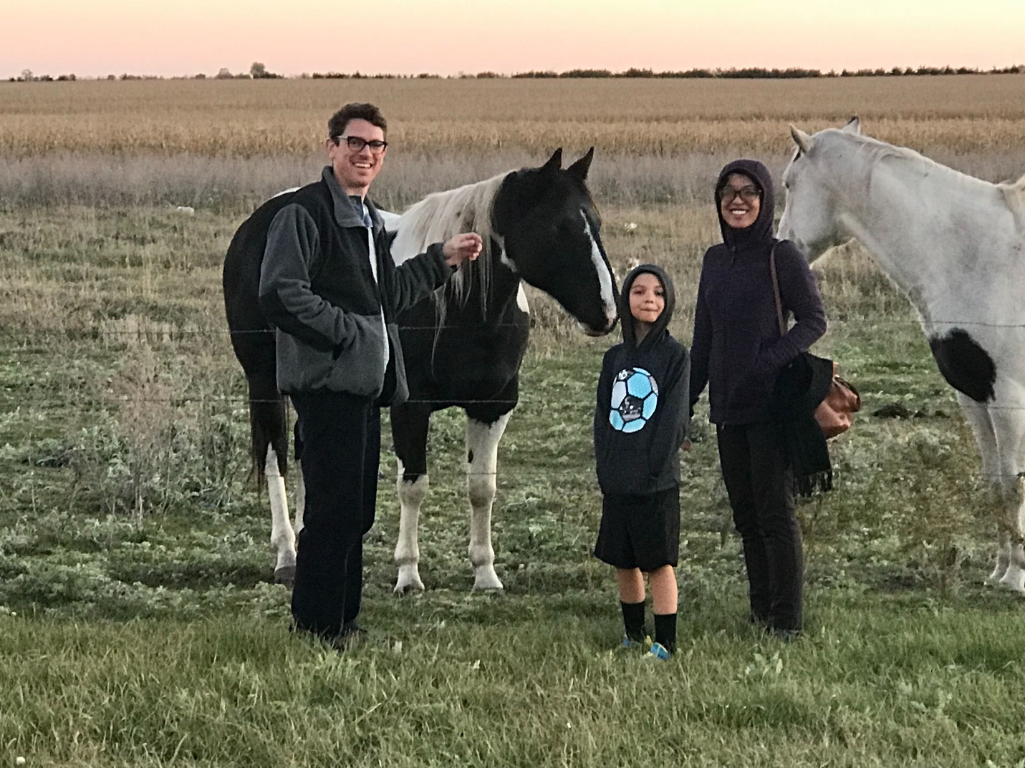

We did get to see the beginnings of what Jim told us is a Native American ritual known as a sweat ceremony. It’s a purification ritual involving an enclosure and heated rocks. Jim said he’d taken part in one sweat so far. He didn’t think he’d make it the whole time, but he did.

Heather and I spent another day visiting an art gallery/museum dedicated to Watertown’s very own landscape portraitist, Terry Redlin. The Redlin Arts Center has many of the wildlife painter’s great works. Heather noticed a theme: animals dominating the foreground, the humans in the rear filling in the landscape.

Back at Jim and Lisa’s, we got in a solid game of 2-on-2 backyard soccer: Junior and me versus Heather and Jim. Lisa documented the game from their deck. It was feisty, and Junior asked that we play again the next time we visit. Of course, we would, we said.

And the last night, Jimbo and I watched a little basketball on the tube after Lisa and Heather and Junior went to bed. We coulda been back in Jersey. We coulda been in Vegas. We coulda been in New Orleans. We talked about the newest NBA studs who erupted onto the scene outta nowhere. We talked about Curry and Durant. We talked about Kyrie and the Knicks and the Brooklyn Nets and how they shoulda never left Jersey. So many things are born in Jersey and leave Jersey.

South Dakota Pic 8 (Jim and Brian on the last night in Watertown)
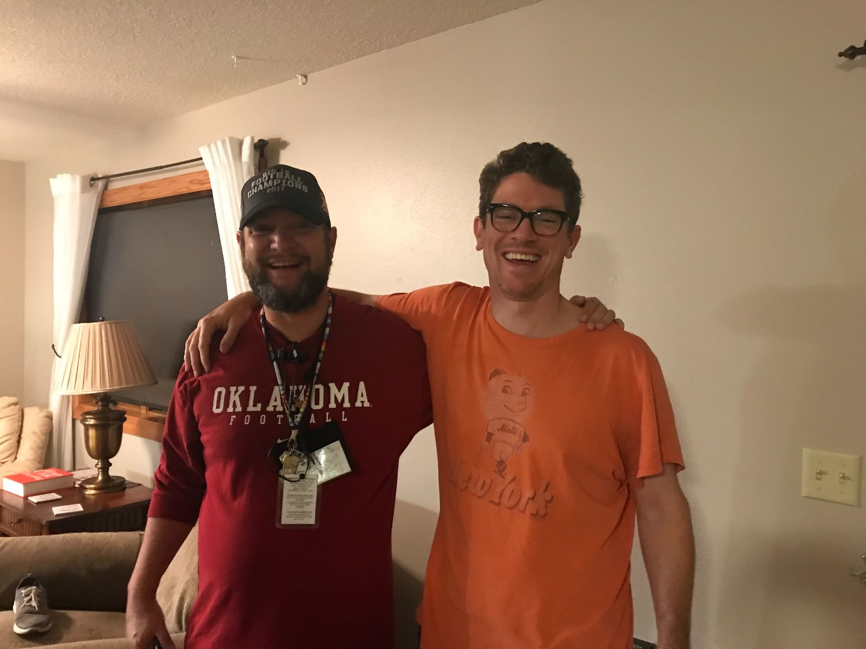

Heather and I hit the road home early Friday morning, the coldest day of the trip. We stopped by the coffee shop in town, and dropped off some postcards at the post office. We’d race them home. And race we did. We sped home a different way than the initial ride west. We headed south through Nebraska. I wanted to see more cornfields, apparently. Then across Iowa.

All told, we hit 10 states in 8 days. Heather and I suffered a near fatal spell of self-destruction in Pittsburgh, where we spent our final day and night on the road. The road is a tricky place for love and friendship and the art of getting along in tight quarters. On the day before we left Pittsburgh, we crossed the Fort Pitt Bridge just as a long, rainy storm shoved its way up the Ohio River. Halfway across, we got slammed with a cold downpour and blinding winds. I wasn’t sure we’d make it across the span. But we did.

South Dakota Pic 9 (Heather and Brian on the Fort Pitt Bridge in Pittsburgh — after they made it across alive)
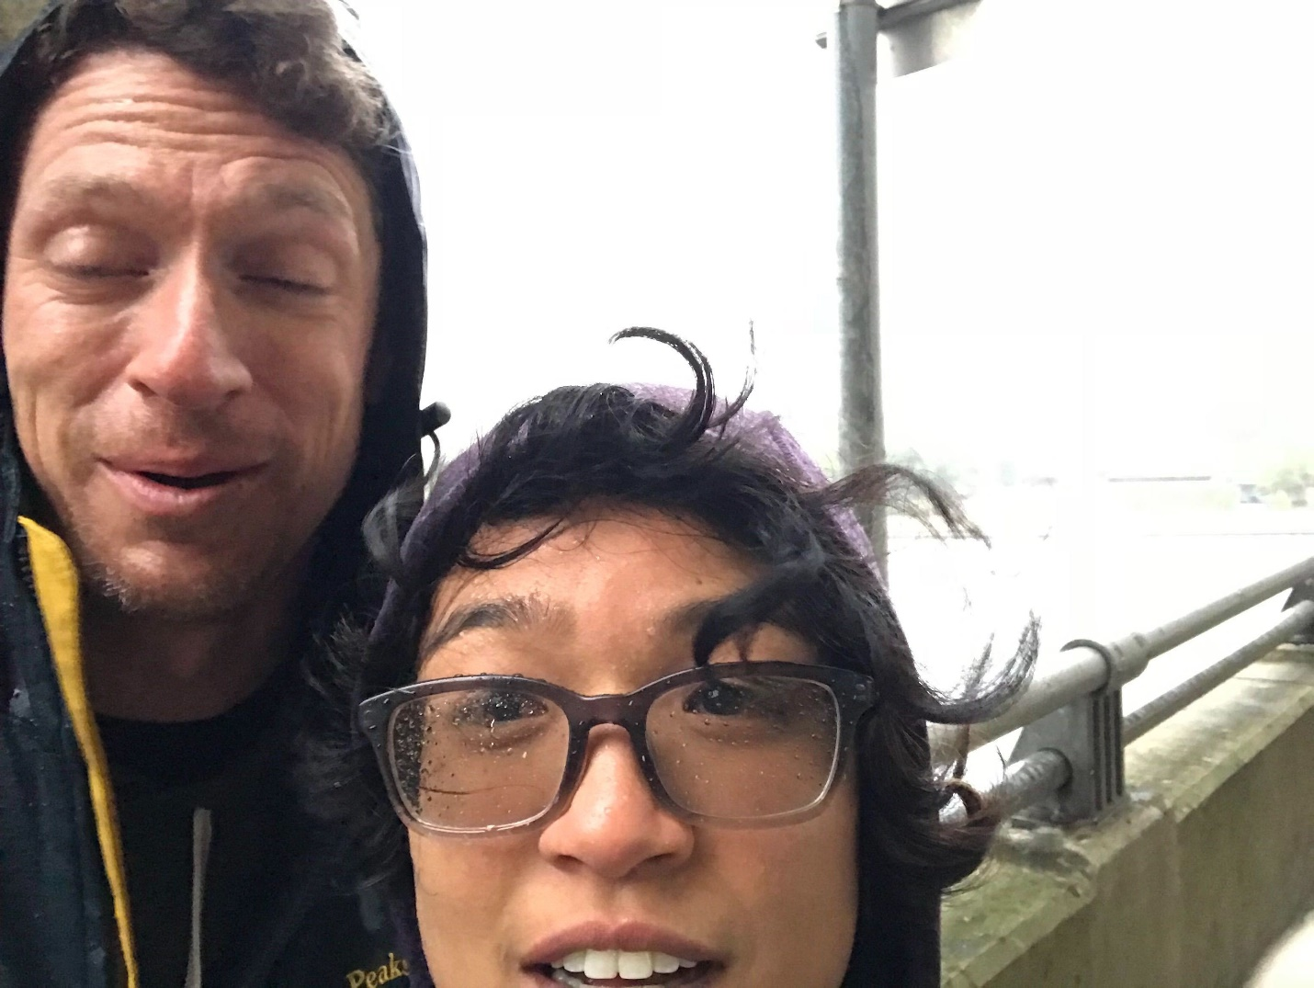

——— END ———

Brian X. McCrone is a journalist and writer who graduated from Immaculate Conception High School in 1998. He and his better half, Heather, currently live in Philadelphia.

