The Amazing Earth Day RACE at Five Rivers!

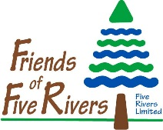
Team Registration Form
Directions:
1. Complete this form in its entirety. Print legibly.
Registration Deadline: April 7, 2017

2. Attach a $25 non-refundable Entry Fee check made out to: Friends of Five Rivers or pay online at www.FriendsofFiveRivers.org (Use the donate now button – please note in the description field Amazing Race).
3. Bring or mail completed Registration Form and Entry Fee to: Friends of Five Rivers
c/o The Amazing Earth Day Race
56 Game Farm Road
Delmar, NY 12054
Team Name: _____________________________________________________________ (Must be a family-friendly name no longer than 2 words.)

Team Captain: _________________________________ Phone Number: _____________________ (Responsible for team members and behavior.)

First and Last Name of All Team Members  (Three members minimum) | Age | Street Address | Email Address
1.

2.

3.

4.

5.

6.

